**NAME – KHUSHI PANWAR**

**ROLL NO – 2021334**

**COMPUTER SCIENCE, 1ST YEAR**

**JAVA PRACTICAL : EXTRA QUESTIONS**

1. **Write a basic Java program to print “Hello World”:**

**import** java.io.*;

**public** **class** HelloWorld{

**public** **static** **void** main(String[] args)**throws** IOException{

System.***out***.println("*****************\nHello World");

System.***out***.println("This is my first program in Java Language!");

}

}

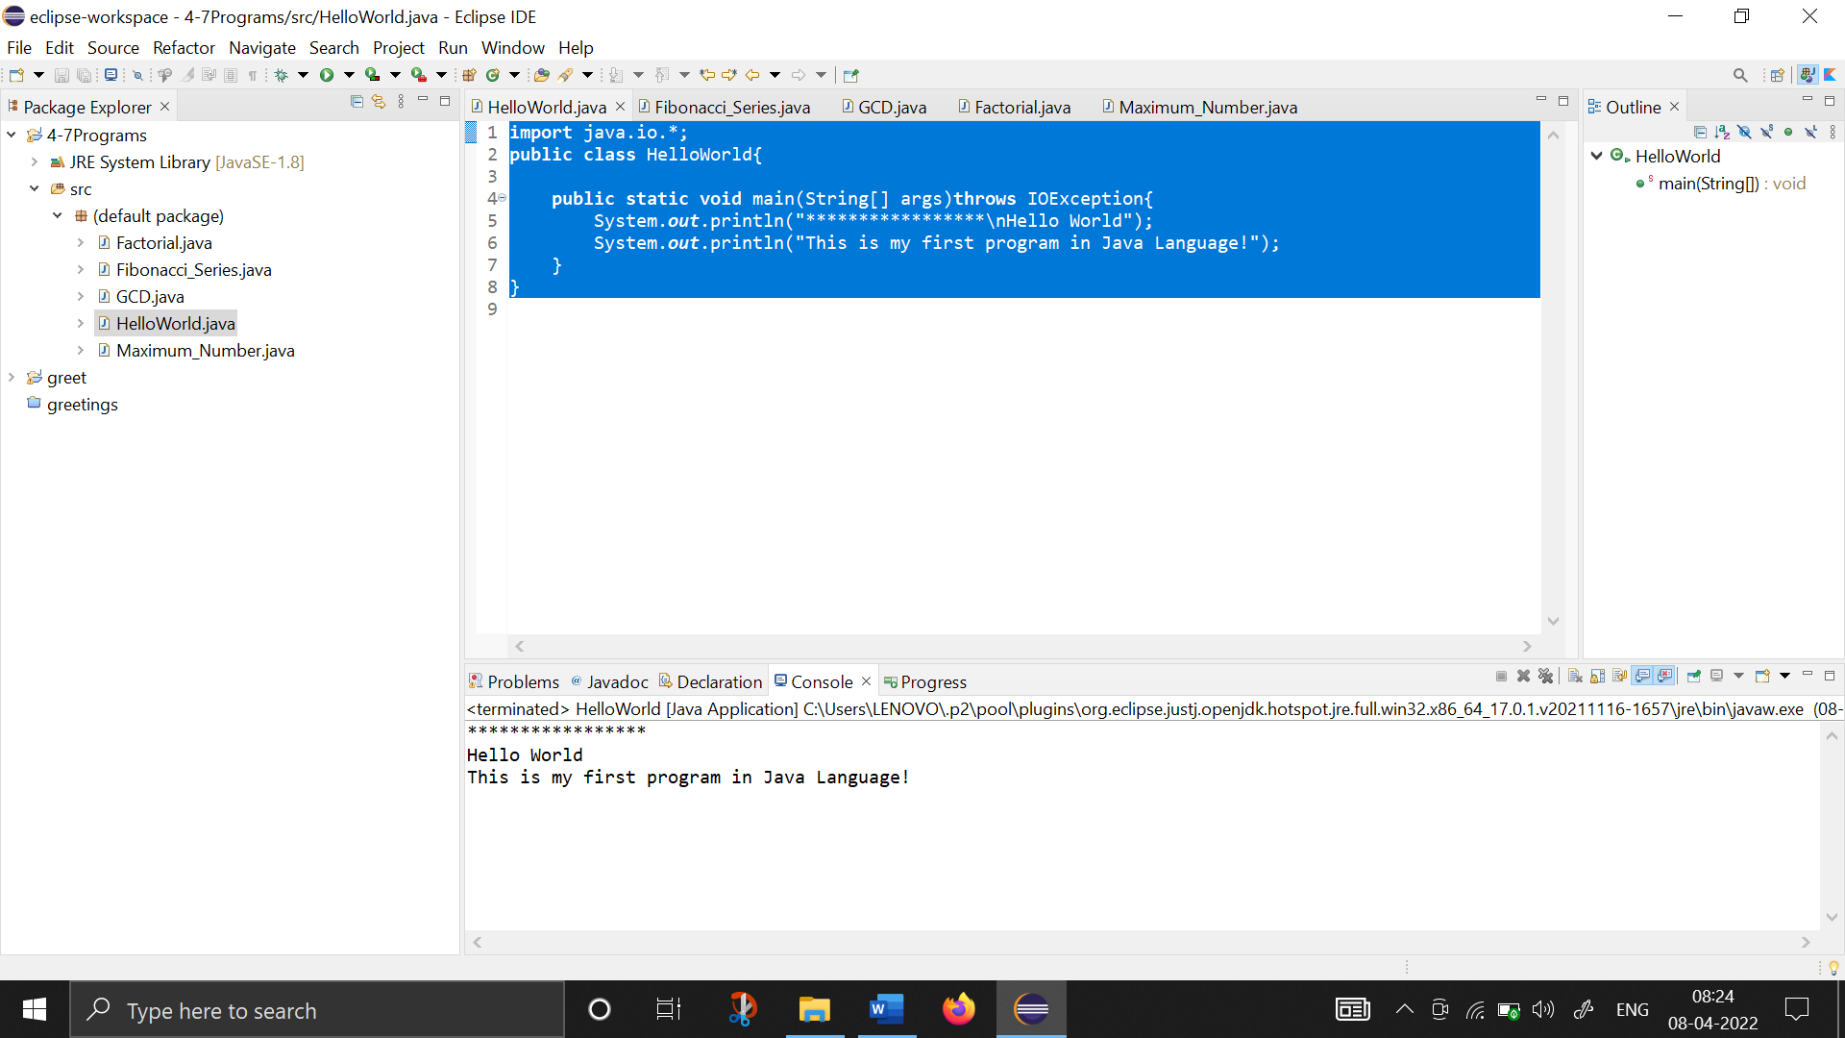

1. **Write a program to find the factorial of a number entered by the user:**

**import** java.io.*;

**public** **class** Factorial{

**public** **static** **void** main(String[] args)**throws** IOException{

System.***out***.println("*****************\nThis program calculates the factorial of a given number! \n*****************\n");

BufferedReader br1=**new** BufferedReader(**new** InputStreamReader(System.***in***));

**int** num;

System.***out***.println("Enter the number here: ");

num=Integer.*parseInt*(br1.readLine()); //used to convert entered input from string to integer

**int** factorial=1;

**for** (**int** i=1; i<=num; i++) {

factorial*=i;

}

System.***out***.println("Factorial of "+num+" is "+factorial);

}

}

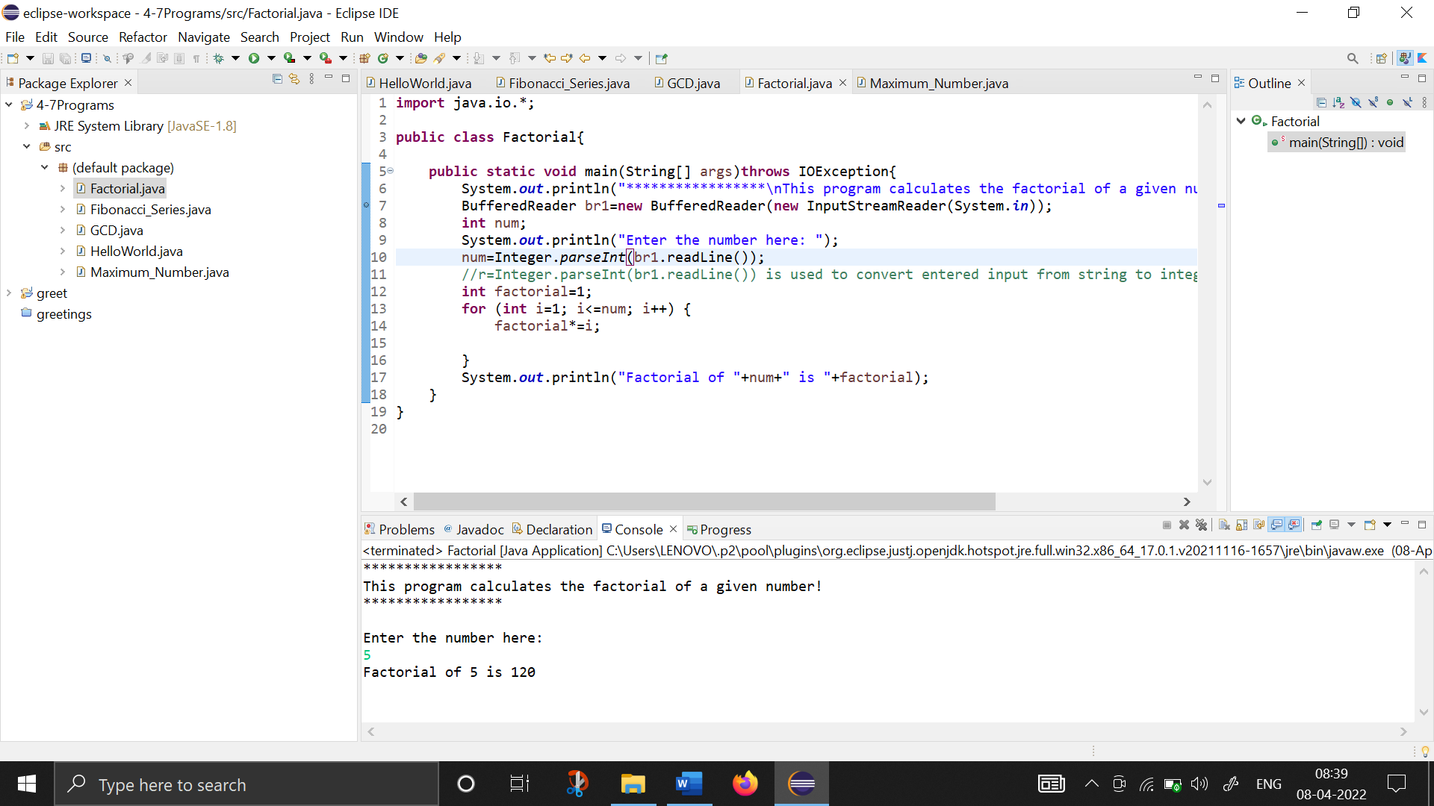

1. **Write a program to print Fibonacci Series:**

**import** java.io.*;

**public** **class** Fibonacci_Series{

**public** **static** **void** main(String[] args)**throws** IOException{

System.***out***.println("*****************\nThis program prints the Fibonacci Series from the number entered by user! \n*****************\n");

**int** a=1, b=1, c;

System.***out***.print("The Basic Fibonacci Series is as -> \n"+a+","+b);

**for** (**int** i=1; i<=10; i++) {

c=a+b;

System.***out***.print(","+c);

a++;

b++;

}

System.***out***.println("\n\n \t*USER DEFINED FIBONACCI SERIES* \n");

BufferedReader br1=**new** BufferedReader(**new** InputStreamReader(System.***in***));

**int** num1, num2, num3, terms;

System.***out***.println("How many terms do you want to print: ");

terms=Integer.*parseInt*(br1.readLine()); //used to convert entered input from string to integer

System.***out***.println("Enter the first number here: ");

num1=Integer.*parseInt*(br1.readLine()); //used to convert entered input from string to integer

System.***out***.println("Enter the second number here: ");

num2=Integer.*parseInt*(br1.readLine()); //used to convert entered input from string to integer

System.***out***.print("The Fibonacci Series is as -> \n"+num1+","+num2);

**for** (**int** i=1; i<=terms; i++) {

num3=num1+num2;

System.***out***.print(","+num3);

num1++;

num2++;

}

}

}

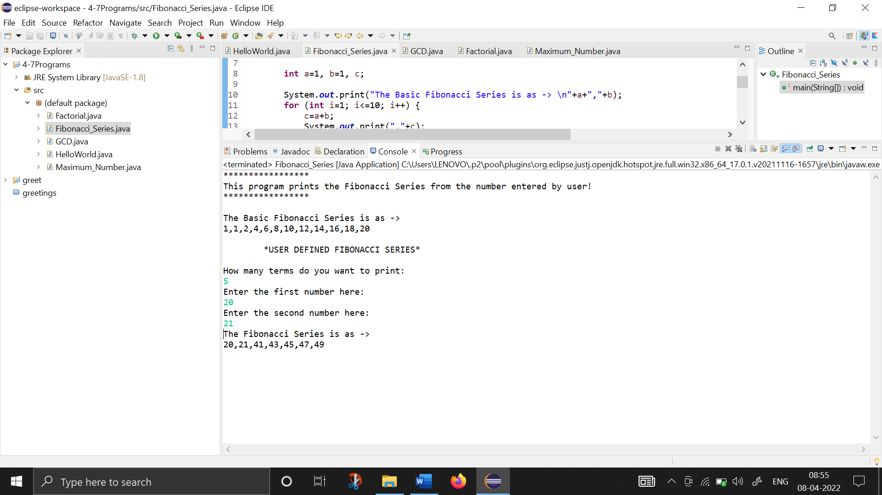

1. **Write a program to find the maximum number from the list of numbers entered by the user:**

**import** java.io.*;

**public** **class** Maximum_Number {

**public** **static** **void** main(String[] args)**throws** IOException{

BufferedReader br1 =**new** BufferedReader(**new** InputStreamReader(System.***in***));

System.***out***.println("**********\nThis program finds the MAXIMUM/GREATEST number from the given list of numbers!\n**********");

**int** term, num, max=0;

System.***out***.print("How many terms/numbers do you want to enter : ");

term=Integer.*parseInt*(br1.readLine());

**for** (**int** i=1; i<=term; i++) {

System.***out***.print("Enter the "+i+" term here : ");

num=Integer.*parseInt*(br1.readLine());

**if** (num>max)

max=num;

}

System.***out***.println("The Maximum/Greatest Number found is "+max);

}

}

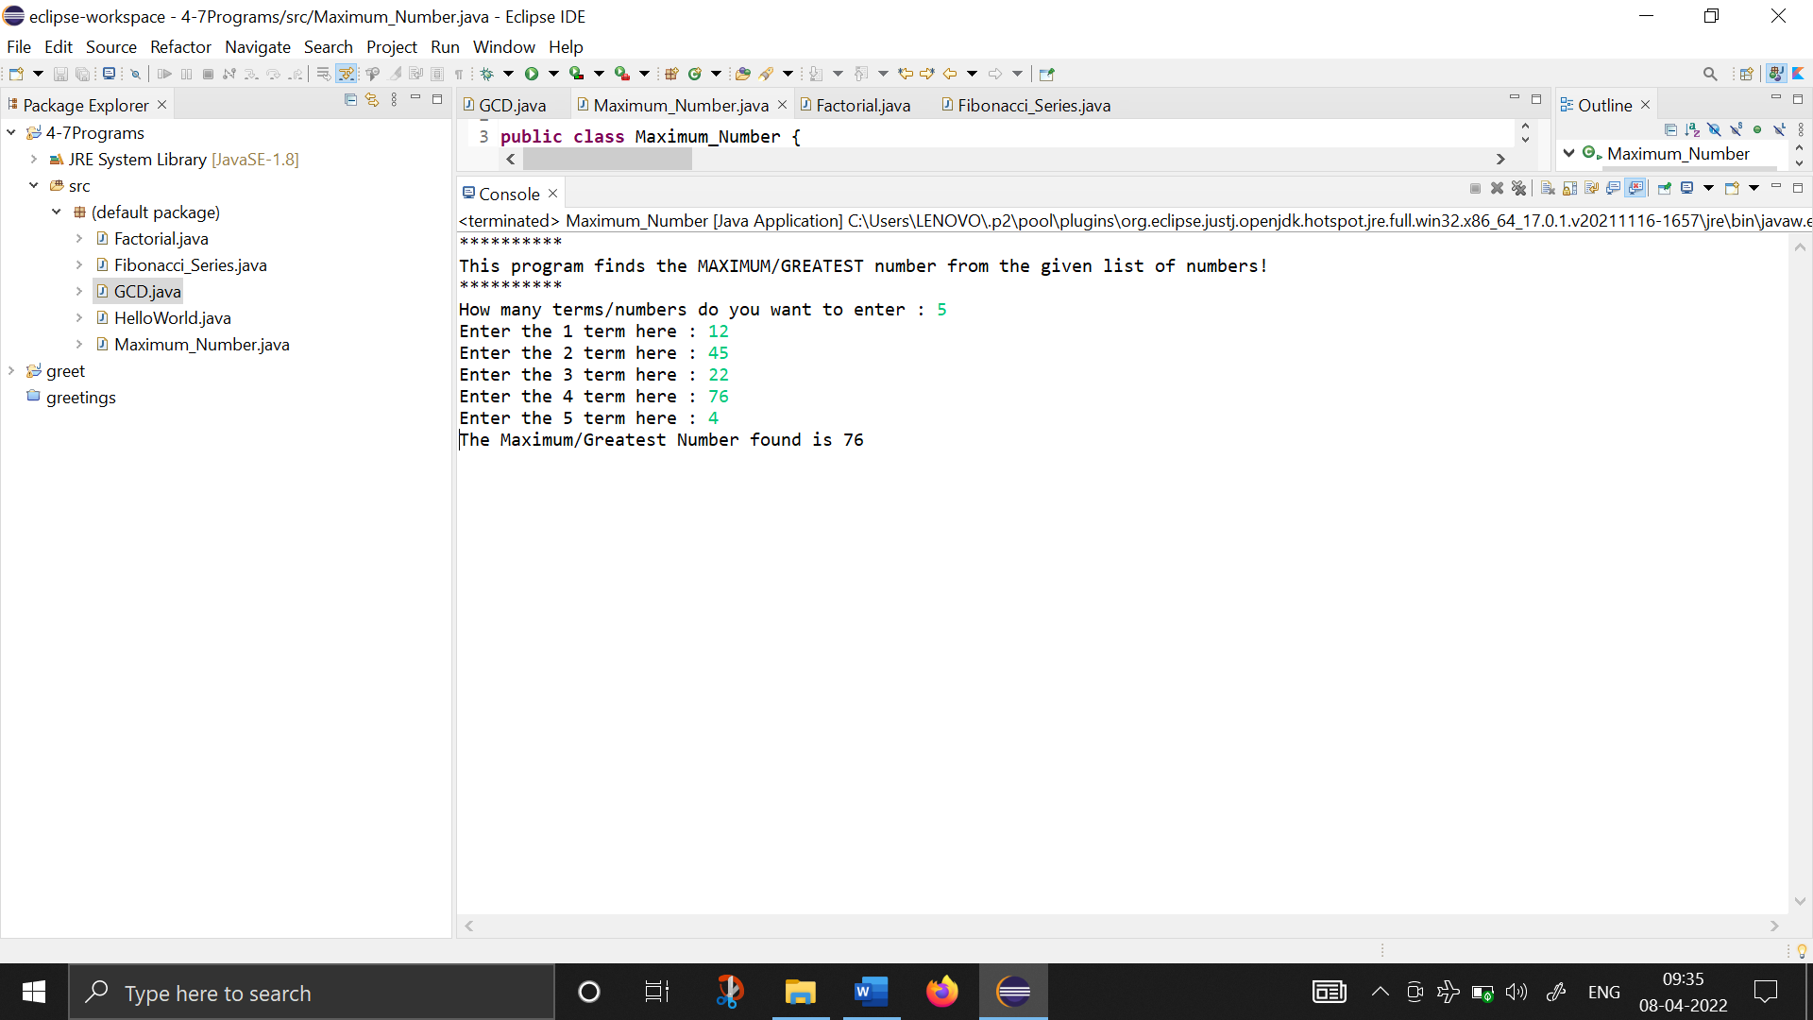

1. **Write a program to find GCD (Greatest Common Divisor) :**

**import** java.io.*;

**public** **class** GCD{

**public** **static** **void** main(String[] args)**throws** IOException{

System.***out***.println("*****************\nThis program calculates the Greatest Common Divisor of two numbers! \n*****************\n");

BufferedReader br1=**new** BufferedReader(**new** InputStreamReader(System.***in***));

**int** num1,num2,gcd=1;

System.***out***.println("Enter the first number here: ");

num1=Integer.*parseInt*(br1.readLine());

System.***out***.println("Enter the second number here : ");

num2=Integer.*parseInt*(br1.readLine());

**for** (**int** i=1; i<=num1 && i<=num2; i++) {

**if** (num1%i==0 && num2%i==0) {

gcd=i;

}

}

System.***out***.println("-> The Greatest Common Divisor of "+num1+" and "+num2+" is "+gcd);

}

}

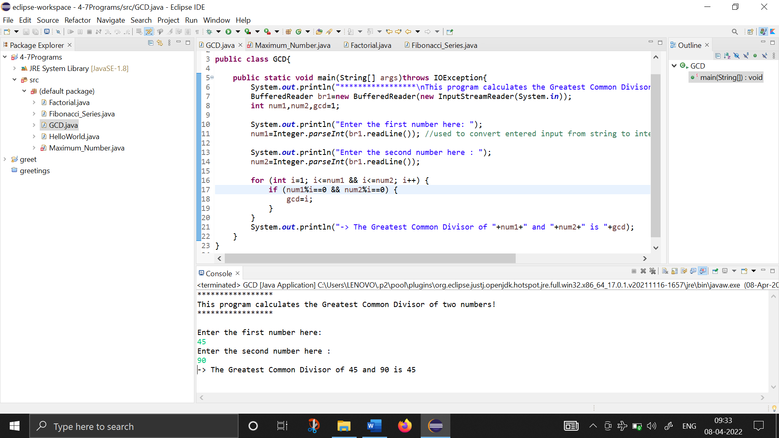

1. **Write a Java program perform binary search :**

**import** java.io.*;

**public** **class** BinarySearchInArrays{

**public** **static** **void** main(String[] args)**throws** IOException{

BufferedReader br1 = **new** BufferedReader(**new** InputStreamReader(System.***in***));

System.***out***.println("THIS PROGRAM PERFORMS THE BINARY SEARCH ON AN ARRAY");

**int** terms, searchNum;

System.***out***.print("\n -> How many elements do you want to enter? -");

terms=Integer.*parseInt*(br1.readLine());

**int**[] A=**new** **int**[terms];

System.***out***.println("\n -> Enter the ordered array elements here -");

**for** (**int** i=0; i<terms; i++){

System.***out***.print("Element at "+i+" index : ");

A[i]=Integer.*parseInt*(br1.readLine());

}

System.***out***.print("\nEnter the element you want to search : ");

searchNum=Integer.*parseInt*(br1.readLine());

**int** flag=0, start=0, end=terms-1, mid;

//binary search program here

**while**(start<=end){

mid=(start+end)/2;

**if** (searchNum>A[mid]) {

start=mid+1;

}

**else** **if**(A[mid]>searchNum) {

end=mid-1;

}

**else** {

flag=1;

**break**;

}

}

**if** (flag!=0)

System.***out***.println("Element found!");

**else**{

System.***out***.println("Element not found!");

}

}

}

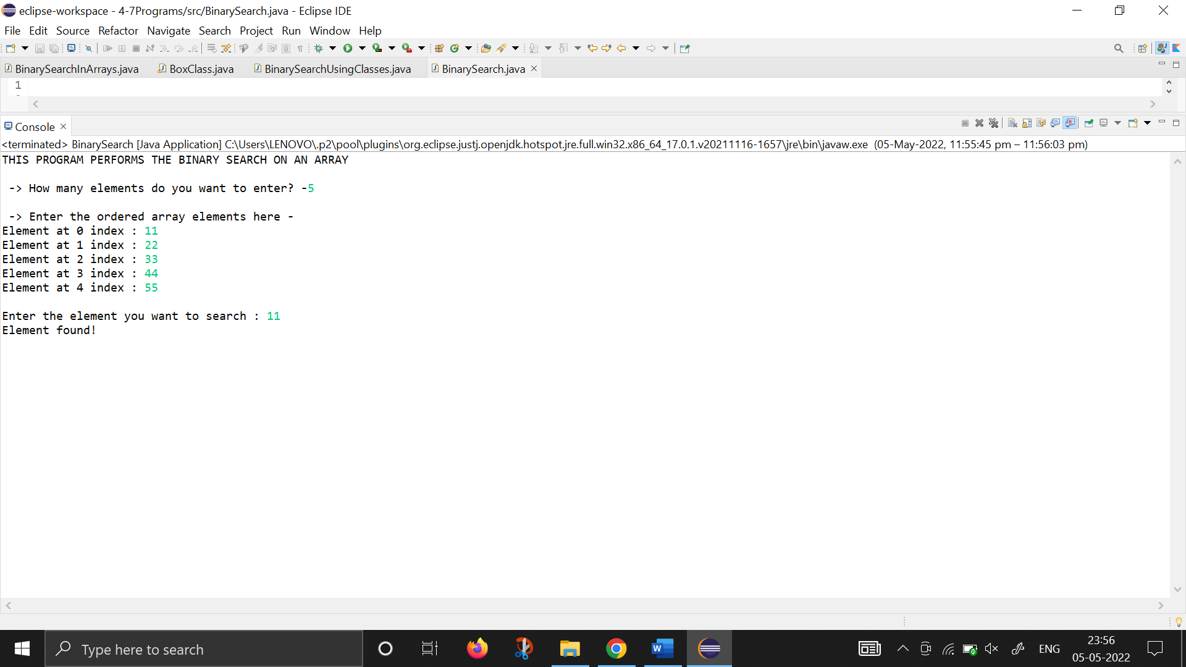

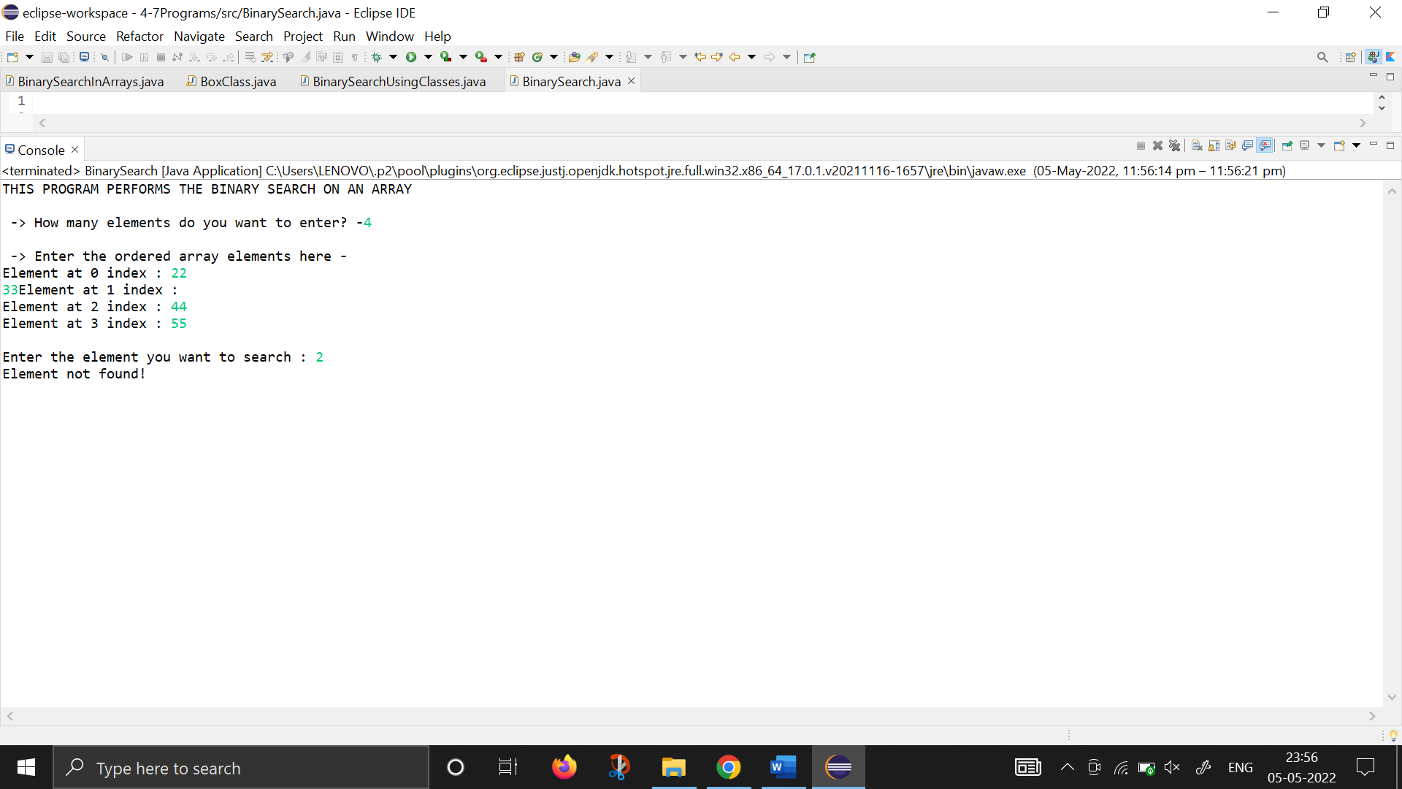

1. **Write a basic Java program to perform binary search using classes in java :**

//BINARY SEARCH USING CLASSES IN JAVA

**import** java.io.*;

**class** binsearch

{

**int** A[],terms;

binsearch(**int** k)

{

A= **new** **int**[k];

terms=k;

}

**void** input() **throws** IOException

{

BufferedReader br1 = **new** BufferedReader(**new** InputStreamReader(System.***in***));

System.***out***.println("\n -> Enter the ordered array elements here -");

**for** (**int** i=0; i<terms; i++){

System.***out***.print("Element at "+i+" index : ");

A[i]=Integer.*parseInt*(br1.readLine());

}

}

**void** search(**int** searchNum)

{

**int** flag=0, start=0, end=terms-1, mid;

//binary search program here

**while**(start<=end){

mid=(start+end)/2;

**if** (searchNum>A[mid]) {

start=mid+1;

}

**else** **if**(A[mid]>searchNum) {

end=mid-1;

}

**else** {

flag=1;

**break**;

}

}

**if** (flag!=0)

System.***out***.println("Element found!");

**else**{

System.***out***.println("Element not found!");

}

}

}

**public** **class** BinarySearchUsingClasses{

**public** **static** **void** main(String[] args)**throws** IOException{

BufferedReader br1 = **new** BufferedReader(**new** InputStreamReader(System.***in***));

**int** terms;

System.***out***.println("THIS PROGRAM PERFORMS THE BINARY SEARCH ON AN ARRAY");

System.***out***.print("\n -> How many elements do you want to enter? -");

terms=Integer.*parseInt*(br1.readLine());

binsearch o1;

o1= **new** binsearch(terms);

o1.input();

**int** searchNum;

System.***out***.print("\nEnter the element you want to search : ");

searchNum=Integer.*parseInt*(br1.readLine());

o1.search(searchNum);

}

}

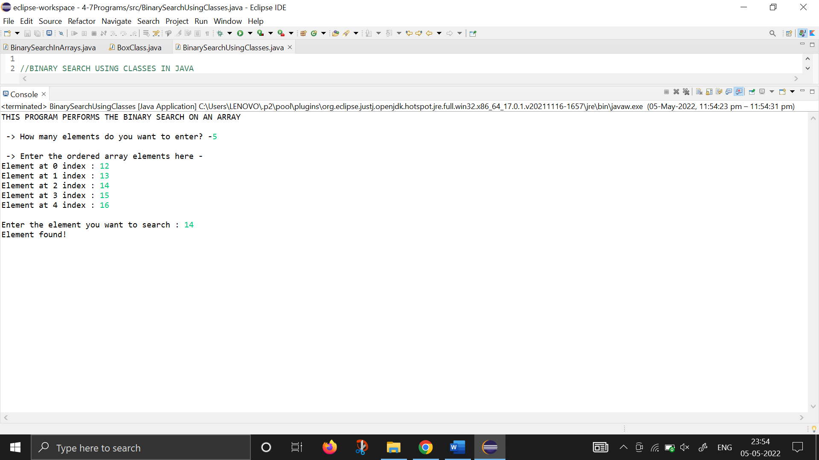

1. **Write a basic Java program to create a matrix and perform matrix operations such as addition, subtraction, transpose and multiplication:**

//THIS PROGRAM PERFORMS VARIOUS MATRIX OPERATIONS NAMELY ADDITION, SUBTRACTION, MULTIPLICATION AND TRANSPOSE OF A MATRIX IN JAVA

**import** java.io.*;

**public** **class** MatrixOperationsUsingFunctions {

**public** **static** **int**[][] createMatrix()**throws** IOException {

BufferedReader br1=**new** BufferedReader(**new** InputStreamReader(System.***in***));

**int** i=1;

System.***out***.println( " =============================");

**int**[][] array=**new** **int**[3][3];

**for** (**int** r=0; r<3; r++){

System.***out***.print("Enter the elements for row "+(r+1)+" : " );

**for**(**int** c=0; c<3; c++) {

array[r][c]=Integer.*parseInt*(br1.readLine());

}

}

System.***out***.println( " =============================");

**return** array;

}

**public** **static** **void** displayMatrix(**int** matrix[][])**throws** IOException{

System.***out***.println( " =============================");

**for** (**int** i=0; i<3; i++){

**for** (**int** j=0; j<3; j++) {

System.***out***.print("\t"+matrix[i][j]);

}

System.***out***.println();

}

System.***out***.println( " =============================");

}

**public** **static** **int**[][] matrixAddition(**int** A[][], **int** B[][])**throws** IOException {

**int**[][] sum=**new** **int**[3][3];

**for** (**int** r=0; r<3; r++){

**for**(**int** c=0; c<3; c++) {

sum[r][c]=A[r][c]+B[r][c];

}

}

**return** sum;

}

**public** **static** **int**[][] matrixSubtraction(**int** A[][], **int** B[][])**throws** IOException {

**int**[][] diff=**new** **int**[3][3];

**for** (**int** r=0; r<3; r++){

**for**(**int** c=0; c<3; c++) {

diff[r][c]=A[r][c]-B[r][c];

}

}

**return** diff;

}

**public** **static** **int**[][] matrixMultiply(**int** A[][], **int** num)**throws** IOException {

**int**[][] product=**new** **int**[3][3];

**for** (**int** r=0; r<3; r++){

**for**(**int** c=0; c<3; c++) {

product[r][c]=A[r][c]*num;

}

}

**return** product;

}

**public** **static** **int**[][] matrixTranspose(**int** A[][])**throws** IOException {

**int**[][] trans=**new** **int**[3][3];

**for** (**int** r=0; r<3; r++){

**for**(**int** c=0; c<3; c++) {

trans[r][c]=A[c][r];

}

}

**return** trans;

}

**public** **static** **void** main(String[] args)**throws** IOException{

BufferedReader br1=**new** BufferedReader(**new** InputStreamReader(System.***in***));

System.***out***.println("** THIS PROGRAM PERFORMS MATRIX OPERATIONS ON 3*3 MATRIX **\n ");

System.***out***.println(" 1. MATRIX ADDITION ");

System.***out***.println(" 2. MATRIX SUBTRACTION ");

System.***out***.println(" 3. MATRIX MULTIPLICATION ");

System.***out***.println(" 4. MATRIX TRANSPOSE ");

**int** choice;

String ch="y";

**while** (ch=="y"){

System.***out***.print("\n -> Enter your choice here : ");

choice=Integer.*parseInt*(br1.readLine());

**switch**(choice) {

**case** 1: System.***out***.println( "\n\t*** OPERATION CHOOSEN : MATRIX ADDITION ***");

System.***out***.println( "\n\t-> CREATING MATRIX ");

**int** A[][] =*createMatrix*();

**int** B[][]=*createMatrix*();

**int** sumMatrix[][]=*matrixAddition*(A, B);

System.***out***.println( "\t-> THE SUM OF TWO MATRIX IS : ");

*displayMatrix*(sumMatrix);

**break**;

**case** 2: System.***out***.println( "\n\t*** OPERATION CHOOSEN : MATRIX SUBTRACTION ***");

System.***out***.println( "\n\t-> CREATING MATRIX ");

**int** A1[][] =*createMatrix*();

**int** B1[][]=*createMatrix*();

**int** diffMatrix[][]=*matrixSubtraction*(A1, B1);

System.***out***.println( "\n\t-> THE DIFFERENCE OF TWO MATRIX IS : ");

*displayMatrix*(diffMatrix);

**break**;

**case** 3: System.***out***.println( "\n\t*** OPERATION CHOOSEN : MATRIX MULTIPLICATION ***");

System.***out***.println( "-> CREATING MATRIX ");

**int** A2[][] =*createMatrix*();

**int** num;

System.***out***.print("Enter the integer for multiplication : ");

num=Integer.*parseInt*(br1.readLine());

**int** prodMatrix[][]=*matrixMultiply*(A2, num);

System.***out***.println( "\n\t-> THE PRODUCT OF THE MATRIX IS : ");

*displayMatrix*(prodMatrix);

**break**;

**case** 4: System.***out***.println( "\n\t *** OPERATION CHOOSEN : MATRIX TRANPOSE ***");

System.***out***.println( "-> CREATING MATRIX ");

**int** A3[][] =*createMatrix*();

**int** transMatrix[][]=*matrixTranspose*(A3);

System.***out***.println( "\n\t-> THE TRANPOSE OF THE MATRIX IS : ");

*displayMatrix*(transMatrix);

**break**;

}

System.***out***.print("Do you want to continue (y/n : ");

ch=br1.readLine();

}

}

}

1. **Write a basic Java program to create a Stack and perform PUSH and POP operations on it (without Exception Handling) :**

**import** java.io.*;

**class** STACK{

**int** list[], size;

**int** tos=-1;

STACK(**int** num){

size=num;

list= **new** **int**[size];

}

**void** push(**int** n){

**if** (tos==size-1) {

System.***out***.println("STACK OVERFLOW : THE STACK IS FULL");

}

**else** {

list[++tos]=n;

}

}

**void** pop(){

**if** (tos==-1) {

System.***out***.println("STACK UNDERFLOW : THE STACK IS EMPTY");

}

**else** {

System.***out***.println(list[tos--]);

}

}

**void** displayStack(){

System.***out***.println("\t -> THE STACK ELEMENTS ARE : ");

**for** (**int** i=0; i<size; i++) {

System.***out***.print("\t"+list[i]);

}

}

}

**public** **class** StackOperations {

**public** **static** **void** main(String[] args) **throws** IOException {

BufferedReader br1=**new** BufferedReader(**new** InputStreamReader(System.***in***));

**int** stackSize, choice, num;

System.***out***.println("CREATING A EMPTY STACK \n");

System.***out***.print("Enter the size of the Stack : ");

stackSize=Integer.*parseInt*(br1.readLine());

System.***out***.println("\n -> A Stack with "+stackSize+" integers will be created!");

STACK s1;

s1= **new** STACK(stackSize);

System.***out***.println("\nPERFORMING STACK OPERATIONS\n");

System.***out***.println(" 1. PUSH the elements in Stack ");

System.***out***.println("2. POP the elements from Stack ");

String ch="y";

**while** (ch.equals("y")) {

System.***out***.print("Enter the stack operation you want to perform (1 or 2) : ");

choice=Integer.*parseInt*(br1.readLine());

**switch**(choice){

**case** 1 : System.***out***.println("\n\t -> OPERATION CHOOSEN : PUSH ");

**for** (**int** i=1; i<=stackSize; i++) {

System.***out***.print("Enter the "+i+" element : ");

num=Integer.*parseInt*(br1.readLine());

s1.push(num);

}

**break**;

**case** 2 : System.***out***.println("\n\t -> OPERATION CHOOSEN : POP ");

**for** (**int** i=1; i<=stackSize; i++) {

s1.pop();

}

**break**;

}

System.***out***.print("\n Do you want to continue(y/n)? ");

ch=br1.readLine();

}

System.***out***.println("\n \t ** PROGRAM ENDS HERE ** ");

}

}

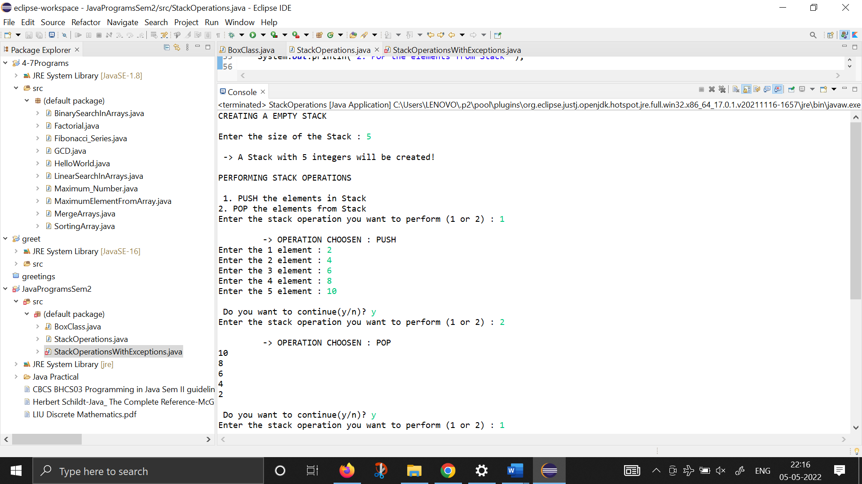

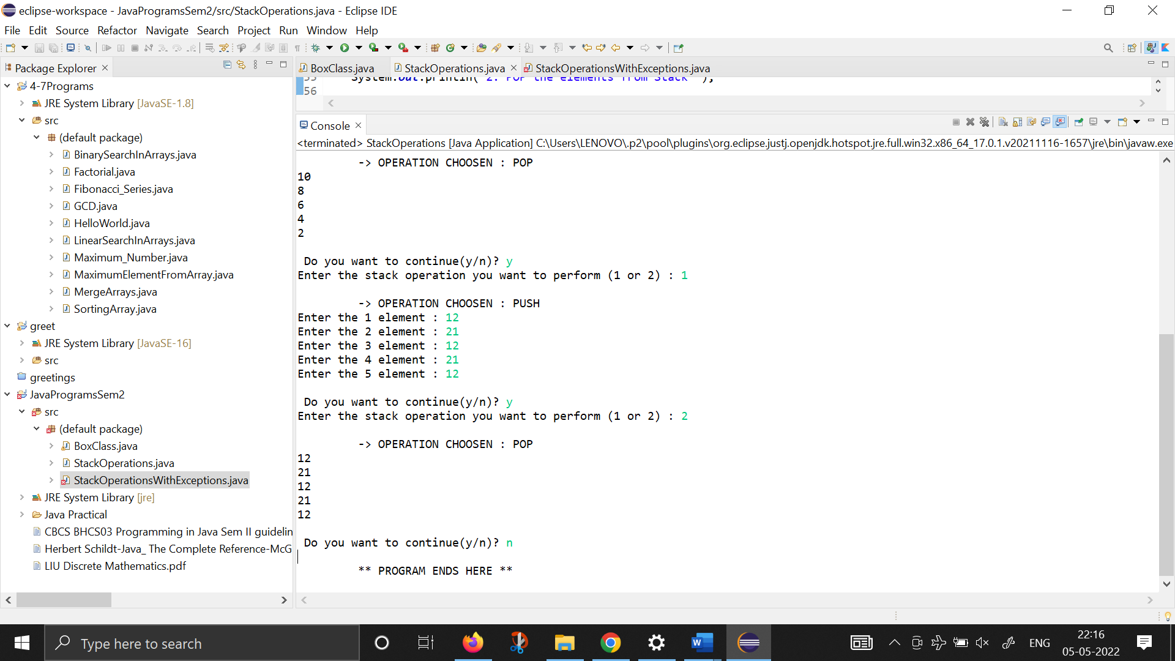

1. **Write a basic Java program to create a Stack and perform PUSH and POP operations on it (with Exception Handling) :**

**import** java.io.*;

**class** STACK1 {

**int** list[], size;

**int** tos=-1;

STACK1(**int** num){

size=num;

list= **new** **int**[size];

}

**void** push(**int** n){

**try** {

**if** (tos==size-1)

**throw** **new** Exception("STACK OVERFLOW");

list[++tos]=n;

}

**catch** (Exception o1) {

System.***out***.println("Element added to stack is :"+o1);

}

}

**int** pop(){

**try** {

**if** (tos==-1)

**throw** **new** Exception("STACK UNDERFLOW");

**return** list[tos--];

}

**catch**(Exception o1) {

**return** -1;

}

}

**void** displayStack(){

System.***out***.println("\t -> THE STACK ELEMENTS ARE : ");

**for** (**int** i=0; i<size; i++) {

System.***out***.print("\t"+list[i]);

}

}

}

**public** **class** StackOperationsWithExceptions {

**public** **static** **void** main(String[] args) **throws** IOException {

BufferedReader br1=**new** BufferedReader(**new** InputStreamReader(System.***in***));

**int** stackSize, choice, num;

System.***out***.println("\t ** STACK AND STACK OPERATIONS ** \n");

System.***out***.println("CREATING A EMPTY STACK");

System.***out***.print("Enter the size of the Stack : ");

stackSize=Integer.*parseInt*(br1.readLine());

System.***out***.println("\n -> A Stack with "+stackSize+" integers will be created!");

STACK1 s1;

s1= **new** STACK1(stackSize);

System.***out***.println("\nPERFORMING STACK OPERATIONS\n");

System.***out***.println("1. PUSH the elements in Stack ");

System.***out***.println("2. POP the elements from Stack ");

System.***out***.println("3. Display all the elements from Stack ");

String ch="y";

**while** (ch.equals("y")) {

System.***out***.print("\n ** Enter the stack operation you want to perform (1,2,3) : ");

choice=Integer.*parseInt*(br1.readLine());

**switch**(choice){

**case** 1 : System.***out***.println("\n\t -> OPERATION CHOOSEN : PUSH ");

**for** (**int** i=1; i<=stackSize; i++) {

System.***out***.print("Enter the "+i+" element : ");

num=Integer.*parseInt*(br1.readLine());

s1.push(num);

}

**break**;

**case** 2 : System.***out***.println("\n\t -> OPERATION CHOOSEN : POP ");

**for** (**int** i=1; i<=stackSize; i++) {

**int** x=s1.pop();

System.***out***.println("The popped element : "+x);

}

**break**;

**case** 3 : System.***out***.println("\n\t -> OPERATION CHOOSEN : DISPLAY STACK ");

s1.displayStack();

}

System.***out***.print("\n Do you want to continue(y/n)? ");

ch=br1.readLine();

}

System.***out***.println("\n \t ** PROGRAM ENDS HERE ** ");

}

}

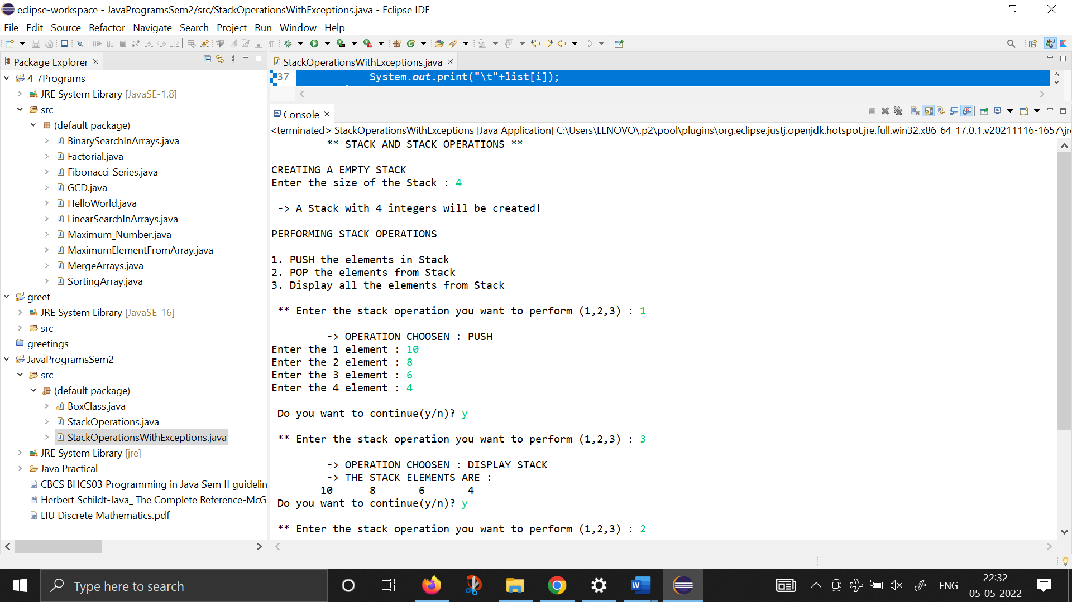

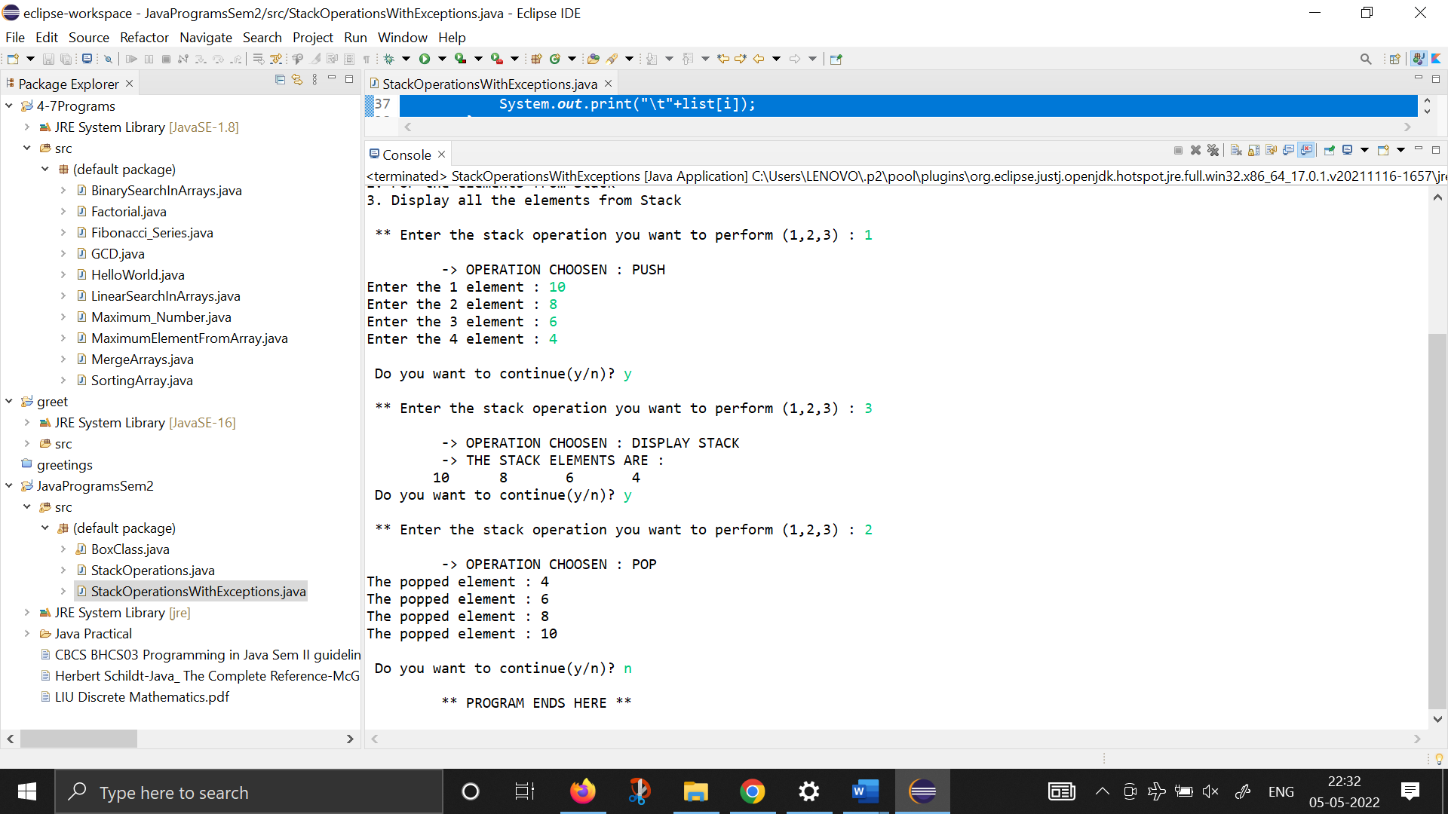

1. **Write a basic Java program to create a box class with increment function and check equality of two objects. Also show constructor overloading and calculate volume :**

**import** java.io.*;

**class** Box{

**int** length, width, height, volume;

Box(){

length=width=height=1;

}

Box(**int** l){

length=l;

width=height=1;

}

Box(**int** l, **int** b){

length=l;

width=b;

height=1;

}

Box(**int** l, **int** b, **int** h){

length=l;

width=b;

height=h;

}

**void** increment() {

length+=+1;

width+=1;

height+=1;

}

Box inputObject()**throws** IOException{

BufferedReader br2=**new** BufferedReader(**new** InputStreamReader(System.***in***));

Box temp=**new** Box();

System.***out***.print("Enter the length : ");

temp.length=Integer.*parseInt*(br2.readLine());

System.***out***.print("Enter the breadth : ");

temp.width=Integer.*parseInt*(br2.readLine());

System.***out***.print("Enter the height : ");

temp.height=Integer.*parseInt*(br2.readLine());

**return** temp;

}

**int** objectEquality(Box o) {

**if** (length==o.length && width==o.width && height==o.height) {

**return** 1;

}

**else**

**return** 0;

}

String volume() {

**int** vol;

vol=height*width*length;

**return** ("The Volume : "+vol);

}

**void** display() {

System.***out***.println("Length : "+length + " ; Width : "+width+ " ; Height : "+height+"\n");

}

}

**public** **class** BoxClass {

**public** **static** **void** main(String[] args)**throws** IOException{

System.***out***.println(" **BOX CLASS AND OPERATIONS ON OBJECTS **\n");

System.***out***.println("1. Incrementing the values of Box Class ");

System.***out***.println("2. Testing the Equality of two Box Objects ");

System.***out***.println("3. Calculating the volume ");

BufferedReader br1 = **new** BufferedReader(**new** InputStreamReader(System.***in***));

**int** choice;

String ch="y";

**while** (ch.equals("y")) {

System.***out***.print("\n -> Which operation do you want to perform (1,2,3) : ");

choice=Integer.*parseInt*(br1.readLine());

**switch**(choice) {

**case** 1: {System.***out***.println("\n\t OPERATION CHOOOSEN : INCREMENTING VALUES OF BOX CLASS");

Box b1=**new** Box();

b1=b1.inputObject();

System.***out***.println("-> Values of Box Oject : ");

b1.display();

b1.increment();

System.***out***.println("-> The Incremented values are : ");

b1.display();

**break**;

}

**case** 2: {System.***out***.println("\n\t OPERATION CHOOOSEN : TESTING EQUALITY OF BOX OBJECTS ");

Box b2=**new** Box();

b2=b2.inputObject();

System.***out***.println("-> Values of 1st Box Oject : ");

b2.display();

Box b3=**new** Box();

b3=b3.inputObject();

System.***out***.println("-> Values of 2nd Box Oject : ");

b3.display();

**int** equalityCheck=b2.objectEquality(b3);

**if** (equalityCheck==1)

System.***out***.println("Both the objects are completely equal");

**else**

System.***out***.println("Both the objects aren't equal");

**break**;

}

**case** 3: {System.***out***.println("\n\t OPERATION CHOOOSEN : VOLUME CALCULATION OF BOX OBJECT ");

Box b4=**new** Box();

b4=b4.inputObject();

System.***out***.println("-> Values of Box Oject : ");

b4.display();

String vol=b4.volume();

**break**;

}

}

System.***out***.print("\n Do you want to continue(y/n)? ");

ch=br1.readLine();

}

System.***out***.println("\n \t ** PROGRAM ENDS HERE ** ");

}

}

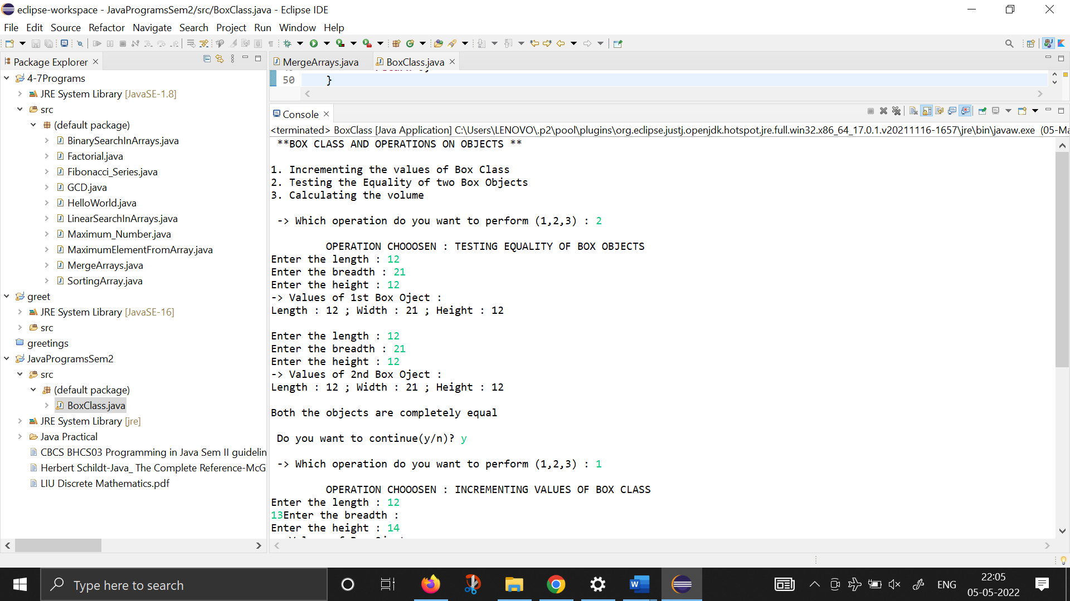

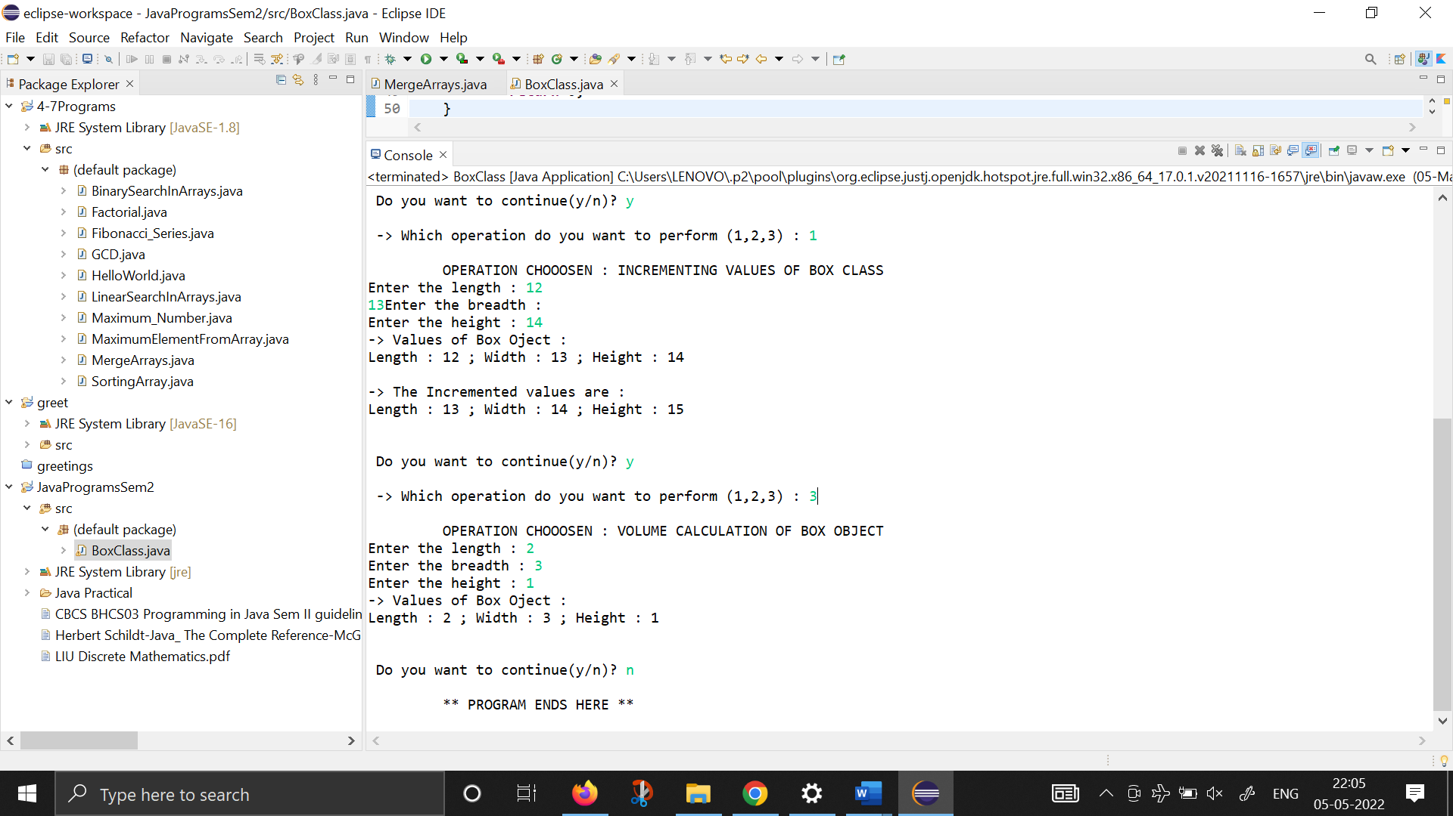

1. **KEY EVENT HANDLING USING KEY LISTENER INTERFACE**

**import** java.awt.*;

**import** java.awt.event.*;

**public** **class** keyEventHandling **extends** Frame **implements** KeyListener {

String msg = "";

String keyState="";

**public** keyEventHandling() {

addKeyListener(**this**);

addWindowListener(**new** MyWindowAdapter());

}

//HANDLIE A KEY RELEASE

**public** **void** keyPressed(KeyEvent ke) {

keyState="Key Down";

repaint();

}

//HANDLE KEY TYPED

**public** **void** keyTyped(KeyEvent ke) {

msg+=ke.getKeyChar();

repaint();

}

//Display Keystrokes

**public** **void** paint(Graphics g) {

g.drawString(msg, 20, 100);

g.drawString(keyState, 20, 50);

}

**public** **static** **void** main (String[] args) {

keyEventHandling appwin = **new** keyEventHandling();

appwin.setSize(**new** Dimension(200,150));

appwin.setTitle("Simple Key");

appwin.setVisible(**true**);

}

@Override

**public** **void** keyReleased(KeyEvent e) {

// **TODO** Auto-generated method stub

}

}

//WHEN THE CLOSE BOX IN THE FRAME IS CLICKED

//CLOSE THE WINDOW ADN EXIT THE PROGRAM

**class** MyWindowAdapter **extends** WindowAdapter{

**public** **void** windowClosing(WindowEvent we) {

System.*exit*(0);

}

}

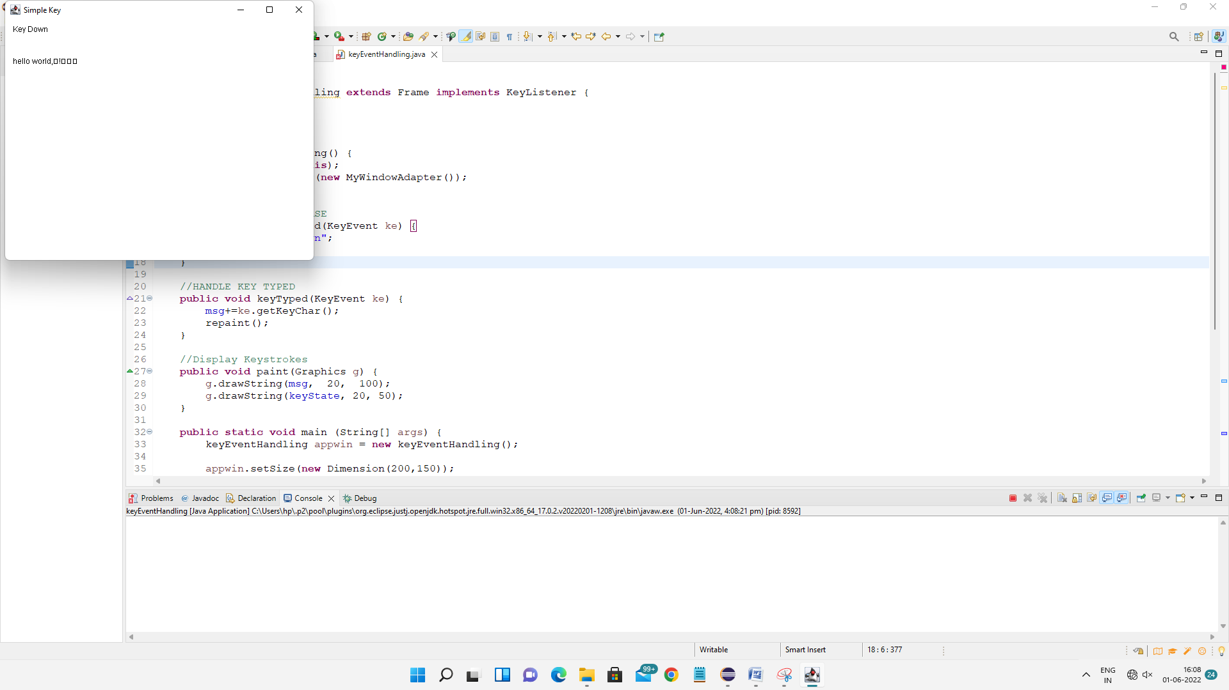

1. **MOUSE EVENT HANDLING USING LISTENER**

**import** java.awt.*;

**import** java.awt.event.*;

**public** **class** MouseEventsDemo **extends** Frame **implements** MouseListener, MouseMotionListener {

String msg="";

**int** mouseX=0, mouseY=0; //coordinates of mouse

**public** MouseEventsDemo() {

addMouseListener(**this**);

addMouseMotionListener(**this**);

addWindowListener(**new** MyWindowAdapter());

}

//HANDLE MOUSE WHEN CLICKED

**public** **void** mouseClicked(MouseEvent me) {

msg=msg+ " -- click received";

repaint();

}

//HANDLE MOUSE ENTERED

**public** **void** mouseEntered(MouseEvent me) {

mouseX=100;

mouseY=100;

msg="Mouse exited";

repaint();

}

//HANDLE BUTTON PRESSED

**public** **void** mousePressed(MouseEvent me) {

//SAVE COORDINATES

mouseX=me.getX();

mouseY=me.getY();

msg="Button down";

repaint();

}

//HANDLE BUTTON RELEASED

**public** **void** mouseReleased(MouseEvent me) {

//SAVE COORDINATES

mouseX=me.getX();

mouseY=me.getY();

msg="Button Released";

repaint();

}

//MOUSE HANDLE DRAGGED

**public** **void** mouseDrageed(MouseEvent me) {

//SAVE COORDINATES

mouseX=me.getX();

mouseY=me.getY();

msg="*"+" mouse at "+ mouseX + ", "+ me.getY();

repaint();

}

//MOUSE HANDLE DRAGGED

**public** **void** mouseMoved(MouseEvent me) {

msg="Moving mouse at "+ me.getX()+ ", "+ me.getY();

repaint();

}

//DISPLAY MSG IN THE WINDOW AT CURRENT X,Y LOCATION

**public** **void** paint(Graphics g) {

g.drawString(msg, mouseX, mouseY);

}

//main function

**public** **static** **void** main (String[] args) {

MouseEventsDemo appwin = **new** MouseEventsDemo();

appwin.setSize(**new** Dimension(300,300));

appwin.setTitle("MouseEventsDemo");

appwin.setVisible(**true**);

}

@Override

**public** **void** mouseExited(MouseEvent e) {

// **TODO** Auto-generated method stub

}

@Override

**public** **void** mouseDragged(MouseEvent e) {

// **TODO** Auto-generated method stub

}

}

//WHEN THE CLOSE BOX IN THE fRAME IS CLICKED, CLOSE THE WINDOW ADN EXIT THE PROGRAM

**class** MyWindowAdapter **extends** WindowAdapter{

**public** **void** windowClosig(WindowEvent we) {

System.*exit*(0);

}

}

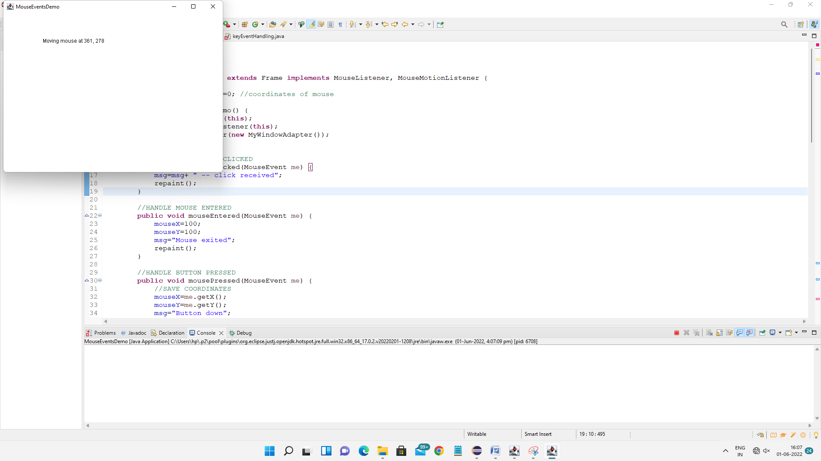

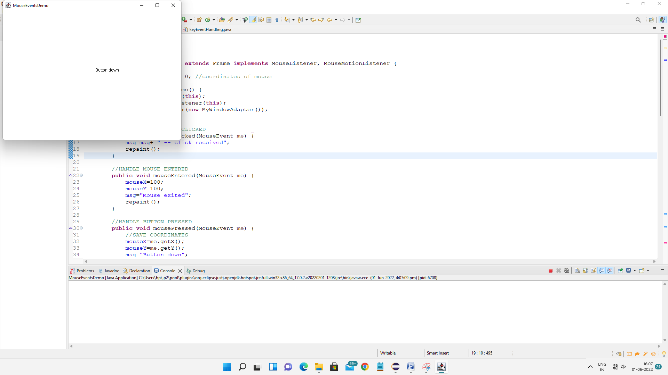

1. **MOUSE EVENT HANDLING USING ADAPTERS**

**import** java.awt.*;

**import** java.awt.event.*;

**public** **class** AdapterDemo **extends** Frame{

String msg="";

**public** AdapterDemo() {

addMouseListener(**new** MyMouseAdapter(**this**));

addMouseMotionListener(**new** MyMouseAdapter(**this**));

addWindowListener(**new** MyWindowAdapter());

}

//display the mouse information

**public** **void** paint(Graphics g) {

g.drawString(msg, 20 , 80);

}

**public** **static** **void** main(String[] args) {

AdapterDemo appwin = **new** AdapterDemo();

appwin.setSize(**new** Dimension(200, 150));

appwin.setTitle("Adapter Demo");

appwin.setVisible(**true**);

}

}

//HANDLE ONLY MOSUE CLICK AND DRAG EVENTS

**class** MyMouseAdapter **extends** MouseAdapter{

AdapterDemo adapterDemo;

**public** MyMouseAdapter(AdapterDemo adapterDemo) {

**this**.adapterDemo = adapterDemo;

}

//HANDLE MOUSE CLICKED

**public** **void** mouseClicked(MouseEvent me) {

adapterDemo.msg = "Mouse Clicked";

adapterDemo.repaint();

}

//HANDLE MOUSE DRAGGED

**public** **void** mouseDragged(MouseEvent me) {

adapterDemo.msg = "Mouse Dragged";

adapterDemo.repaint();

}

}

//WHEN THE CLOSE BOX IN THE FRAME IS CLICKED, CLSOE THE WINDOW AND EXIT THE PROGRAM

**class** MyWindowAdapter **extends** WindowAdapter{

**public** **void** windowClosing(WindowEvent we) {

System.*exit*(0);

}

}

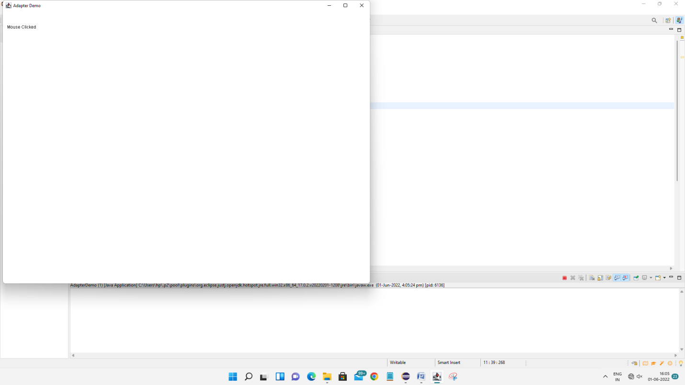

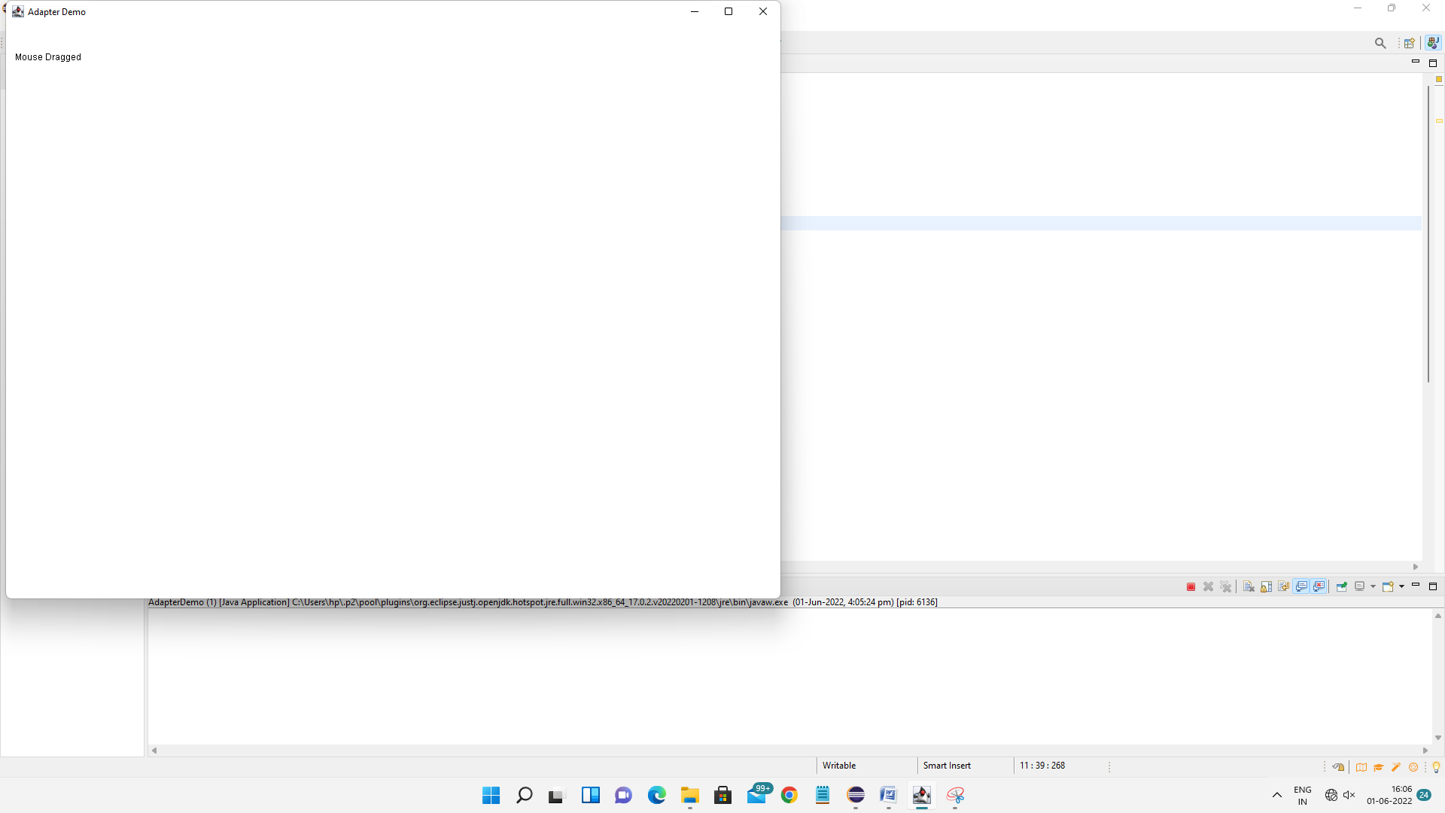

1. **WRITE A PROGRAM TO CREATE A FRAME USING AWT. IMPLEMENT mouseClicked(), mouseEntered() and mouseExited() events such that:**
2. **Size of the frame should be tripled when mouse enters it**
3. **Frame should reduce to its original size when mouse is clicked in it**
4. **Close the frame when mouse exits it**

**import** java.awt.*;

**import** java.awt.event.*;

**public** **class** MouseEvents **extends** Frame{

Dimension o1;

**public** MouseEvents() {

setSize(**new** Dimension(300,300));

o1=getSize();

addMouseListener(**new** MyMouseAdapter(**this**));

}

**public** **static** **void** main(String[] args) {

MouseEvents o1 = **new** MouseEvents();

o1.setTitle("Mouse Events Frame : Ques 8");

o1.setVisible(**true**);

}

**class** MyMouseAdapter **extends** MouseAdapter{

MouseEvents f1;

**public** MyMouseAdapter(MouseEvents o1) {

f1=o1;

}

**public** **void** mouseEntered(MouseEvent me) {

**int** h,w;

Dimension dl=f1.getSize();

h=dl.height*3;

w=dl.width*3;

f1.setSize(h,w);

}

**public** **void** mouseClicked(MouseEvent me) {

f1.setSize(o1.height, o1.width);

}

**public** **void** mouseExited(MouseEvent me) {

System.*exit*(0);

}

}

}

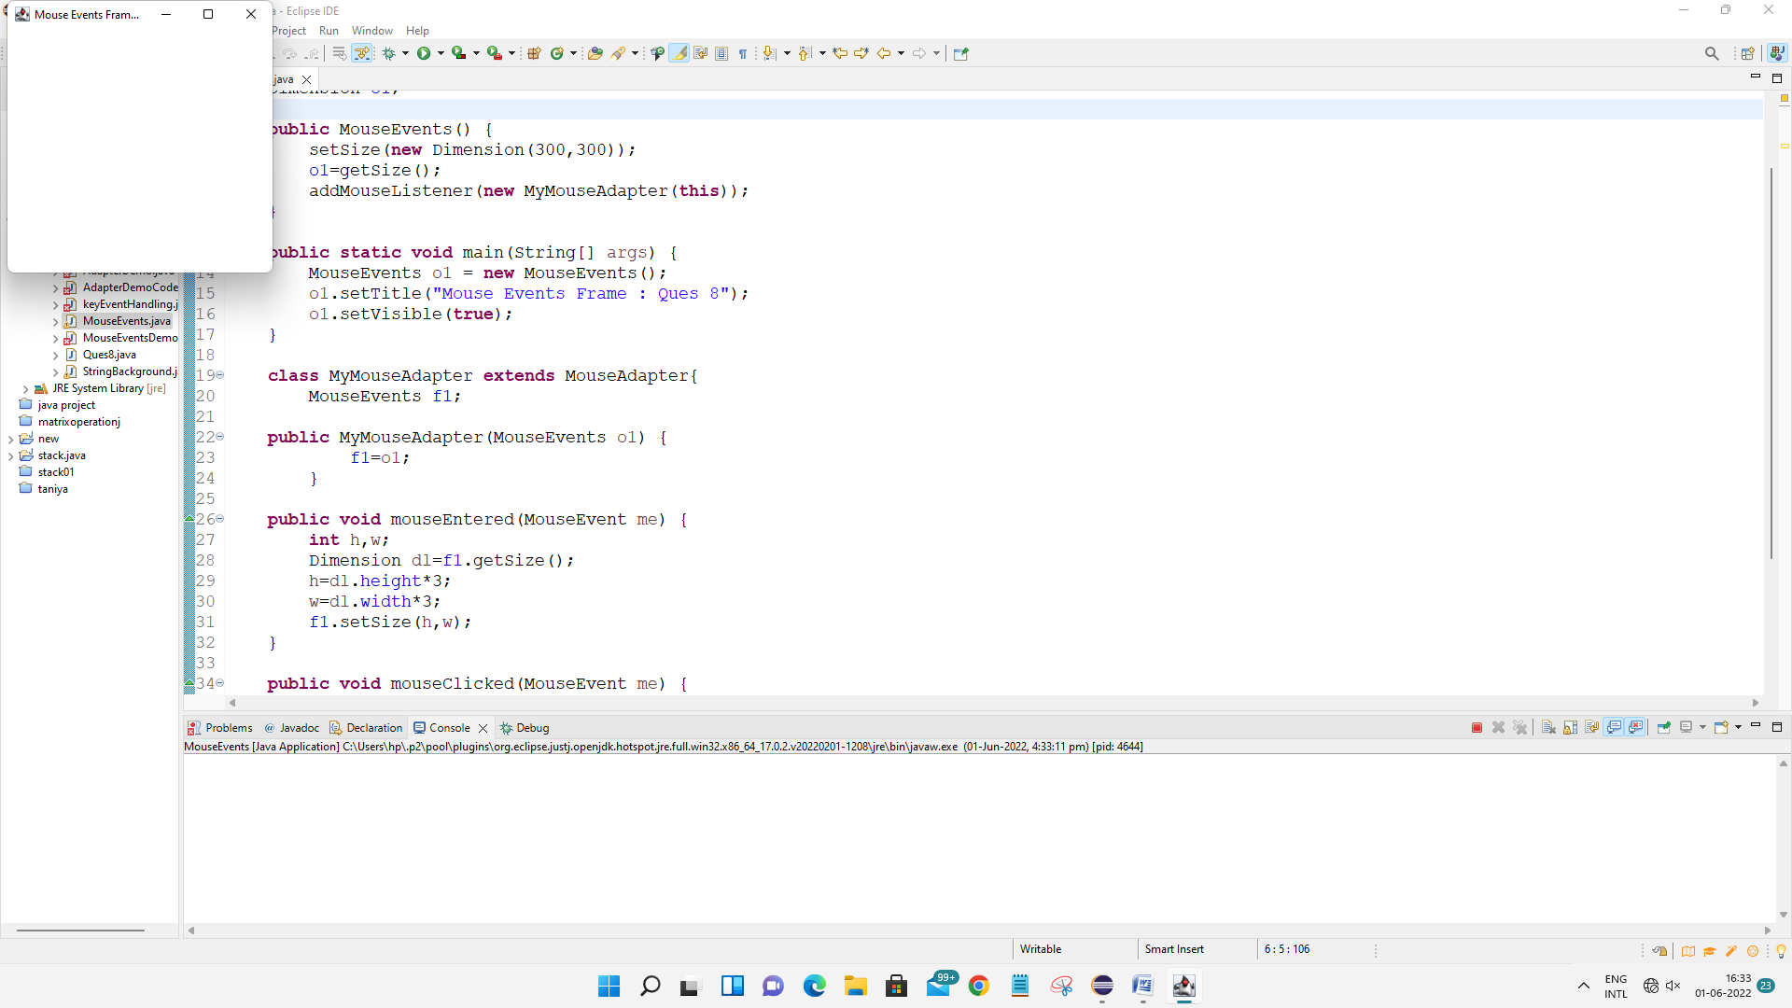

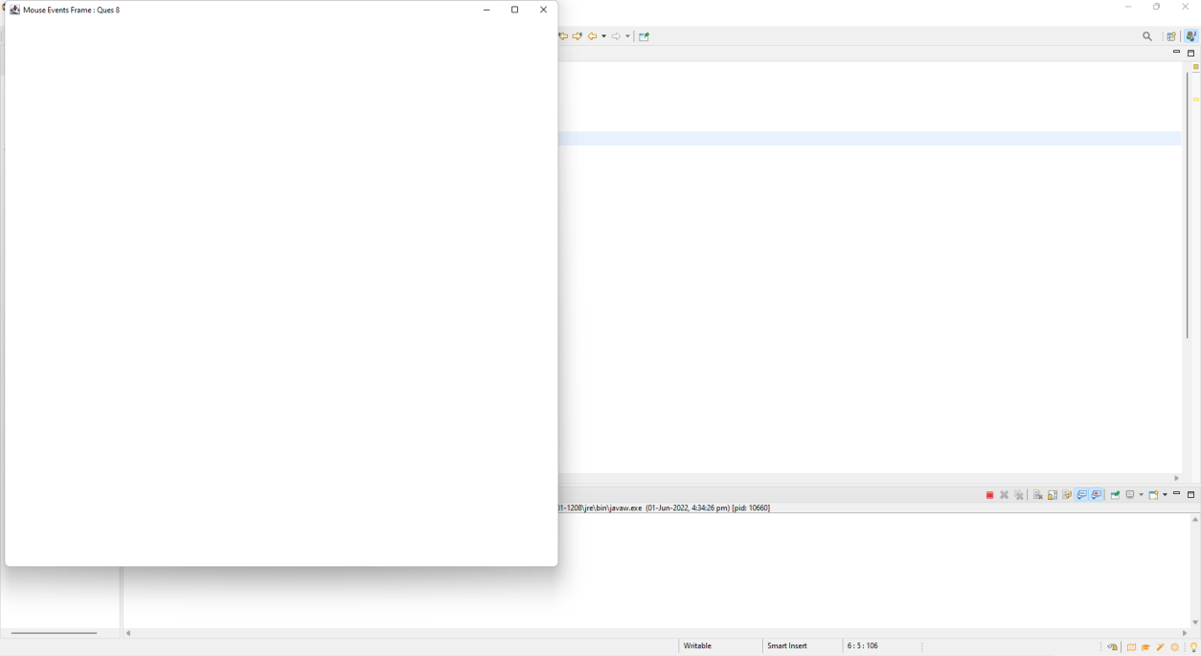

1. **USING AWT, WIRTE A PROGRAM TO DISPLAY A STRING IN FRAME WINDOW WITH PINK COLOR AS BACKGROUND**

**import** java.awt.*;

**import** java.awt.event.*;

**public** **class** StringBackground **extends** Frame{

Dimension o1;

**public** StringBackground() {

setSize(800,800);

setBackground(Color.***pink***);

addWindowListener(**new** MyWindowAdapter());

}

**public** **void** paint(Graphics g) {

g.drawString("Hello World!", 300 , 300);

}

**public** **static** **void** main(String[] args) {

StringBackground o1 = **new** StringBackground();

o1.setTitle("QUESTION 9");

o1.setVisible(**true**);

}

**class** MyWindowAdapter **extends** WindowAdapter{

**public** **void** windowClosing(WindowEvent o1) {

System.*exit*(0);

}

}

}

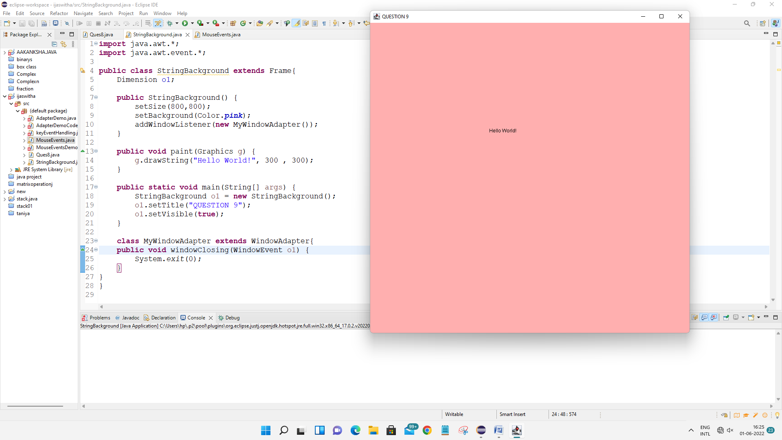

1. **Write a program that has two buttons named “Red” and “Blue”. When a button is pressed the background color is set to the color named by the button’s label. (LIST QUES 10)**

**import** java.awt.*;

**import** java.awt.event.*;

**public** **class** awtRBButton **extends** Frame **implements** ActionListener {

Button red,blue;

**public** awtRBButton()

{

setLayout(**new** FlowLayout());

red=**new** Button("RED");

blue=**new** Button("BLUE");

add(red);

add(blue);

red.addActionListener(**this**);

blue.addActionListener(**this**);

addWindowListener(**new** WindowAdapter() {

**public** **void** windowClosing(WindowEvent we ) {

System.*exit*(0);

}

});

}

**public** **void** actionPerformed(ActionEvent e1) {

String s=e1.getActionCommand();

**if**(s.equals("RED"))

{

setBackground(Color.***red***);

}

**else**

**if**(s.equals("BLUE"))

{

setBackground(Color.***blue***);

}

}

**public** **static** **void** main(String[] args) {

awtRBButton o1=**new** awtRBButton();

o1.setSize(**new** Dimension(500,500));

o1.setTitle("Question 10 : Red Blue Button ");

o1.setVisible(**true**);

}

}

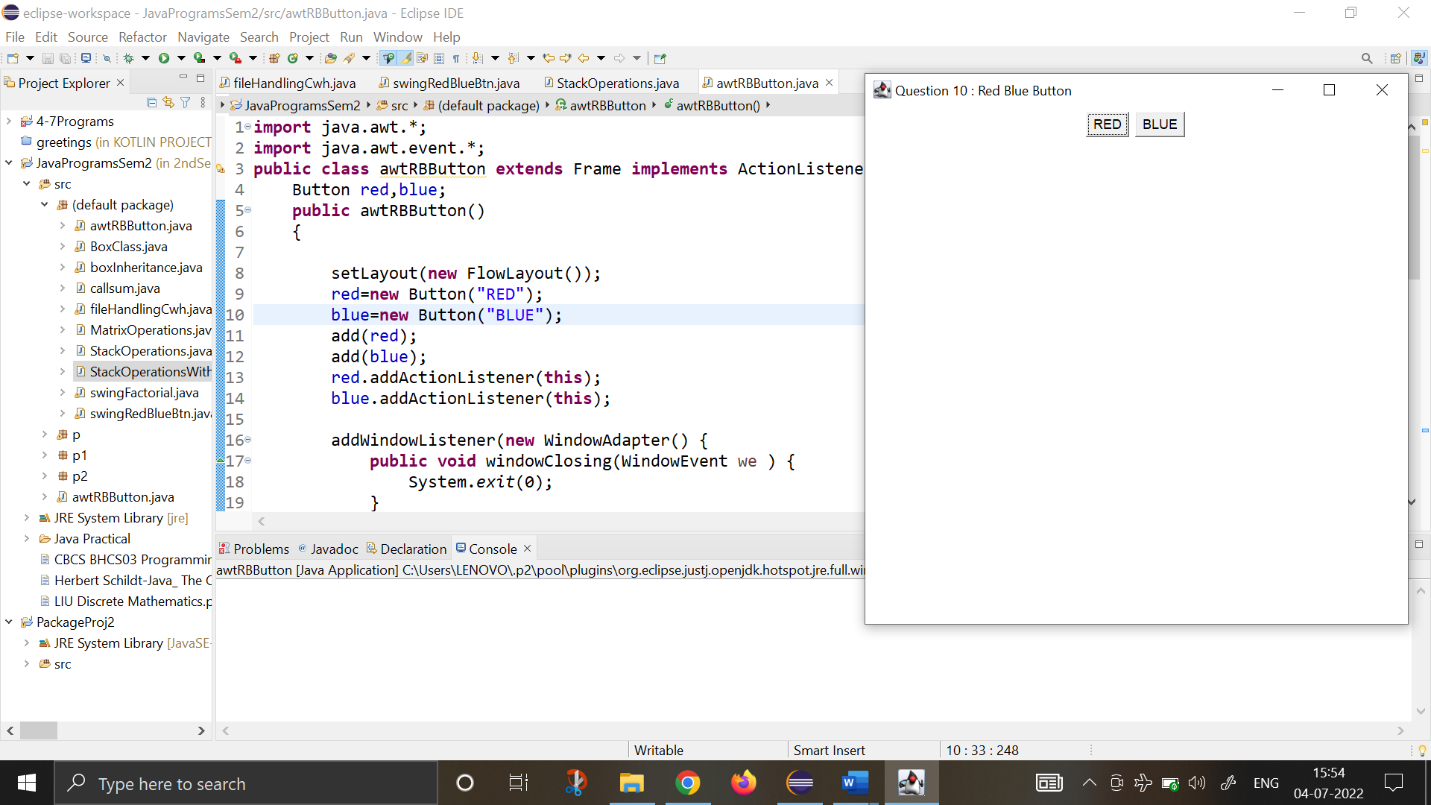

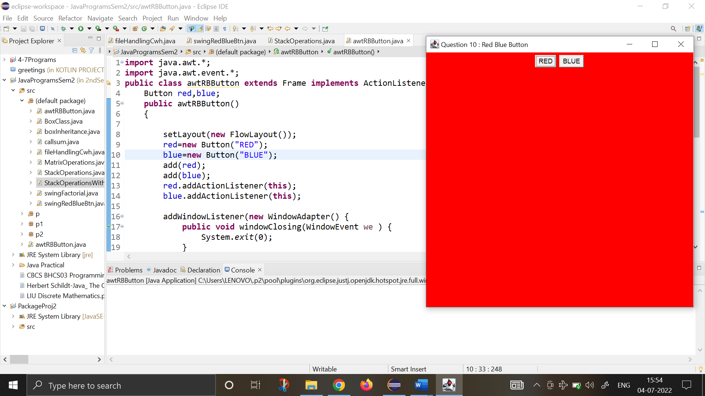

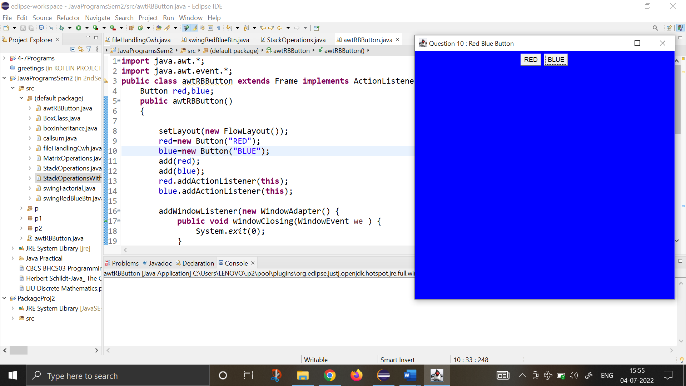

1. **Using SWING, write a program to display a string in frame window with pink color as background.**

**import** java.awt.*;

**import** javax.swing.*;

**public** **class** Ques13ii **extends** JFrame {

JLabel o1;

Ques13ii(){

setSize(400,400);

setDefaultCloseOperation(JFrame.***EXIT_ON_CLOSE***);

getContentPane().setBackground(Color.***pink***);

setLayout(**new** FlowLayout());

o1=**new** JLabel(" Hi There! This is a Java program @_@ ");

getContentPane().add(o1);

setVisible(**true**);

}

**public** **static** **void** main(String[] args) {

SwingUtilities.*invokeLater*(**new** Runnable() {

**public** **void** run(){

**new** Ques13ii();

}

});

}

}

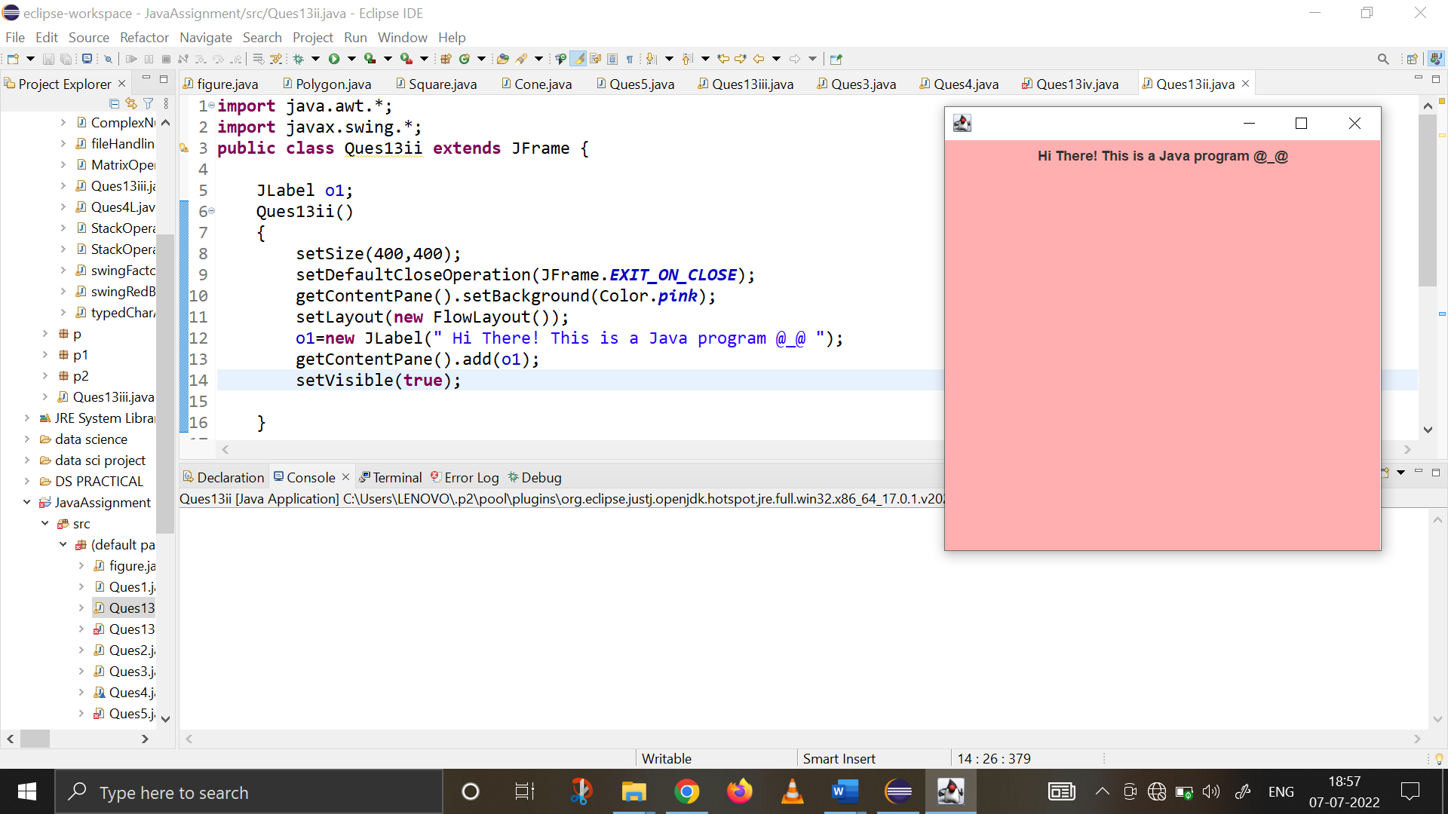

1. **Create a class TwoDim which contains private members as x and y coordinates in package P1. Define the default constructor, a parameterized constructor and override toString() method to display the co-ordinates. Now reuse this class and in package P2 create another class ThreeDim, adding a new dimension as z as its private member. Define the constructors for the subclass and override toString() method in the subclass also. Write appropriate methods to show dynamic method dispatch. The main() function should be in a package P.**

**Package P1**

**package** p1;

**public** **class** twodim {

**int** x, y;

**public** twodim() {

x=y=0;

}

**public** twodim(**int** i, **int** j){

x=i;

y=j;

}

**public** String toString(){

**return** ("\n\t-> THE COORDINATES ARE : "+x+" , "+y);

}

}

**Package P2**

**package** p2;

**import** p1.twodim;

**public** **class** threedim **extends** twodim{

**int** z;

**public** threedim(){

**super**();

z=0;

}

**public** threedim(**int** i, **int** j, **int** k){

**super**(i,j);

z=k;

}

**public** String toString() {

**return** **super**.toString()+" and "+z;

}

}

**Package P : main() function**

**package** p;

**import** java.io.*;

**import** p1.twodim;

**import** p2.threedim;

**public** **class** coordMain {

**public** **static** **void** main(String[] args)**throws** IOException{

BufferedReader br=**new** BufferedReader(**new** InputStreamReader(System.***in***));

System.***out***.println("\t ================================================");

System.***out***.println("\t THE PROGRAM STORES 2D & 3D COORDINATES ");

System.***out***.println("1. 2-Dimensional \n2. 3-Dimensional ");

**int** choice;

**int** a,b,c;

String output;

String ch="y";

**while** (ch.equals("y")) {

System.***out***.println("\t ================================================");

System.***out***.print("-> Enter your choice(1,2) : ");

choice=Integer.*parseInt*(br.readLine());

**switch**(choice) {

**case** 1: System.***out***.println("\n\t ** 2 DIMENSION CHOOSEN ** ");

System.***out***.print("- Enter x coordinate: ");

a=Integer.*parseInt*(br.readLine());

System.***out***.print("- Enter y coordinate: ");

b=Integer.*parseInt*(br.readLine());

twodim o1=**new** twodim(a,b);

output=o1.toString();

System.***out***.println(output);

**break**;

**case** 2: System.***out***.println("\n\t ** 3 DIMENSION CHOOSEN ** ");

System.***out***.print("- Enter x coordinate: ");

a=Integer.*parseInt*(br.readLine());

System.***out***.print("- Enter y coordinate: ");

b=Integer.*parseInt*(br.readLine());

System.***out***.print("- Enter z coordinate: ");

c=Integer.*parseInt*(br.readLine());

threedim o2=**new** threedim(a,b,c);

output=o2.toString();

System.***out***.println(output);

**break**;

**default** : System.***out***.println("Invalid Choice! Try again. \n");

}

System.***out***.print("\nDo you want to continue(y/n) : ");

ch=br.readLine();

}

System.***out***.print("\n PROGRAM ENDS HERE! ");

}

}

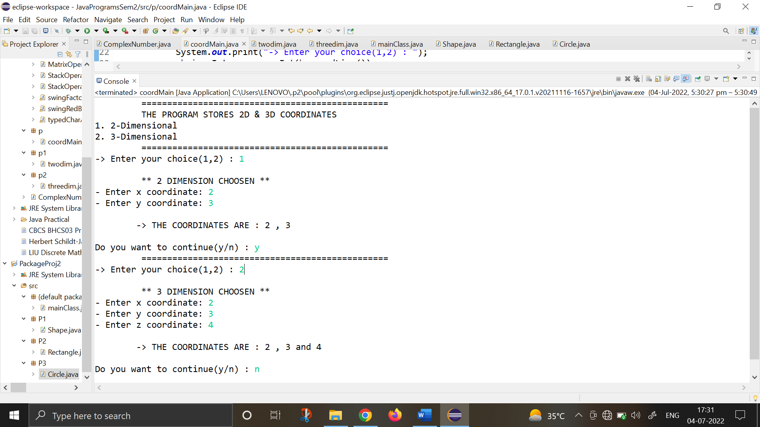

1. **Define an abstract class Shape in package P1. Inherit two more classes: Rectangle in package P2 and Circle in package P3. Write a program to ask the user for the type of shape and then using the concept of dynamic method dispatch, display the area of the appropriate subclass. Also write appropriate methods to read the data. The main() function should not be in any package.**

**Package P1**

**package** P1;

**public** **abstract** **class** Shape {

**public** **double** area;

**public** **abstract** **void** computeArea();

**public** **void** display() {

System.***out***.println(area);

}

}

**Package P2**

**package** P2;

**import** P1.Shape;

**import** java.io.*;

**public** **class** Rectangle **extends** Shape {

**double** length, breadth;

**public** **void** input() **throws** IOException {

BufferedReader br=**new** BufferedReader(**new** InputStreamReader(System.***in***));

System.***out***.print("Enter the length and breadth : ");

length=Integer.*parseInt*(br.readLine());

breadth=Integer.*parseInt*(br.readLine());

}

**public** Rectangle() {

length=breadth=0;

}

**public** Rectangle(**double** a, **double** b) {

length=a;

breadth=b;

}

**public** **void** computeArea() {

area=length*breadth;

}

**public** **void** display() {

System.***out***.print("Rectange Area is as follows : ");

**super**.display();

}

}

**Package P3**

**package** P3;

**import** java.io.*;

**import** P1.Shape;

**public** **class** Circle **extends** Shape{

**double** radius;

**public** Circle() {

radius=0;

}

**public** Circle(**double** r) {

radius=r;

}

**public** **void** input() **throws** IOException {

BufferedReader br=**new** BufferedReader(**new** InputStreamReader(System.***in***));

System.***out***.print("Enter the radius : ");

radius=Integer.*parseInt*(br.readLine());

}

**public** **void** computeArea() {

area=22/7*radius*radius;

}

**public** **void** display() {

System.***out***.print("Circle Area is as follows : ");

**super**.display();

}

}

**Default Package - MAIN() FUNCTION :**

**import** P1.Shape;

**import** P2.Rectangle;

**import** P3.Circle;

**import** java.io.*;

**public** **class** mainClass {

**public** **static** **void** main(String[] args)**throws** IOException{

BufferedReader br=**new** BufferedReader(**new** InputStreamReader(System.***in***));

System.***out***.println("\t ================================================");

System.***out***.println("\t THE PROGRAM CALCULATES THE AREA OF SHAPES ");

System.***out***.println("1. Rectangle \n2. Circle ");

**int** choice;

Shape obj;

String ch="y";

**while** (ch.equals("y")) {

System.***out***.println("\t ================================================");

System.***out***.print("-> Enter your choice(1,2) : ");

choice=Integer.*parseInt*(br.readLine());

**switch**(choice) {

**case** 1: System.***out***.println("\n\t ** SHAPE CHOOSEN : RECTANGLE ** ");

Rectangle o1=**new** Rectangle();

o1.input();

obj=o1;

obj.computeArea();

obj.display();

**break**;

**case** 2: System.***out***.println("\n\t ** SHAPE CHOOSEN : CIRCLE ** ");

Circle o2=**new** Circle();

o2.input();

obj=o2;

obj.computeArea();

obj.display();

**break**;

**default** : System.***out***.println("Invalid Choice! Try again. \n");

}

System.***out***.print("\nDo you want to continue(y/n) : ");

ch=br.readLine();

}

System.***out***.print("\n PROGRAM ENDS HERE! ");

}

}

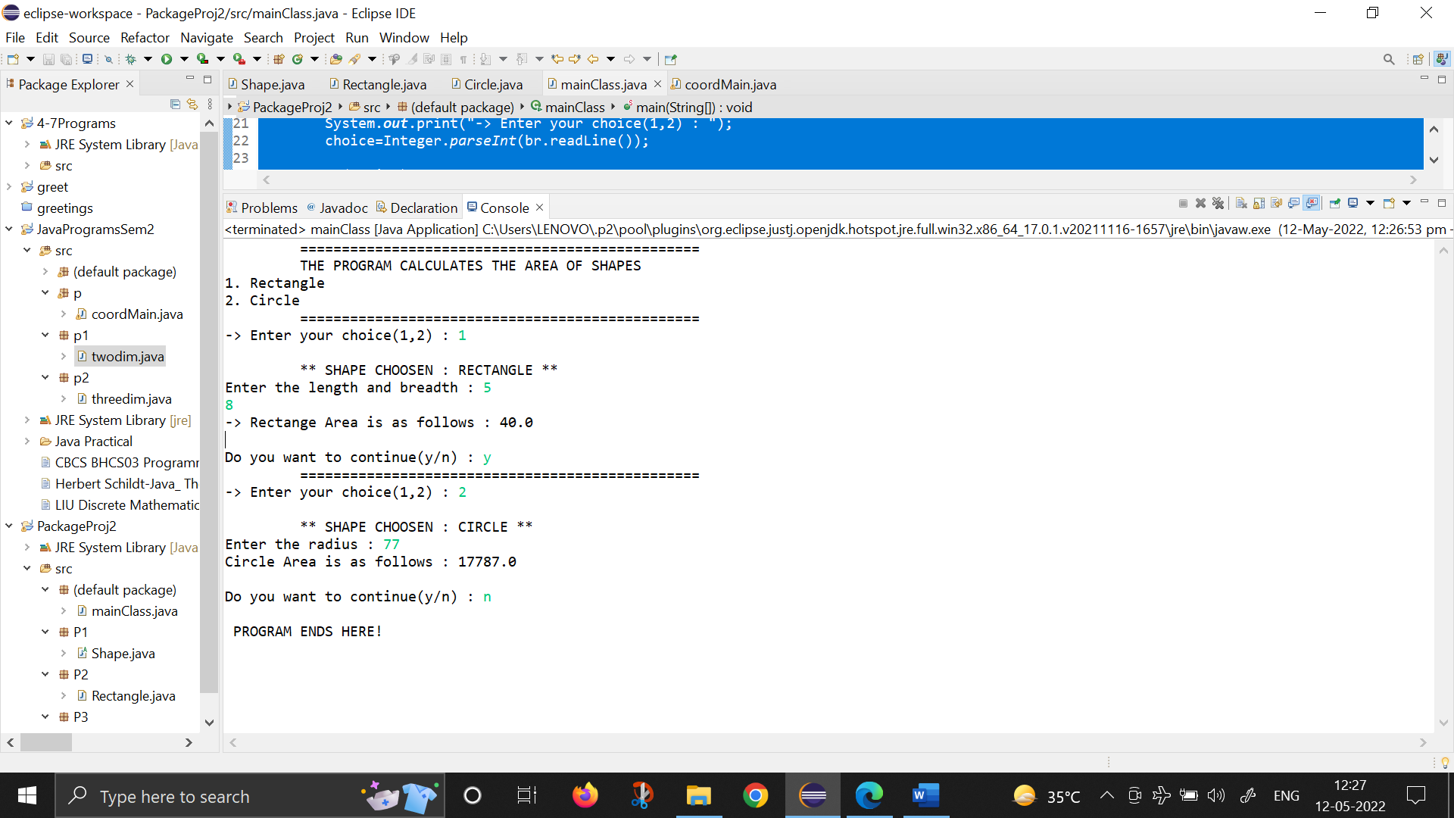

1. **WAP to Implement account class in package P1 & account class in package P2. Write appropriate function to display balance.**

# PACKAGE p1:

package p1;

public class account{ double balance;

public account() { balance=0;

}

public double deposit (double x) { balance=balance+x;

return balance;

}

public double withdraw(double x) { balance=balance-x;

return balance;

}

public void display() { System.*out*.print(balance);

}

}

# PACKAGE p2:

package p2;

import p1.account; public class miaccount {

public static void main(String[] args) { account o1=new account(); o1.deposit(10);

System.*out*.print("Balance after deposit : "); o1.display();

System.*out*.println(); o1.withdraw(2);

System.*out*.print("Remaining balance after withdrawal : ");

o1.display();

}

}

# OUTPUT:

Balance after deposit: 10.0

Remaining balance after withdrawal: 8.0

1. **WAP to implement figure, rectangle , triangle class using inheritance , use dynamic method dispatch to display the area.**

**class** Figure{

**double** dim1;

**double** dim2;

Figure(**double** a,**double** b)

{

dim1=a;

dim2=b;

}

**double** area()

{

System.***out***.println("Area for figure is undefined:");

**return** 0;

}

}

**class** Rectangle **extends** Figure{ Rectangle(**double** a, **double** b){

**super**(a,b);

}

**double** area(){

System.***out***.println("Inside araea for Rectangle:");

**return** dim1*dim2;

}

}

**class** Triangle **extends** Figure{ Triangle(**double** a, **double** b){

**super**(a,b);

}

**double** area()

{

System.***out***.println("Inside araea for Triangle:");

**return** dim1*dim2/2;

}

}

**public class** FindAreas {

**public static void** main(String[] args) { Figure f=**new** Figure (10,10);

Rectangle r=**new** Rectangle(9,5); Triangle t=**new** Triangle(10,8); Figure figerf;

figerf=r;

System.***out***.println("Area is " + figerf.area()); figerf=t;

System.***out***.println("Area is " + figerf.area()); figerf=f;

System.***out***.println("Area is " + figerf.area());

}

}

# OUTPUT:

Inside area for Rectangle: Area is 45.0

Inside area for Triangle: Area is 40.0

Inside for figure is undefined: Area is 0.0

1. **Create an exception subclass UnderAge, which prints “Under Age” along with the age value when an object of UnderAge class is printed in the catch statement. Write a class exceptionDemo in which the method test() throws UnderAge exception if the variable age passed to it as argument is less than 18. Write main() method also to show working of the program.**

import java.io.*;

class exceptionDemo extends Exception{

private int num;

public exceptionDemo(int a){

num=a;

}

public String toString() {

String op="Exception: UnderAge ; Age: "+num;

return op;

}

}

public class Ques4L{

public static String test(int a) throws exceptionDemo{

if (a<18) {

throw new exceptionDemo(a);

}

return " Age: "+a;

}

public static void main(String[] args) throws IOException, Exception {

System.out.println("\t **PROGRAM TO CHECK THE INPUT AGE \n\t\t WITH EXCEPTION HANDLING**");

BufferedReader br=new BufferedReader(new InputStreamReader(System.in));

int input;

String result;

String ch="y";

while (ch.equals("y")) {

System.out.print("\n-> Enter the Age : ");

input=Integer.parseInt(br.readLine());

try {

result=test(input);

System.out.println(result);

} catch(exceptionDemo e) {

System.out.println("Caught "+e);

}

System.out.print("\nDo you want to continue(y/n) : ");

ch=br.readLine();

}

System.out.println("\n*** PROGRAM ENDS HERE! ***");

}

}

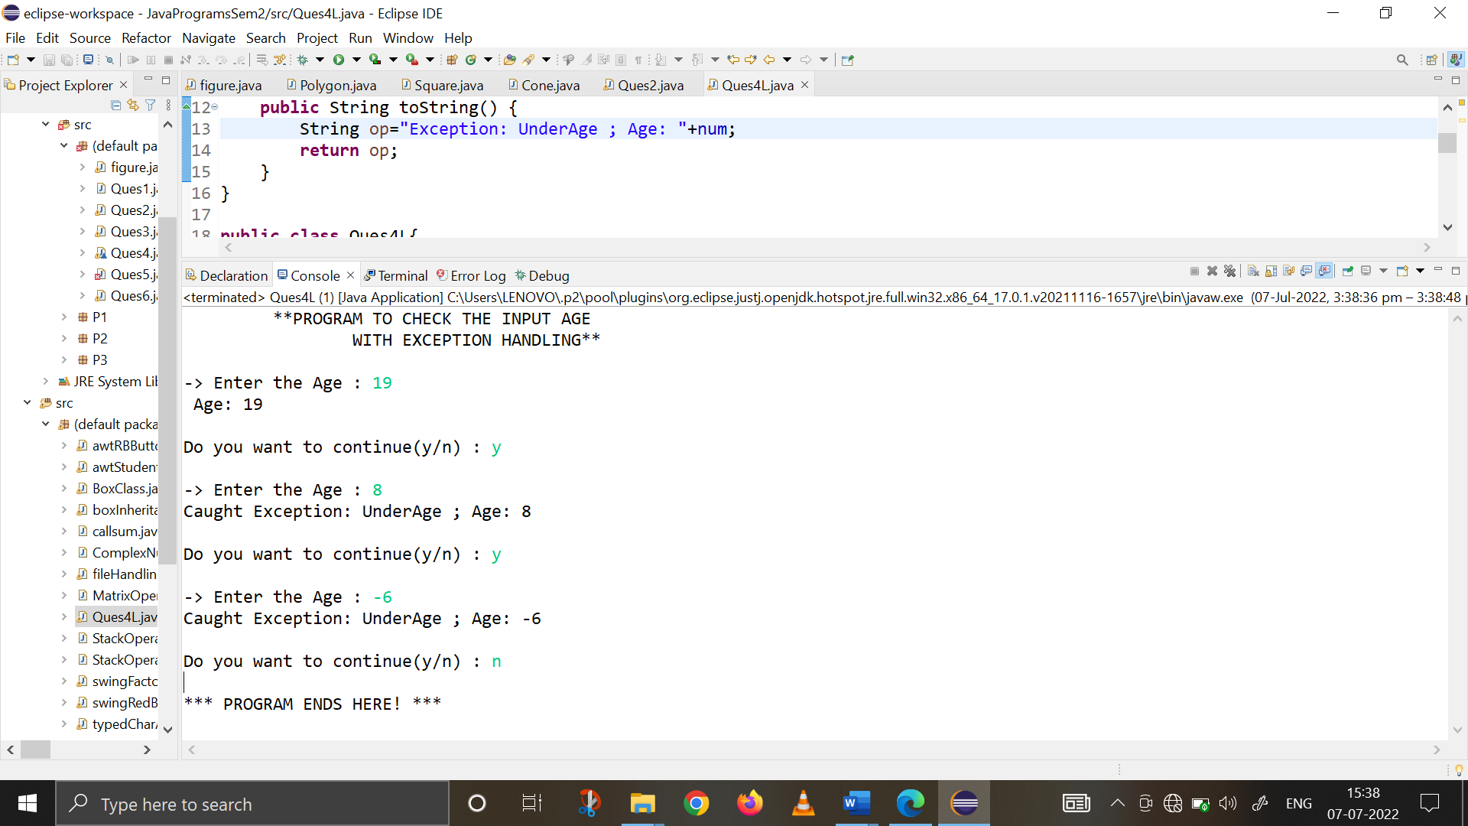

1. **Write a program to implement stack. Use exception handling to manage underflow and overflow conditions**

**import** java.io.*;

**class** STACK1 {

**int** list[], size;

**int** tos=-1;

STACK1(**int** num){

size=num;

list= **new** **int**[size];

}

**void** push(**int** n){

**try** {

**if** (tos==size-1)

**throw** **new** Exception("STACK OVERFLOW");

list[++tos]=n;

}

**catch** (Exception o1) {

System.***out***.println("Element added to stack is :"+o1);

}

}

**int** pop(){

**try** {

**if** (tos==-1)

**throw** **new** Exception("STACK UNDERFLOW");

**return** list[tos--];

}

**catch**(Exception o1) {

**return** -1;

}

}

**void** displayStack(){

System.***out***.println("\t -> THE STACK ELEMENTS ARE : ");

**for** (**int** i=0; i<size; i++) {

System.***out***.print("\t"+list[i]);

}

}

}

**public** **class** StackOperationsWithExceptions {

**public** **static** **void** main(String[] args) **throws** IOException {

BufferedReader br1=**new** BufferedReader(**new** InputStreamReader(System.***in***));

**int** stackSize, choice, num;

System.***out***.println("\t ** STACK AND STACK OPERATIONS ** \n");

System.***out***.println("CREATING A EMPTY STACK");

System.***out***.print("Enter the size of the Stack : ");

stackSize=Integer.*parseInt*(br1.readLine());

System.***out***.println("\n -> A Stack with "+stackSize+" integers will be created!");

STACK1 s1;

s1= **new** STACK1(stackSize);

System.***out***.println("\nPERFORMING STACK OPERATIONS\n");

System.***out***.println("1. PUSH the elements in Stack ");

System.***out***.println("2. POP the elements from Stack ");

System.***out***.println("3. Display all the elements from Stack ");

String ch="y";

**while** (ch.equals("y")) {

System.***out***.print("\n ** Enter the stack operation you want to perform (1,2,3) : ");

choice=Integer.*parseInt*(br1.readLine());

**switch**(choice){

**case** 1 : System.***out***.println("\n\t -> OPERATION CHOOSEN : PUSH ");

**for** (**int** i=1; i<=stackSize; i++) {

System.***out***.print("Enter the "+i+" element : ");

num=Integer.*parseInt*(br1.readLine());

s1.push(num);

}

**break**;

**case** 2 : System.***out***.println("\n\t -> OPERATION CHOOSEN : POP ");

**for** (**int** i=1; i<=stackSize; i++) {

**int** x=s1.pop();

System.***out***.println("The popped element : "+x);

}

**break**;

**case** 3 : System.***out***.println("\n\t -> OPERATION CHOOSEN : DISPLAY STACK ");

s1.displayStack();

}

System.***out***.print("\n Do you want to continue(y/n)? ");

ch=br1.readLine();

}

System.***out***.println("\n \t ** PROGRAM ENDS HERE ** ");

}

}

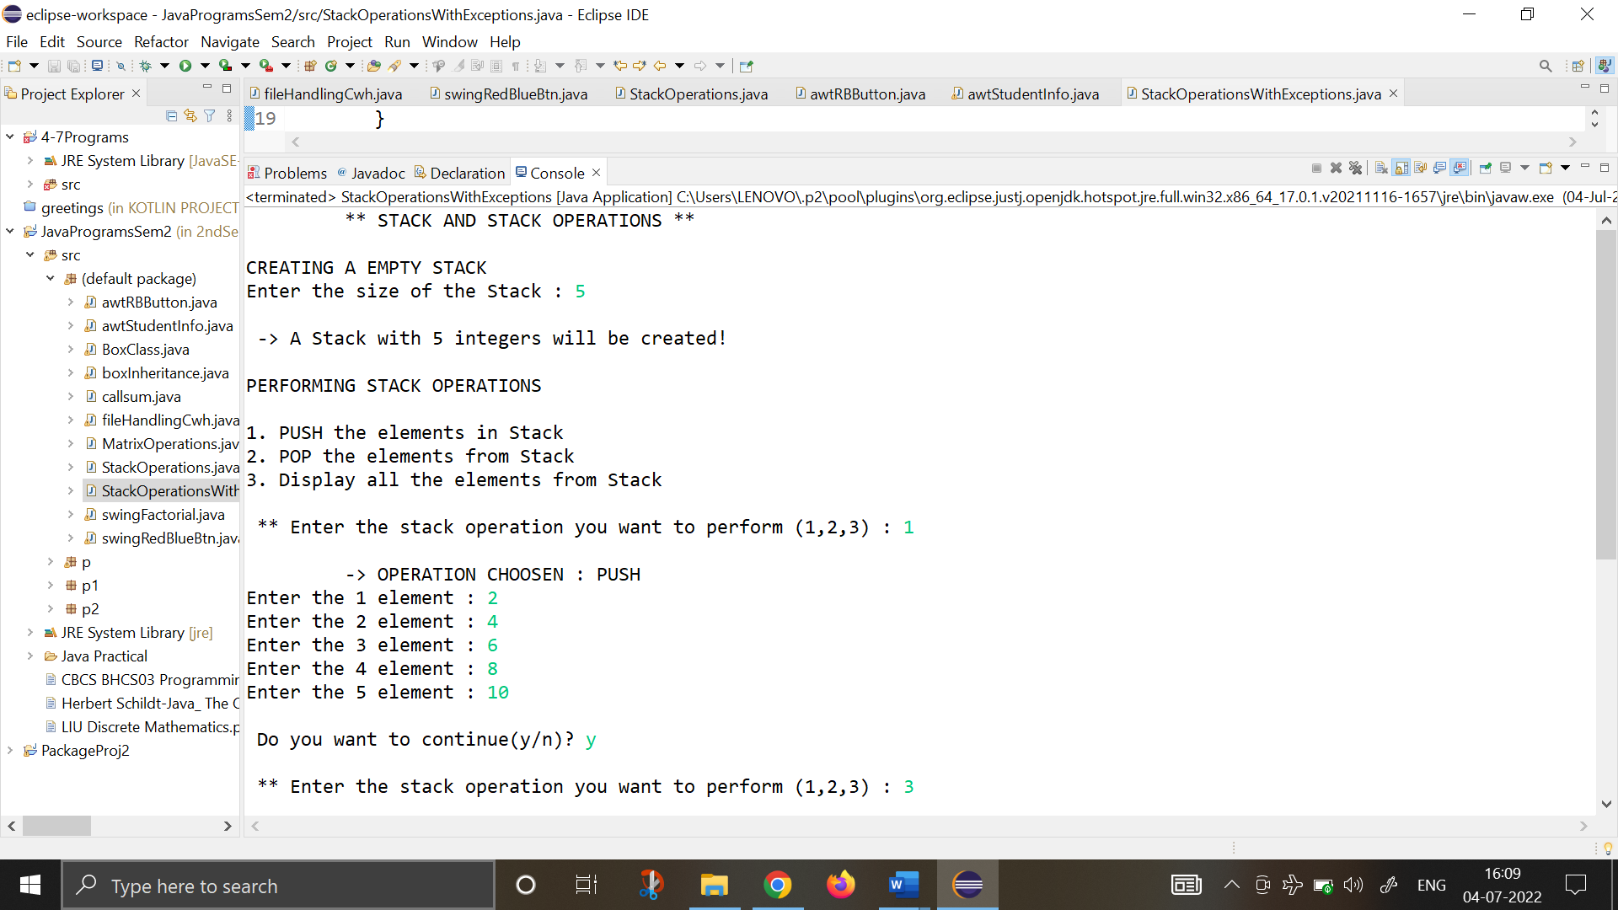

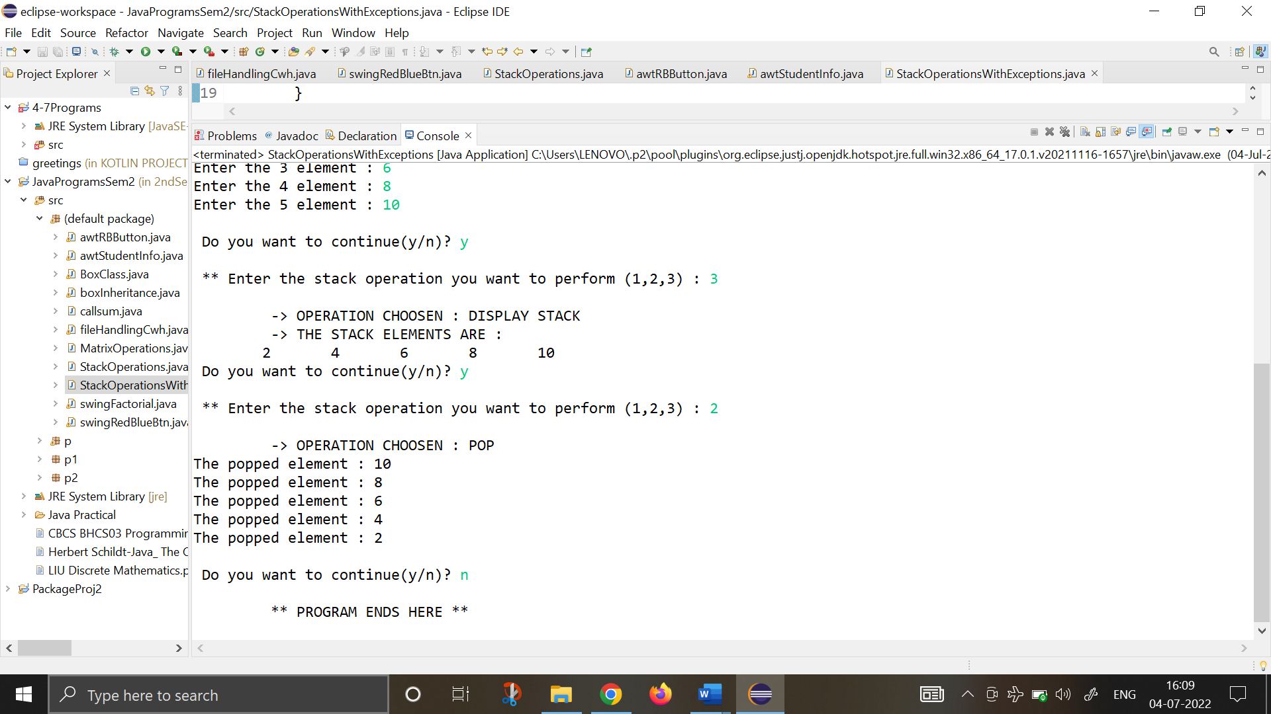

1. **Write a program on nested exception handling.**

**import** java.io.IOException;

**public** **class** Exception {

**static** **void** nest_try(**int** a)

   {

**try**

  {

  System.***out***.println(" Now we are in nest try function ");

**if**(a==1)

  {

  a=a/(a-a);

  }

**if**(a==2)

  {

**int** array[]= {5};

  array[4]=8;

  }

  }

**catch**(ArrayIndexOutOfBoundsException o1)

  {

  System.***out***.println(" Array index out of bounds :- "+o1);

  }

**finally**

  {

  System.***out***.println(" Finally block in nest_try function ");

  }

  System.***out***.println(" End of nest_try Function @_@ ");

   }

**public** **static** **void** main(String[] args) **throws** IOException {

// **TODO** Auto-generated method stub

**try**

     {

**int** x=args.length;

     System.***out***.println(" x = "+ x);

**int** y=34/x;

     System.***out***.println(" y = "+ y);

*nest_try*(x);

     System.***out***.println("After nest_try Function return ");

     }

**catch**(ArithmeticException o1)

     {

     System.***out***.println(" Arithmetic Exception "+o1);

     }

     System.***out***.println(" End of main ");

}

}

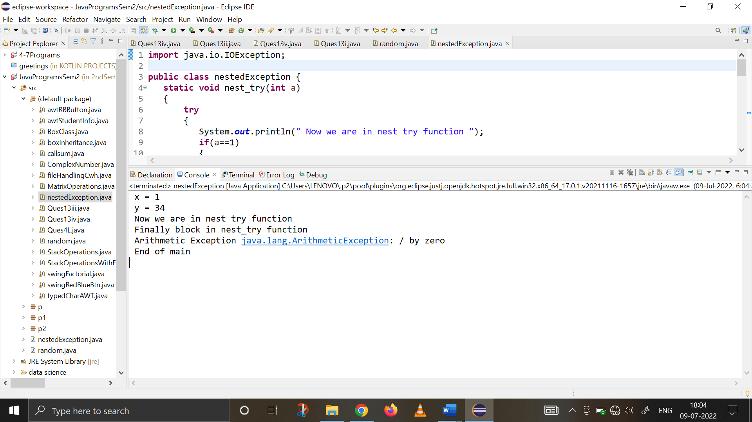

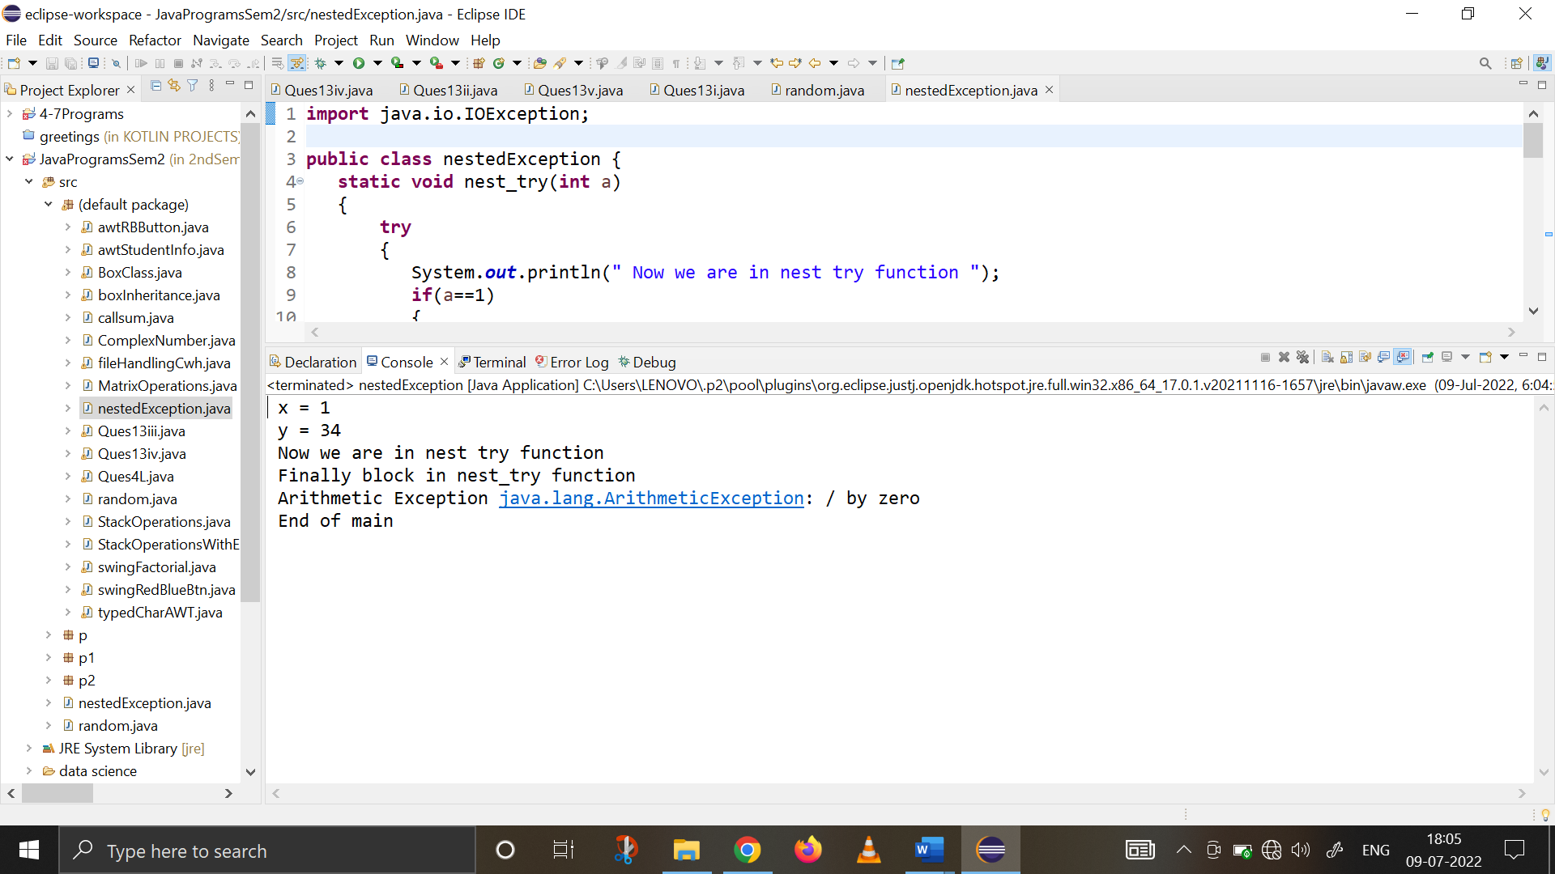

1. **Write a program on random function using exception handling.**

**import** java.util.Random;

**public** **class** random {

**public** **static** **void** main(String[] args) {

// **TODO** Auto-generated method stub

**int** n1,n2,result;

   Random o1=**new** Random();

**for**(**int** i=0;i<=5;i++)

   {

**try**

  {

  n1=o1.nextInt();

  n2=o1.nextInt();

  System.***out***.println(" number 1 :- "+n1 );

  System.***out***.println(" number 2 :- "+n2 );

  result = 12345/(n1/n2);

  }

**catch**(ArithmeticException e)

  {

  System.***out***.println(" Divide by zero :- "+o1 );

  result=0;

  }

  System.***out***.println(" Result :-  "+result );

   }

}

}

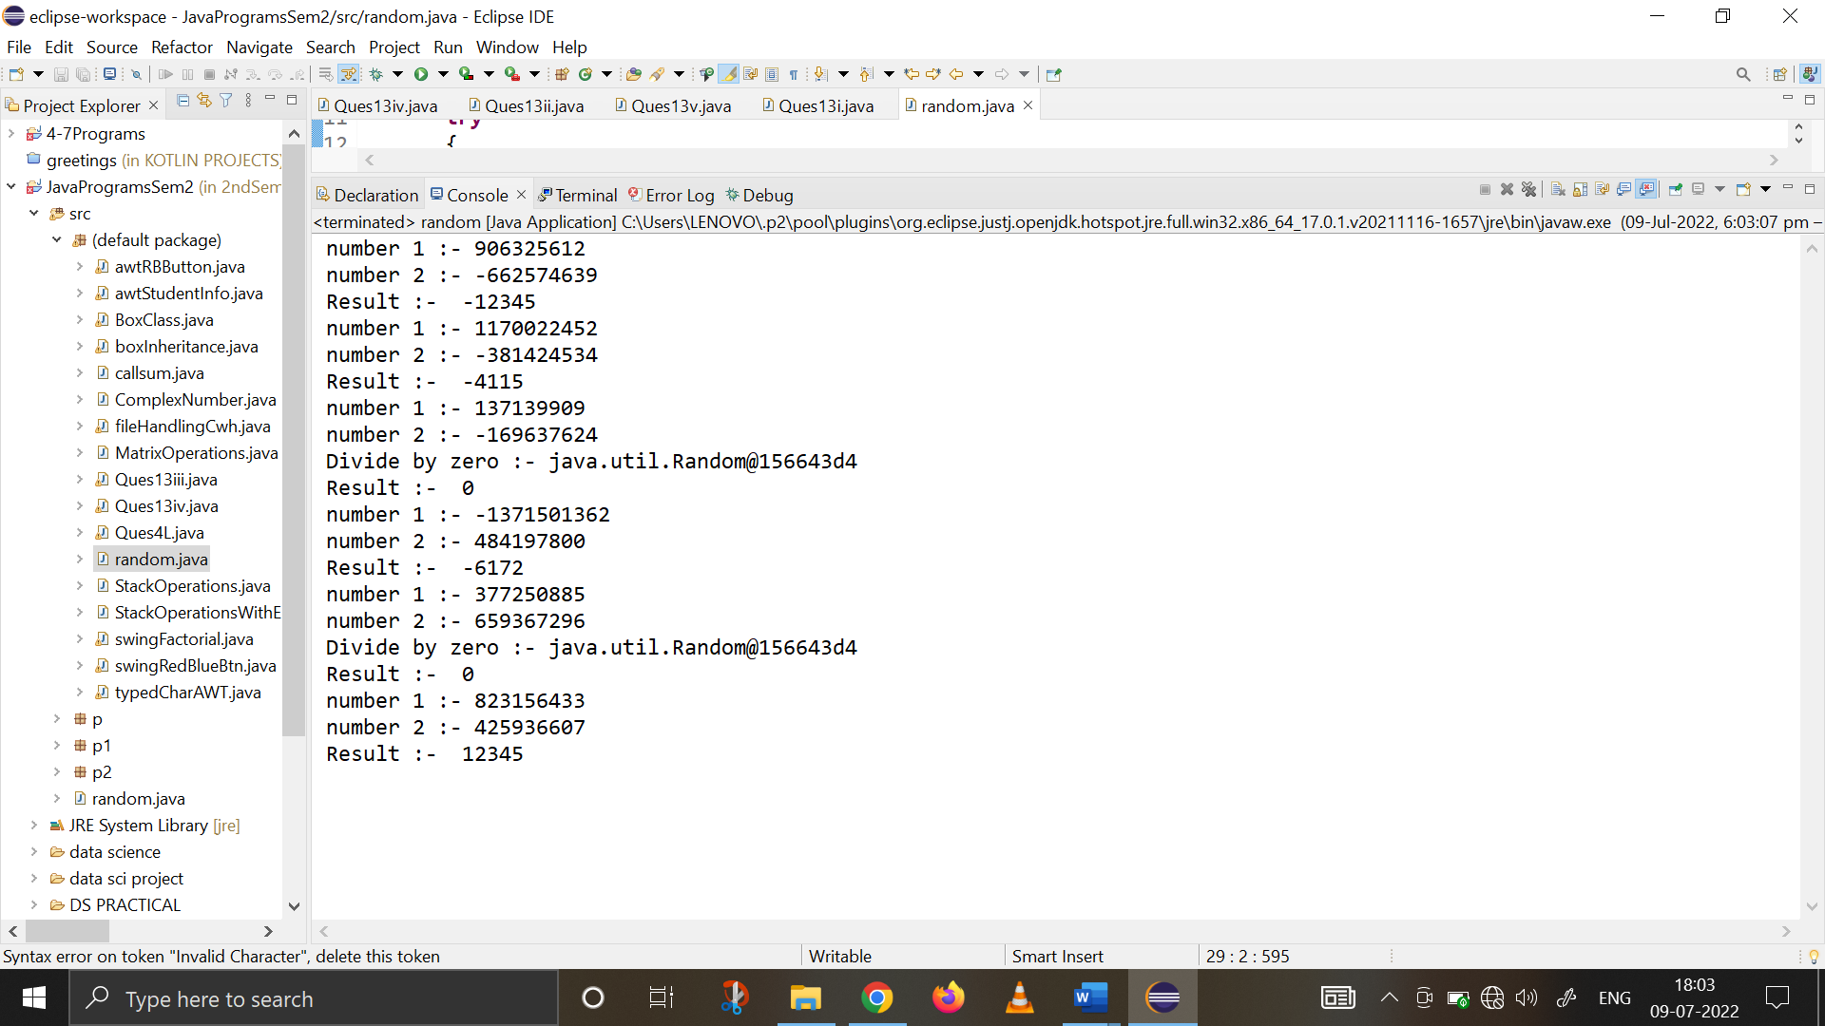

1. **Write a program that copies content of one file to another. Pass the names of the files through command-line arguments.**

**import** java.io.*;

**public** **class** Ques6 {

**public** **static** **void** main(String[] args) **throws** IOException

{

System.***out***.println("\t** PROGRAM TO COPY THE CONTENTS OF FILE **\n ");

**int** i;

FileInputStream fin = **null**;

FileOutputStream fout = **null**;

**if**(args.length != 2) {

System.***out***.println("Enter the arguments");

**return**;

}

**try** {

fin = **new** FileInputStream(args[0]);

fout = **new** FileOutputStream(args[1]);

**do** {

i= fin.read();

**if**(i != -1)

{

fout.write(i);

}

}**while**(i != -1);

System.***out***.println("-> SOURCE FILE (Using CommandLine): "+args[0]);

System.***out***.println("-> DESTINATION FILE (Using CommandLine): "+args[1]);

System.***out***.println("\n-> File copied Successfully!");

}

**catch**(IOException e)

{

System.***out***.println("-> I/O Error :"+e);

}

}

}

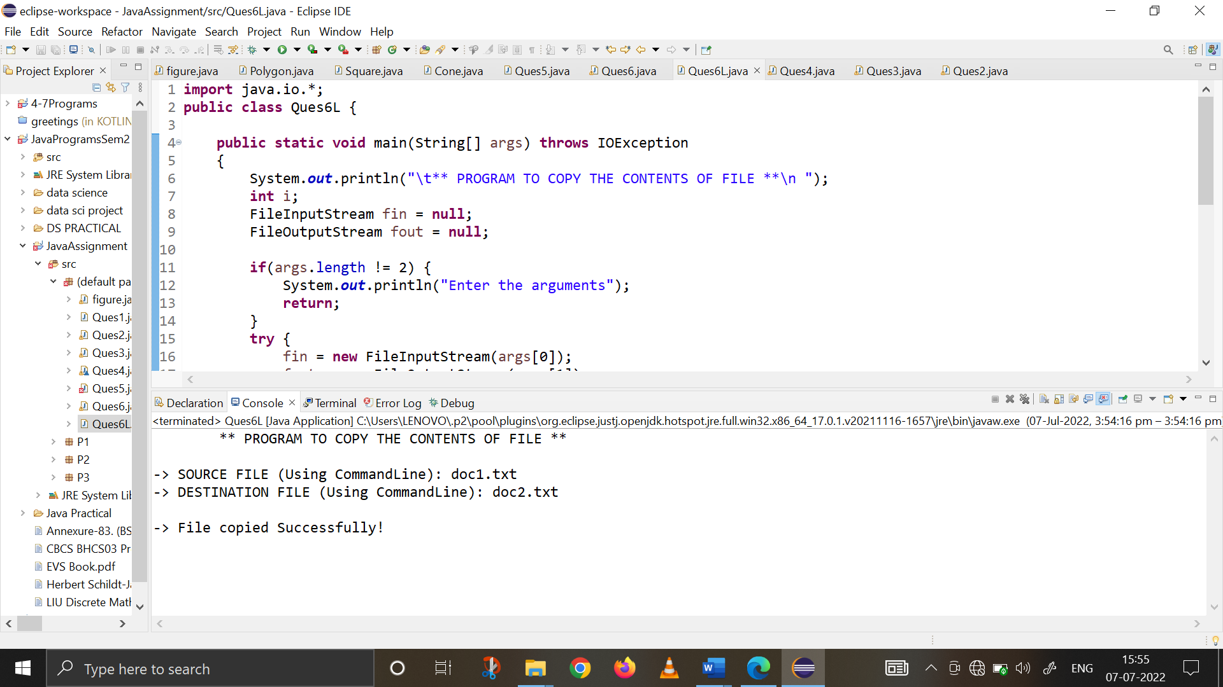

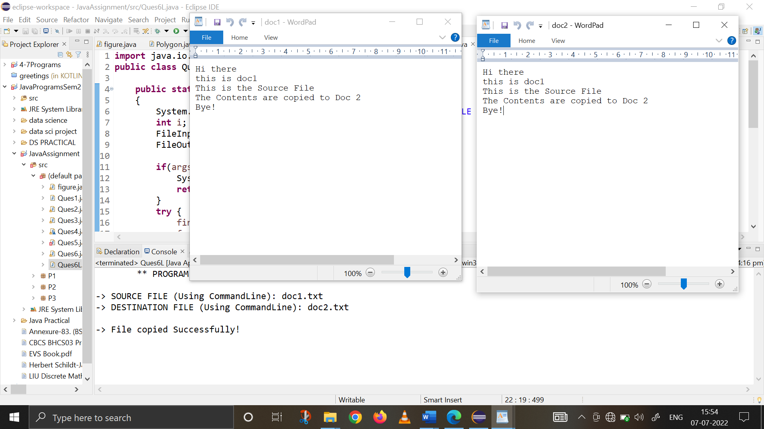

1. **Write a program to read a file and display only those lines that have the first two characters as '//' (Use try with resources).**

**import** java.io.*;

**public** **class** Ques7L {

**public** **static** **void** main(String[] args)**throws** IOException

{

FileInputStream o1= **new** FileInputStream("doc1.txt");

**int** x= o1.read();

**while**(x!=-1) {

**char** x1=(**char**)x;

**char** y=(**char**)o1.read();

**char** ch=(**char**)o1.read();

**if**(x1=='/' && y=='/')

{

**while**(ch!='\n')

{

System.***out***.print(ch);

ch=(**char**)o1.read();

}

System.***out***.print(ch);

}

**else**

{

**while**(ch!='\n')

{

ch=(**char**) o1.read();

}

}

x=o1.read();

}

o1.close();

}

}

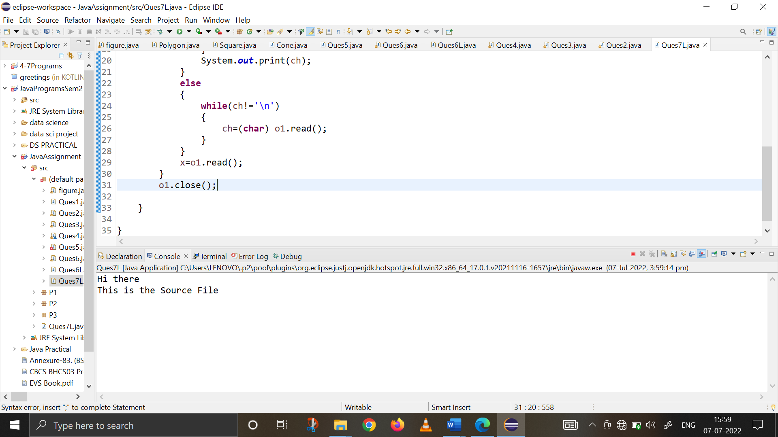 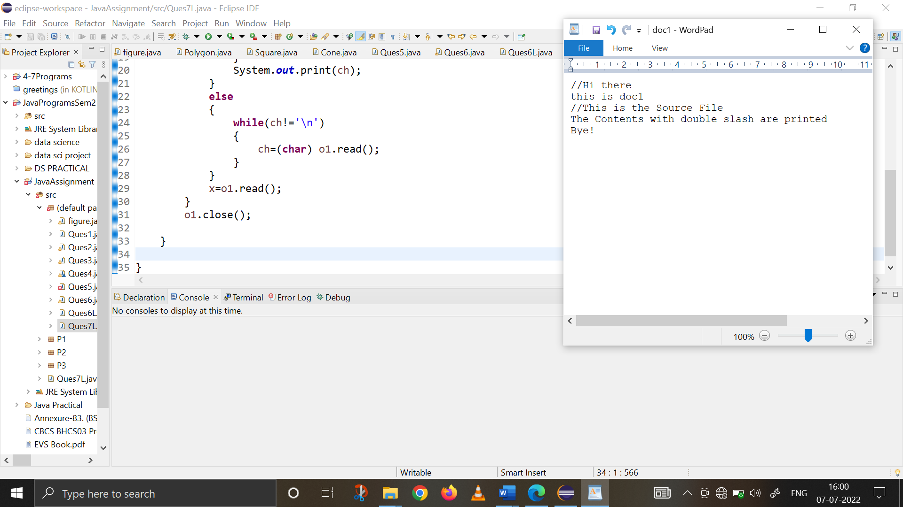

1. **Write a program to display the number of characters, words, paragraphs, whitespace and sentences in a file.**

**import** java.io.*;

**public** **class** fileHandling {

**public** **static** **void** main(String[] args) **throws** IOException {

File file = **new** File("file1.txt");

FileInputStream fileInputStream = **new** FileInputStream(file);

InputStreamReader inputStreamReader = **new** InputStreamReader(fileInputStream);

BufferedReader bufferedReader = **new** BufferedReader(inputStreamReader);

String line;

**int** wordCount = 0;

**int** characterCount = 0;

**int** paraCount = 0;

**int** whiteSpaceCount = 0;

**int** sentenceCount = 0;

**while** ((line = bufferedReader.readLine()) != **null**) {

**if** (line.equals("")) {

paraCount += 1;

}

**else** {

characterCount += line.length();

String words[] = line.split("\\s+");

wordCount += words.length;

whiteSpaceCount += wordCount - 1;

String sentence[] = line.split("[!?.:]+");

sentenceCount += sentence.length;

}

}

**if** (sentenceCount >= 1) {

paraCount++;

}

System.***out***.println("Total word count = "+ wordCount);

System.***out***.println("Total number of sentences = "+ sentenceCount);

System.***out***.println("Total number of characters = "+ characterCount);

System.***out***.println("Number of paragraphs = "+ paraCount);

System.***out***.println("Total number of whitespaces = "+ whiteSpaceCount);

}

}

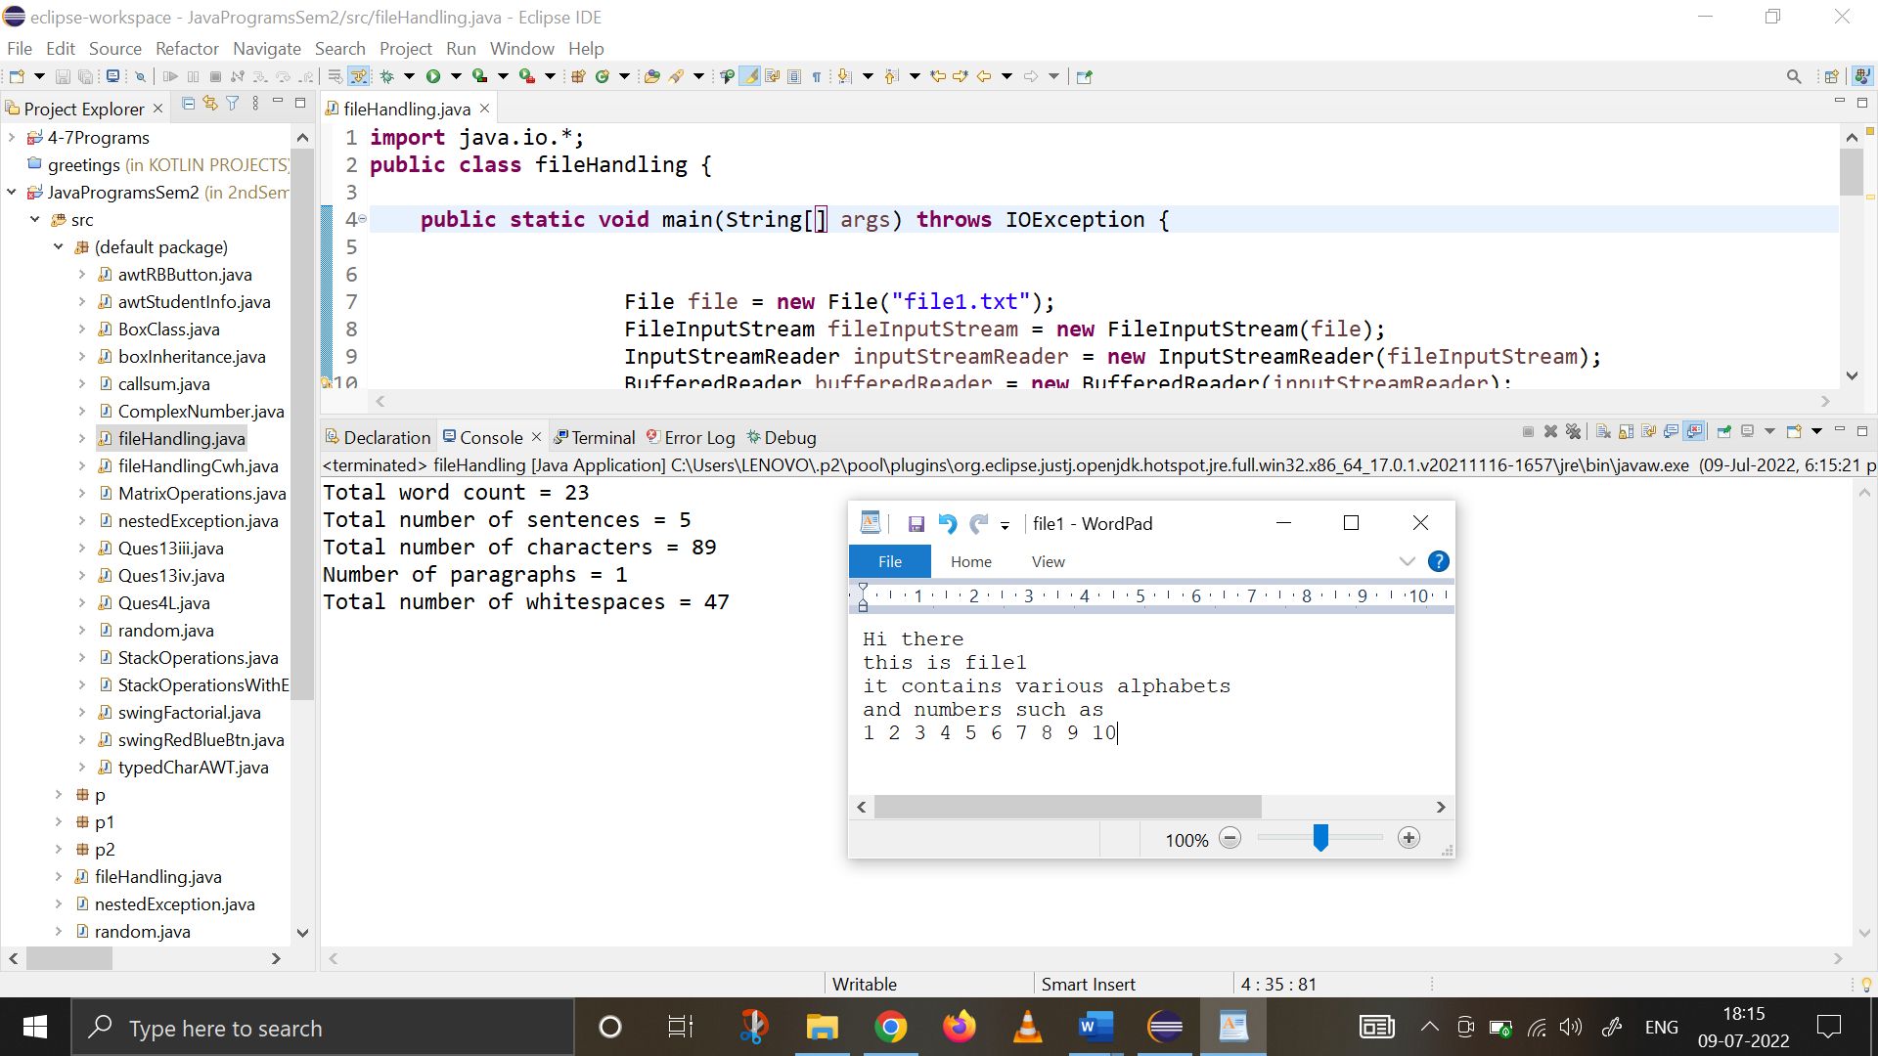

1. **Write a program to create a frame using AWT. Implement mouseClicked(), mouseEntered() and mouseExited() events such that:**

**a) Size of the frame should be tripled when mouse enters it.**

**b) Frame should reduce to its original size when mouse is clicked in it.**

**c) Close the frame when mouse exits it.**

**import** java.awt.*;

**import** java.awt.event.*;

**import** javax.swing.*;

**public** **class** Ques13i{

JFrame o1;

Dimension d;

Ques13i(){

o1=**new** JFrame("QUES 13: MOUSE EVENT HANDLING USING SWING");

o1.setSize(300,300);

d=o1.getSize();

o1.setDefaultCloseOperation(JFrame.***EXIT_ON_CLOSE***);

o1.addMouseListener(**new** MyMouseAdapter1(**this**));

o1.setVisible(**true**);

}

**public** **static** **void** main(String[] args) {

SwingUtilities.*invokeLater*(**new** Runnable() {

**public** **void** run()

{

**new** Ques13i();

}

});

}

}

**class** MyMouseAdapter1 **extends** MouseAdapter

{

Ques13i o2;

MyMouseAdapter1(Ques13i o2)

{

**this**.o2=o2;

}

**public** **void** mouseClicked(MouseEvent m1)

{

o2.o1.setSize(o2.d.width,o2.d.height);

}

**public** **void** mouseEntered(MouseEvent m)

{

Dimension d;

d=o2.o1.getSize();

o2.o1.setSize(d.width*3,d.height*3);

}

**public** **void** mouseExited(MouseEvent m)

{

System.*exit*(0);

}

}

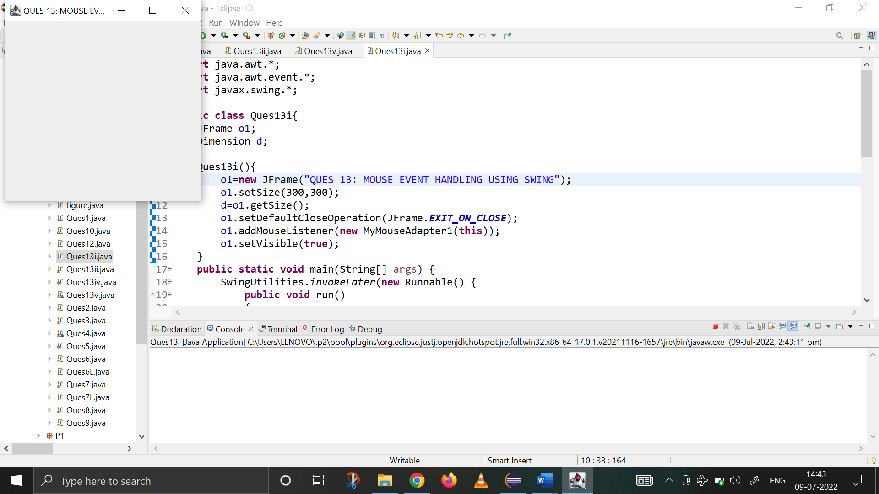

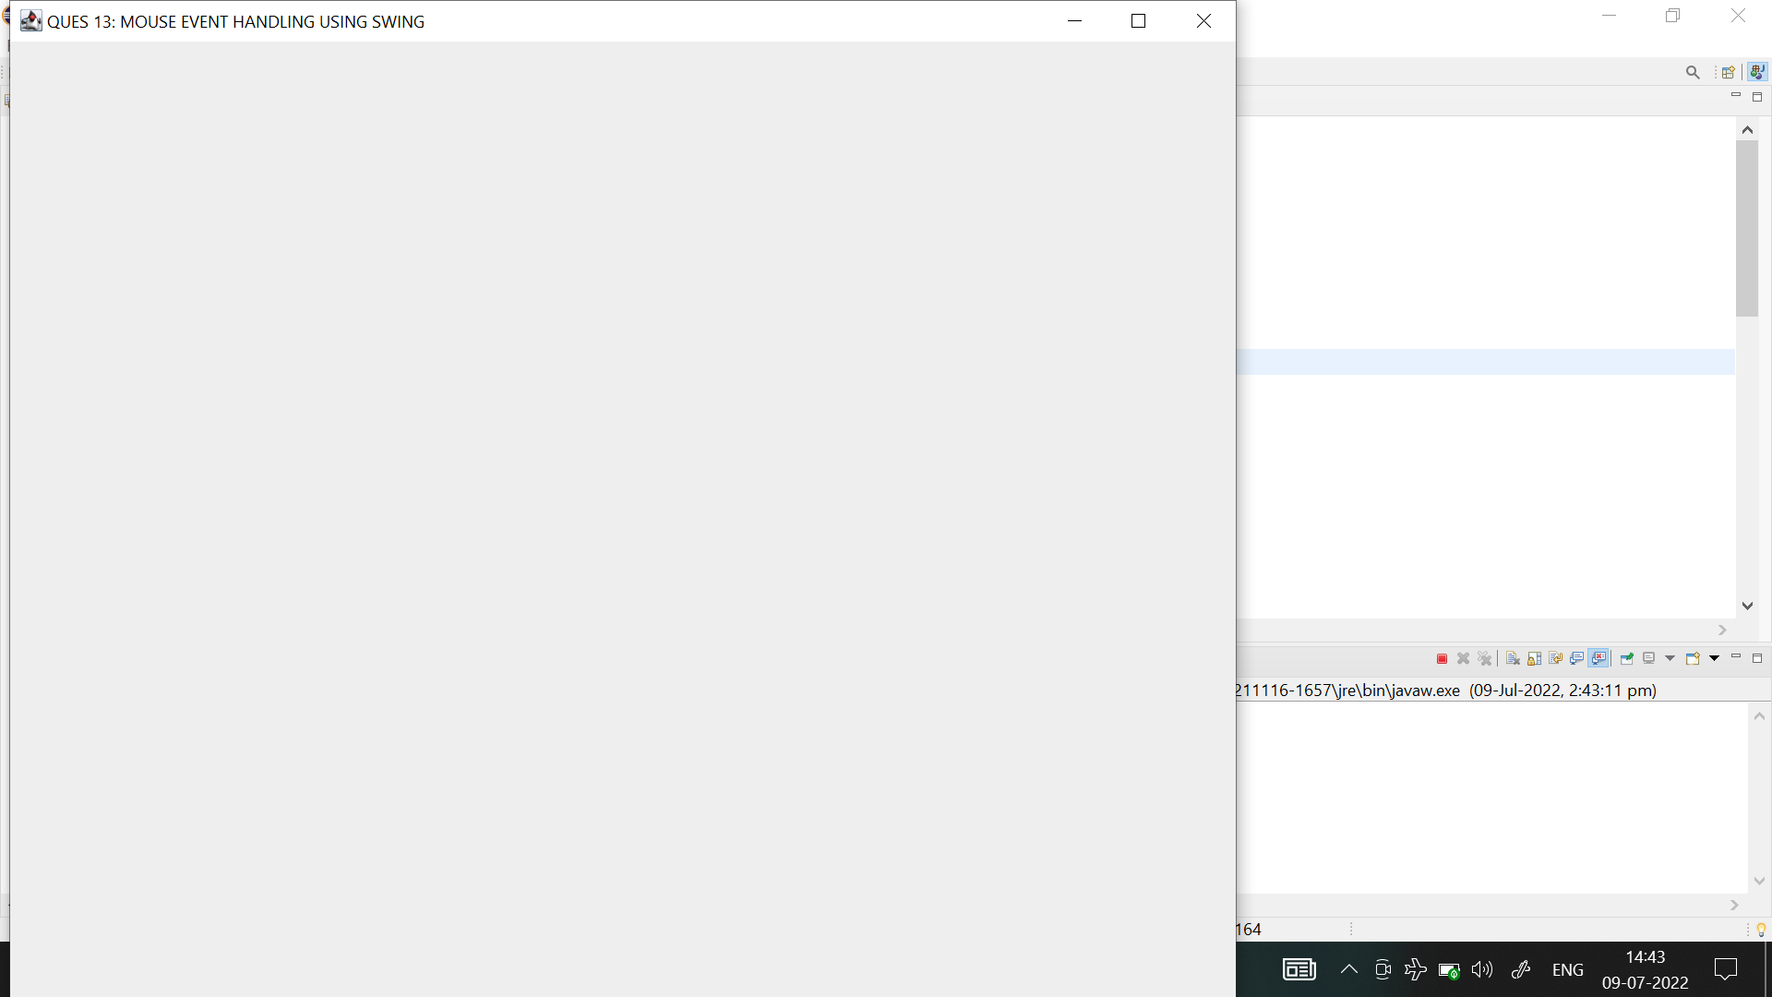

1. **Using SWING, write a program to display a string in frame window with pink color as background.**

**import** java.awt.*;

**import** javax.swing.*;

**public** **class** Ques13ii **extends** JFrame {

JLabel o1;

Ques13ii(){

setSize(400,400);

setDefaultCloseOperation(JFrame.***EXIT_ON_CLOSE***);

getContentPane().setBackground(Color.***pink***);

setLayout(**new** FlowLayout());

o1=**new** JLabel(" Hi There! This is a Java program @_@ ");

getContentPane().add(o1);

setVisible(**true**);

}

**public** **static** **void** main(String[] args) {

SwingUtilities.*invokeLater*(**new** Runnable() {

**public** **void** run(){

**new** Ques13ii();

}

});

}

}



1. **Using SWING, write a program to create two buttons named “Red” and “Blue”. When a button is pressed the background color should be set to the color named by the button’s label.**

**import** java.awt.*;

**import** java.awt.event.*;

**import** javax.swing.*;

**public** **class** Ques13iii {

JLabel jlab;

JFrame jfrm;

JButton jbtnRed, jbtnBlue;

Ques13iii(){

//Basic Frame Settings to set up display window

JFrame jfrm=**new** JFrame("Java Application for Red Blue Button");

JPanel panel=**new** JPanel();

jfrm.getContentPane().setBackground(Color.***WHITE***);

jfrm.setSize(500,500);

jfrm.setVisible(**true**);

jfrm.setLayout(**new** FlowLayout());

jfrm.setDefaultCloseOperation(JFrame.***EXIT_ON_CLOSE***);

//color and button settings

Color c=**new** Color(255,255,255);

JButton jbtnRed=**new** JButton("RED");

jbtnRed.setBackground(Color.***WHITE***);

JButton jbtnBlue=**new** JButton("BLUE");

jbtnBlue.setBackground(Color.***WHITE***);

//adding all components to the frame

jfrm.add(jbtnRed);

jfrm.add(jbtnBlue);

jlab=**new** JLabel("Press a button");

jfrm.add(jlab);

//action listener for red and blue

jbtnRed.addActionListener(**new** ActionListener() {

**public** **void** actionPerformed(ActionEvent ae) {

jfrm.getContentPane().setBackground(Color.***RED***);

jlab.setText("\nRED Button pressed!");

}

});

jbtnBlue.addActionListener(**new** ActionListener() {

**public** **void** actionPerformed(ActionEvent ae) {

jfrm.getContentPane().setBackground(Color.***BLUE***);

jlab.setText("\nBLUE Button pressed!");

}

});

jbtnRed.addActionListener(**new** ActionListener() {

**public** **void** actionPerformed(ActionEvent ae) {

jfrm.getContentPane().setBackground(Color.***BLUE***);

jlab.setText("BLUE Button pressed!");

}

});

}

**public** **static** **void** main(String[] args) {

SwingUtilities.*invokeLater*(**new** Runnable() {

**public** **void** run() {

**new** Ques13iii();

}

});

}

}

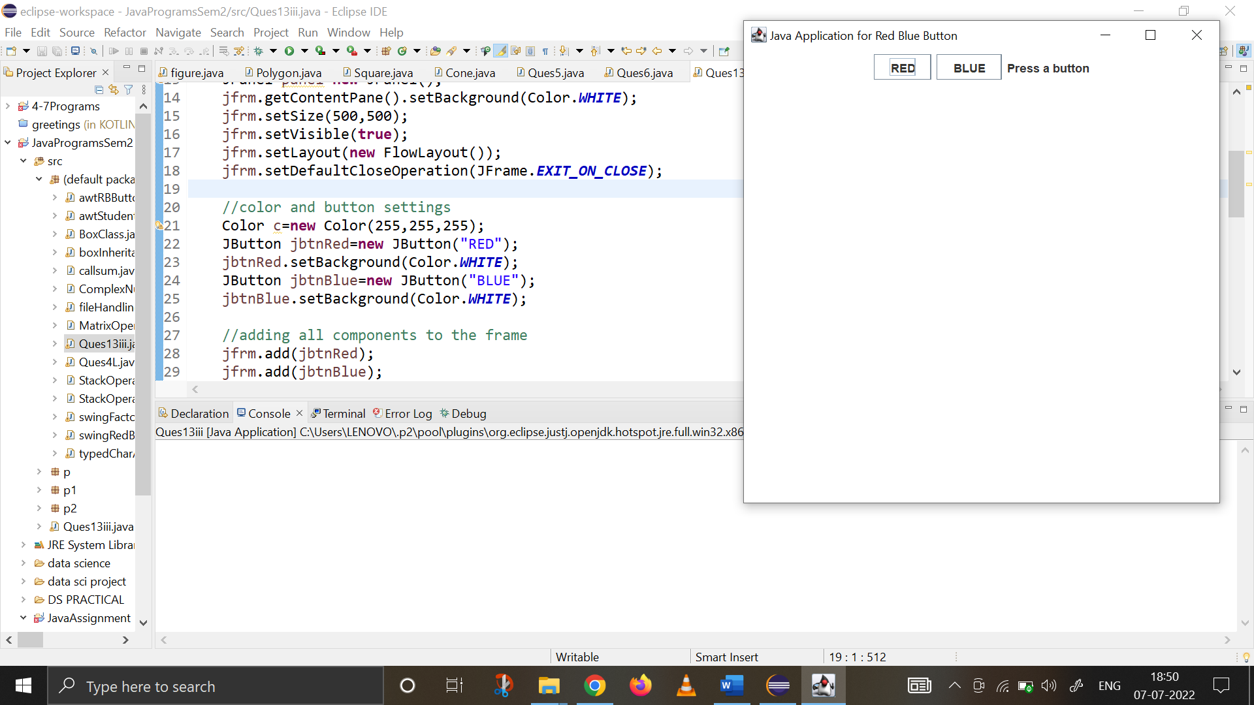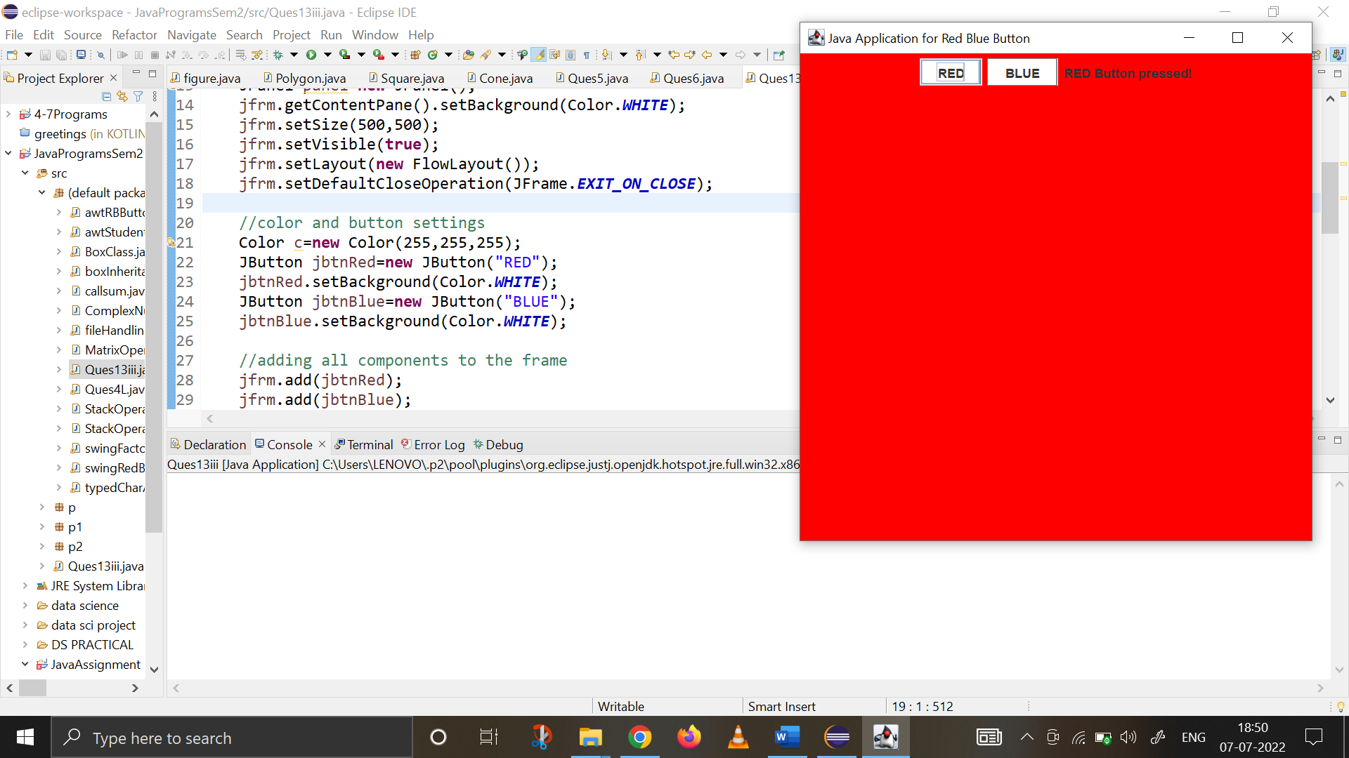

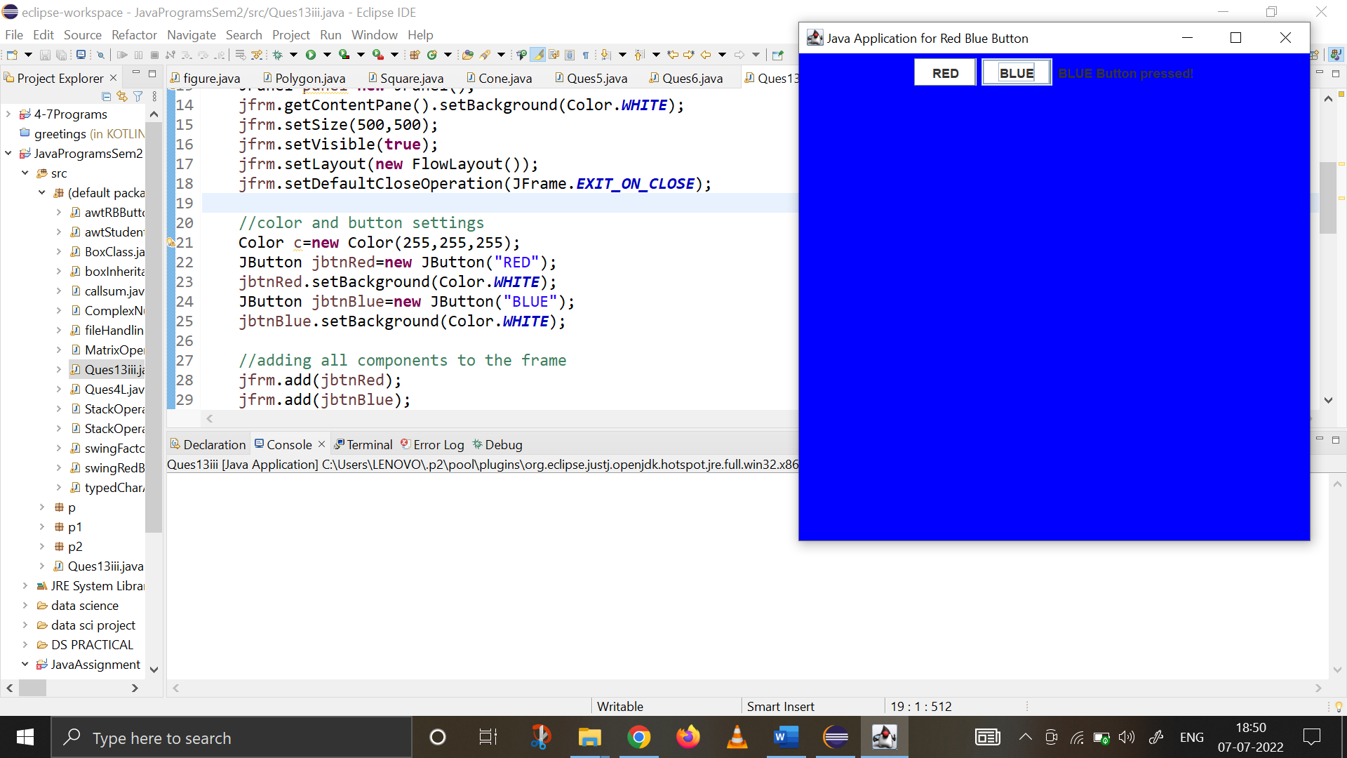

1. **Using SWING, write a program using appropriate adapter class to display the message (“Typed character is: ”) in the frame window when user types any key.**

**import** java.awt.*;

**import** java.awt.event.*;

**import** javax.swing.*;

**class** PanelK **extends** JPanel

{

String msg1= "TYPED CHARACTERS : ";

**protected** **void** paintComponent (Graphics g)

{

**super**.paintComponent(g);

g.drawString(msg1, 150, 150);

}

}

**class** MyKeyAdapter1 **extends** KeyAdapter{

PanelK o1;

MyKeyAdapter1(PanelK o2){

o1=o2;

}

**public** **void** keyTyped(KeyEvent ke)

{

o1.msg1+=ke.getKeyChar();

o1.repaint();

}

}

**class** FrameK **extends** JFrame

{

PanelK panel;

FrameK(){

**super**("Key Event Handling Swings" );

setSize(450,450);

setDefaultCloseOperation(JFrame.***EXIT_ON_CLOSE***);

getContentPane().setBackground(Color.***pink***);

panel= **new** PanelK();

add(panel);

addKeyListener(**new** MyKeyAdapter1(panel));

setVisible(**true**);

}

}

**public** **class** Ques13iv{

**public** **static** **void** main(String[] args) {

SwingUtilities.*invokeLater*(**new** Runnable() {

**public** **void** run() {

**new** FrameK();

}

});

}

}

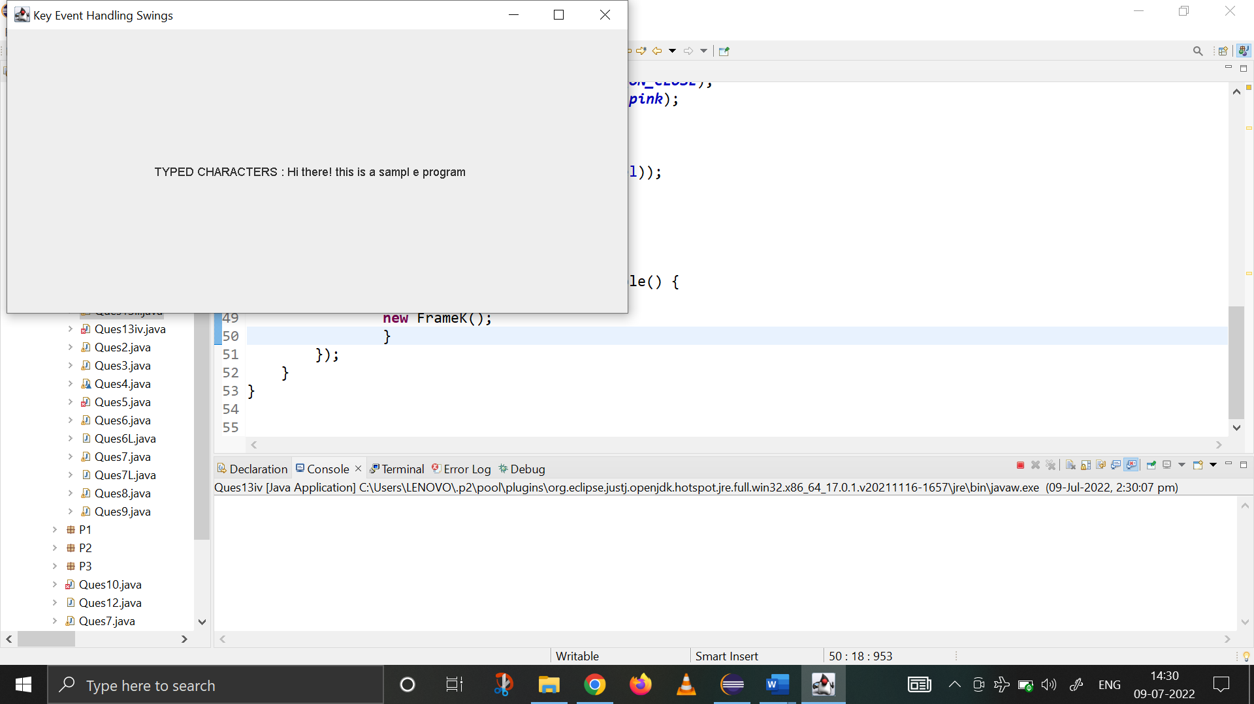

1. **Using SWING, write a program to create two buttons labelled ‘A’ and ‘B’. When button ‘A’ is pressed, it displays your personal information (Name, Course, Roll No, College) and when button ‘B’ is pressed, it displays your CGPA in previous semester.**

**import** java.awt.*;

**import** java.awt.event.*;

**import** javax.swing.*;

**class** PanelClass **extends** JPanel {

**public** String msg1="";

String msg2="";

String msg3="";

String msg4="";

**protected** **void** paintComponent(Graphics g){

**super**.paintComponent(g);

g.drawString(msg1,100,100);

g.drawString(msg2,100,120);

g.drawString(msg3,100,140);

g.drawString(msg4,100,160);

}

}

**class** Ques13v **extends** JFrame **implements** ActionListener{

JLabel label;

PanelClass panel;

Ques13v (){

panel=**new** PanelClass();

getContentPane().add(panel);

setSize(500,400);

setDefaultCloseOperation(JFrame.***EXIT_ON_CLOSE***);

JButton b1=**new** JButton("A");

JButton b2=**new** JButton("B");

b1.addActionListener(**this**);

b2.addActionListener(**this**);

panel.setLayout(**new** FlowLayout());

panel.add(b1);

panel.add(b2);

setVisible(**true**);

}

**public** **void** actionPerformed(ActionEvent ae){

String str=ae.getActionCommand();

**if**(str.equals("A")){

panel.msg1="Name : Khushi Panwar";

panel.msg2="Course : BSc.(H) Computer Sciences.";

panel.msg3="Roll no. : 2021334";

panel.msg4 ="College : Shaheed Rajguru College of Apllied Siences for Women.";

panel.repaint();

}

**else**{

panel.msg1="CGPA : 9";

panel.msg2="";

panel.msg3="";

panel. msg4="";

panel.repaint();

}

}

**public** **static** **void** main(String[] args) {

SwingUtilities.*invokeLater*(**new** Runnable() {

**public** **void** run(){

**new** Ques13v();

}

});

}

}

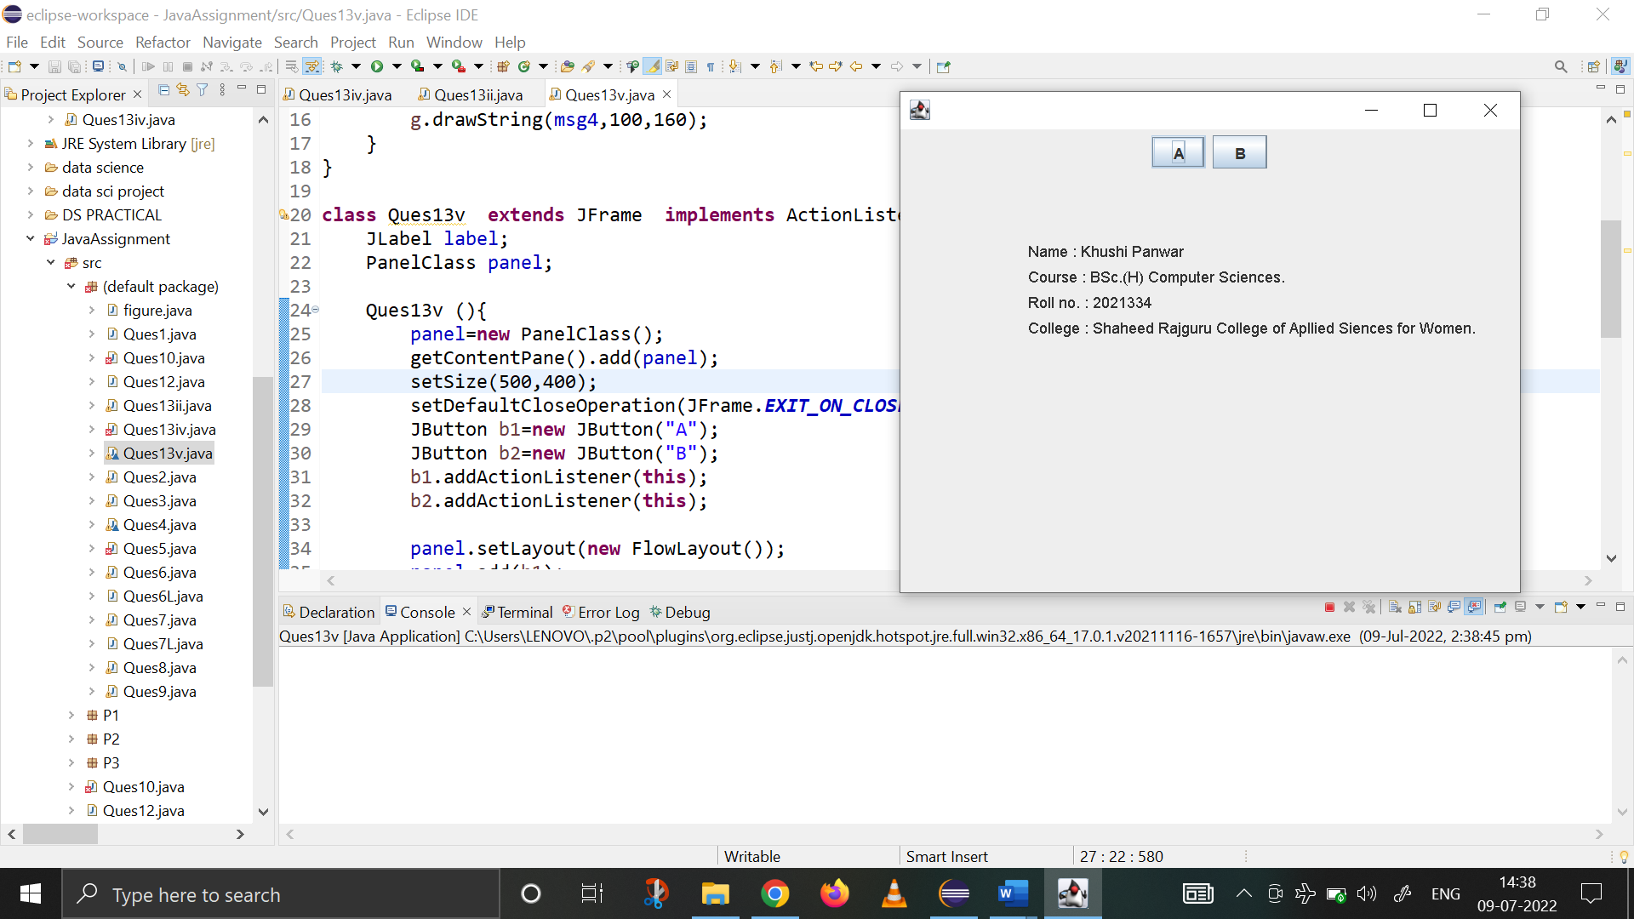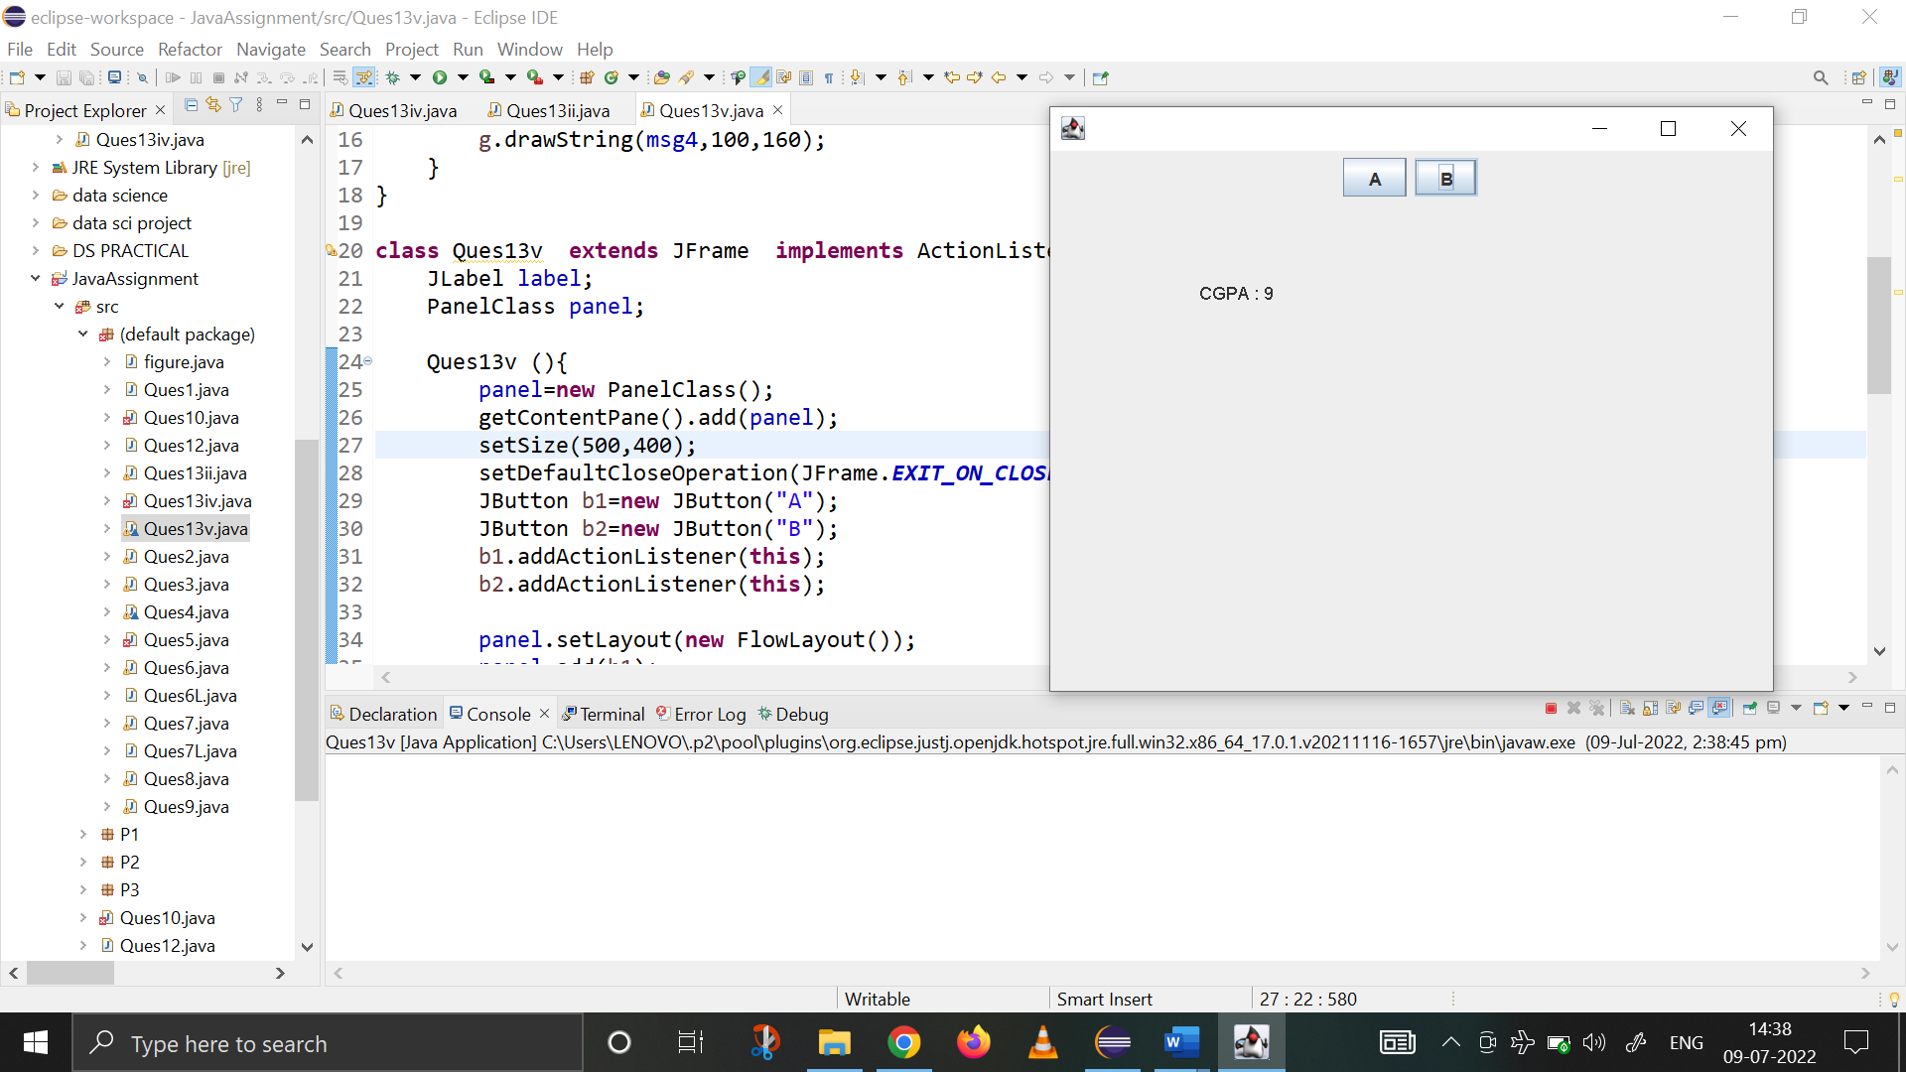

1. **WAP with red, blue and green button and changing background**

**import** java.awt.*;

**import** java.awt.event.*;

**import** javax.swing.*;

**public** **class** RGBBackgroundSwing **implements** ActionListener {

JFrame jfrm;

**public** RGBBackgroundSwing ()

{

jfrm = **new** JFrame(" Red Green Blue Background Program using Swing ");

jfrm.setLayout(**new** FlowLayout());

jfrm.setDefaultCloseOperation(JFrame.***EXIT_ON_CLOSE***);

jfrm.setSize(500,500);

JButton Red=**new** JButton("Red");

JButton Blue=**new** JButton("Blue");

JButton Green=**new** JButton("Green");

jfrm.getContentPane().add(Red);

jfrm.getContentPane().add(Blue);

jfrm.getContentPane().add(Green);

jfrm.setVisible(**true**);

Red.addActionListener(**this**);

Blue.addActionListener(**this**);

Green.addActionListener(**this**);

}

**public** **void** actionPerformed(ActionEvent ae)

{ String st=ae.getActionCommand();

**if**(st.equals("Red"))

jfrm.getContentPane().setBackground(Color.***red***);

**else** **if**(st.equals("Blue"))

jfrm.getContentPane().setBackground(Color.***blue***);

**else** **if**(st.equals("Green"))

jfrm.getContentPane().setBackground(Color.***green***);

}

**public** **static** **void** main(String[] args) {

SwingUtilities.*invokeLater*(**new** Runnable() {

**public** **void** run() {

**new** RGBBackgroundSwing();

}

});

}

}

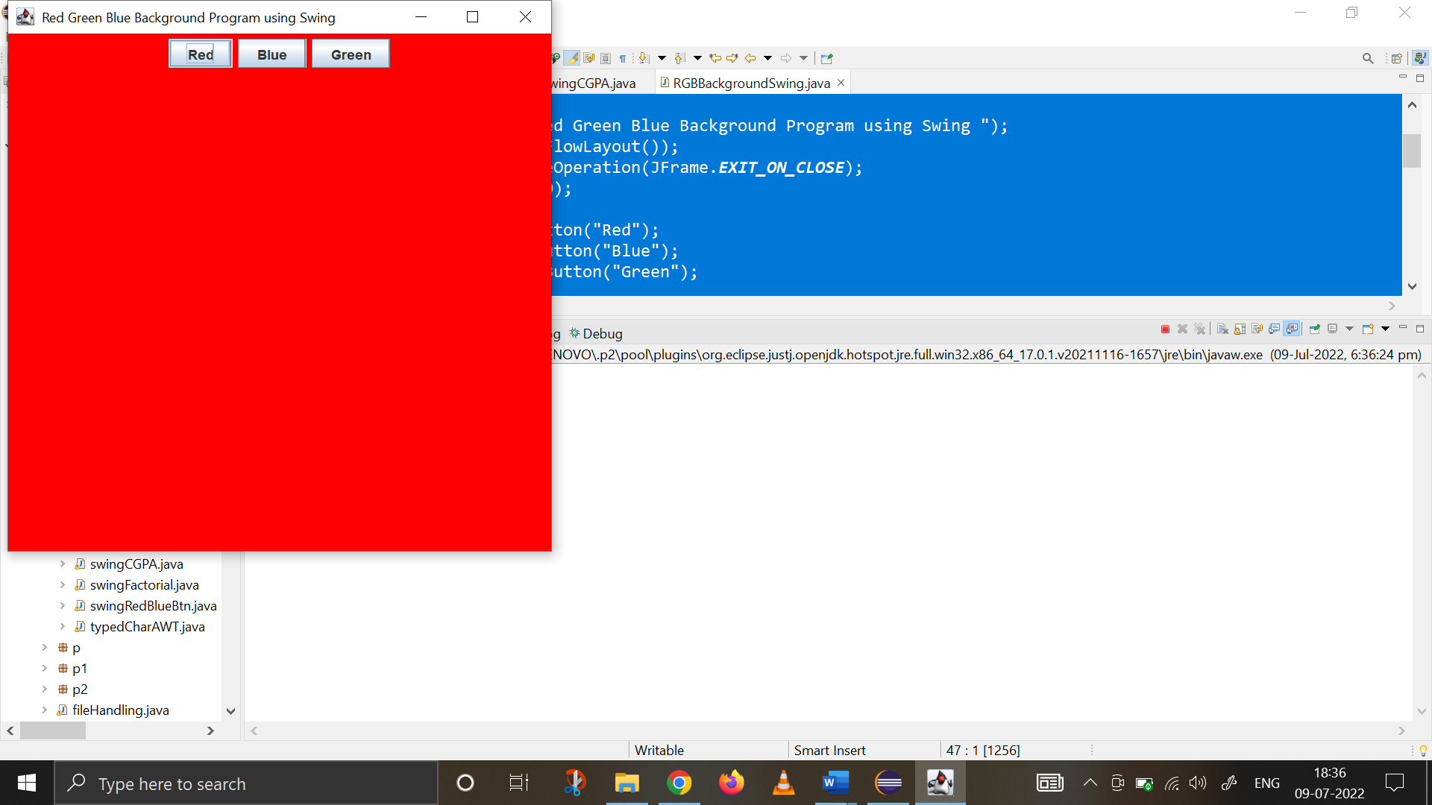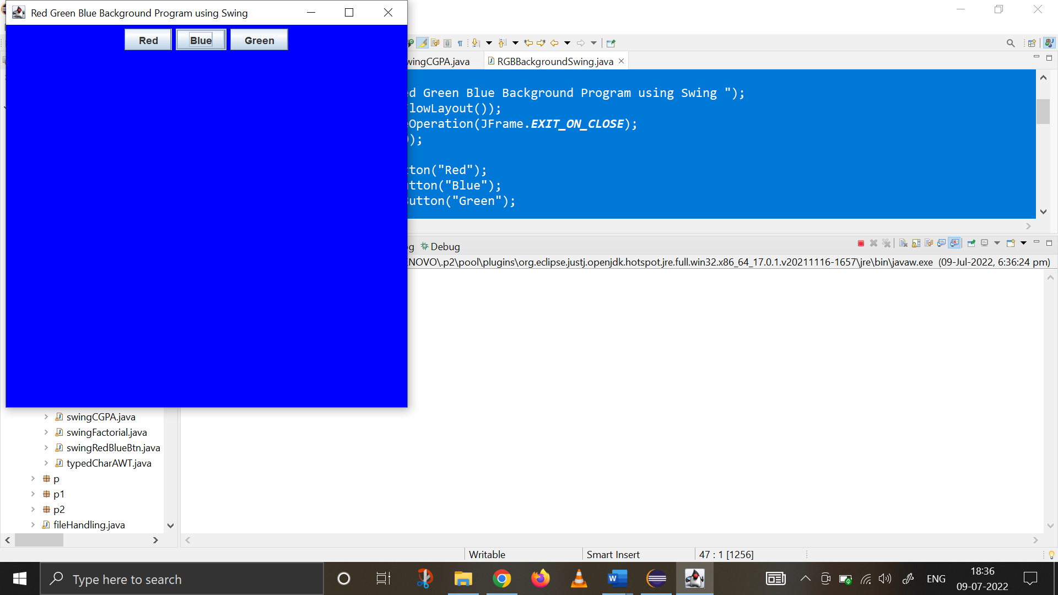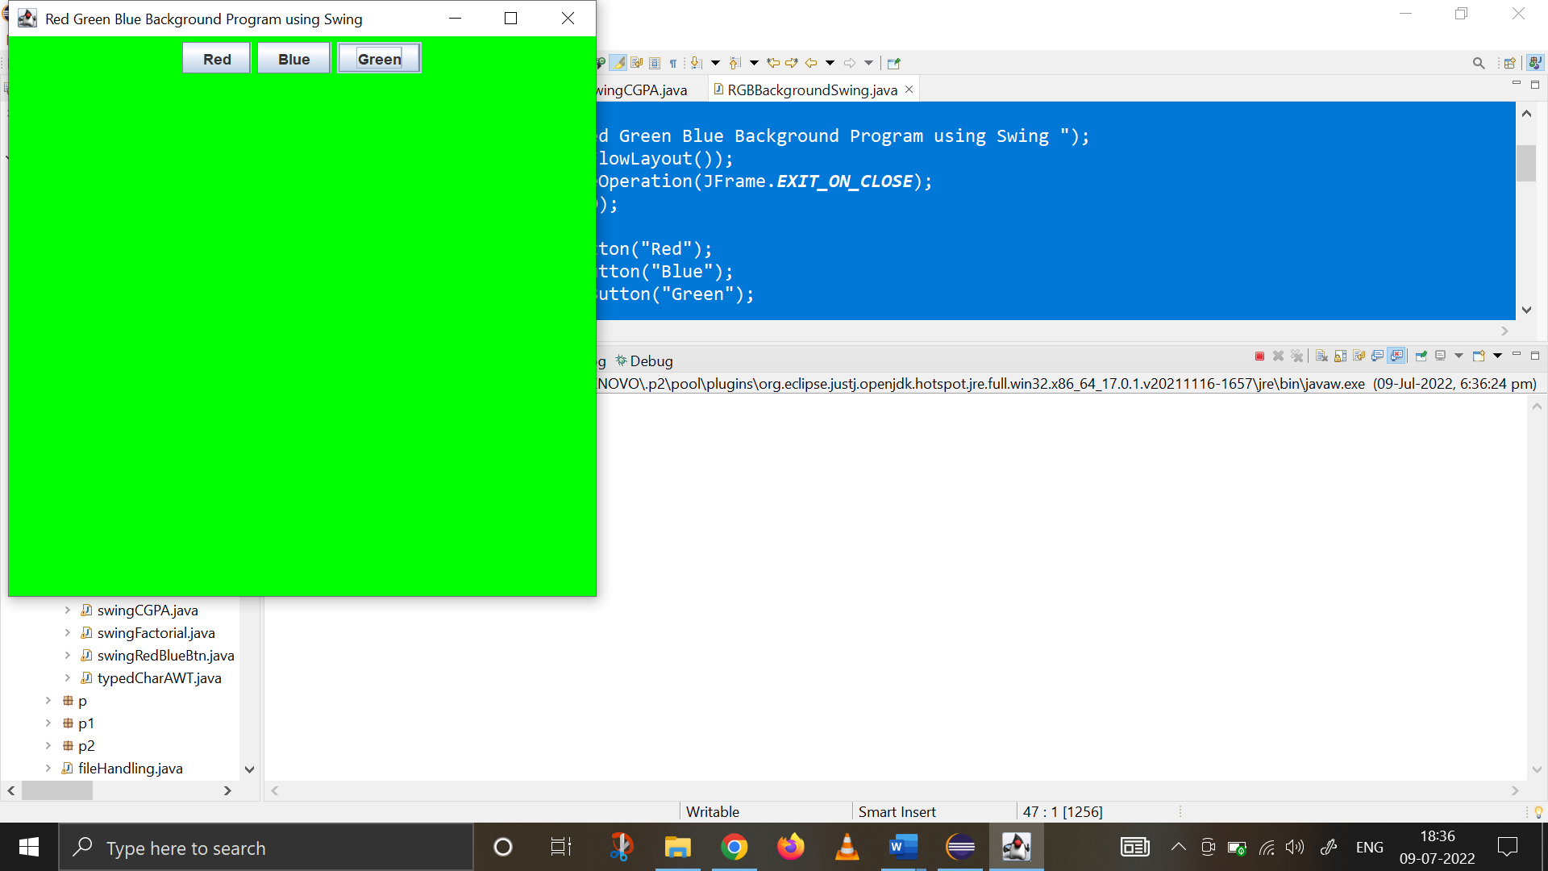

1. **WAP showing the student info and its CGPA using panel**

**import** java.awt.*;

**import** java.awt.event.*;

**import** javax.swing.*;

**import** java.util.*;

**class** student_info **extends** JPanel {

Button A,B;

String msg1="",msg2="",msg3="",msg4="";

**public** student_info()

{ setBackground(Color.***gray***);}

**protected** **void** paintComponent(Graphics g)

{

**super**.paintComponent(g);

g.drawString(msg1, 20, 100);

g.drawString(msg2, 20, 130);

g.drawString(msg3, 20, 160);

g.drawString(msg4, 20, 190);

}

}

**public** **class** swingCGPA **extends** JFrame **implements** ActionListener

{

JLabel jl;

student_info si;

swingCGPA()

{

setTitle(" Swing Frame panel @_@ ");

setSize(300,300);

setDefaultCloseOperation(JFrame.***EXIT_ON_CLOSE***);

si=**new** student_info();

getContentPane().add(si);

JButton A=**new** JButton("A");

JButton B=**new** JButton("B");

si.setLayout(**new** FlowLayout());

si.add(A);

si.add(B);

A.addActionListener(**new** ActionListener() {

**public** **void** actionPerformed(ActionEvent e1) {

String str = e1.getActionCommand();

**if**(str.equals("A"))

si.msg1=" NAME - KHUSHI PANWAR";

si.msg2=" COURSE - BSC(H) COMPUTER SCIENCE ";

si.msg3=" ROLL NUMBER - 2021334";

si.msg4=" COLLEGE NAME - SRCASW ";

si.repaint();

} });

B.addActionListener(**new** ActionListener() {

**public** **void** actionPerformed(ActionEvent e1) {

String str = e1.getActionCommand();

**if**(str.equals("B"))

si.msg1=" CGPA IN PREVIOUS SEMESTER :- 9.0 ";

si.msg2="";

si.msg3="";

si.msg4="";

si.repaint();

} });

setVisible(**true**);

}

**public** **static** **void** main(String[] args) {

SwingUtilities.*invokeLater*(**new** Runnable() {

**public** **void** run()

{ **new** swingCGPA();}

});

}

@Override

**public** **void** actionPerformed(ActionEvent e) {

// **TODO** Auto-generated method stub

}

}

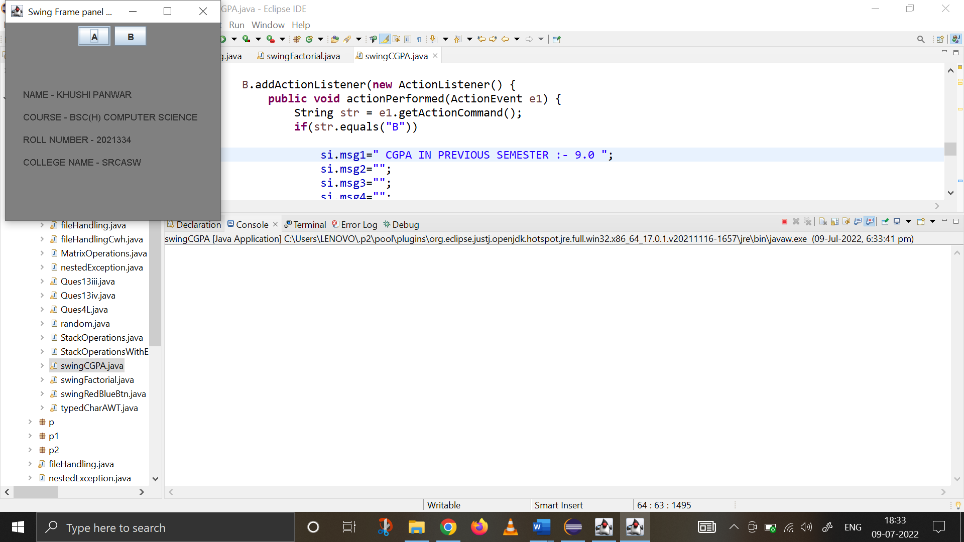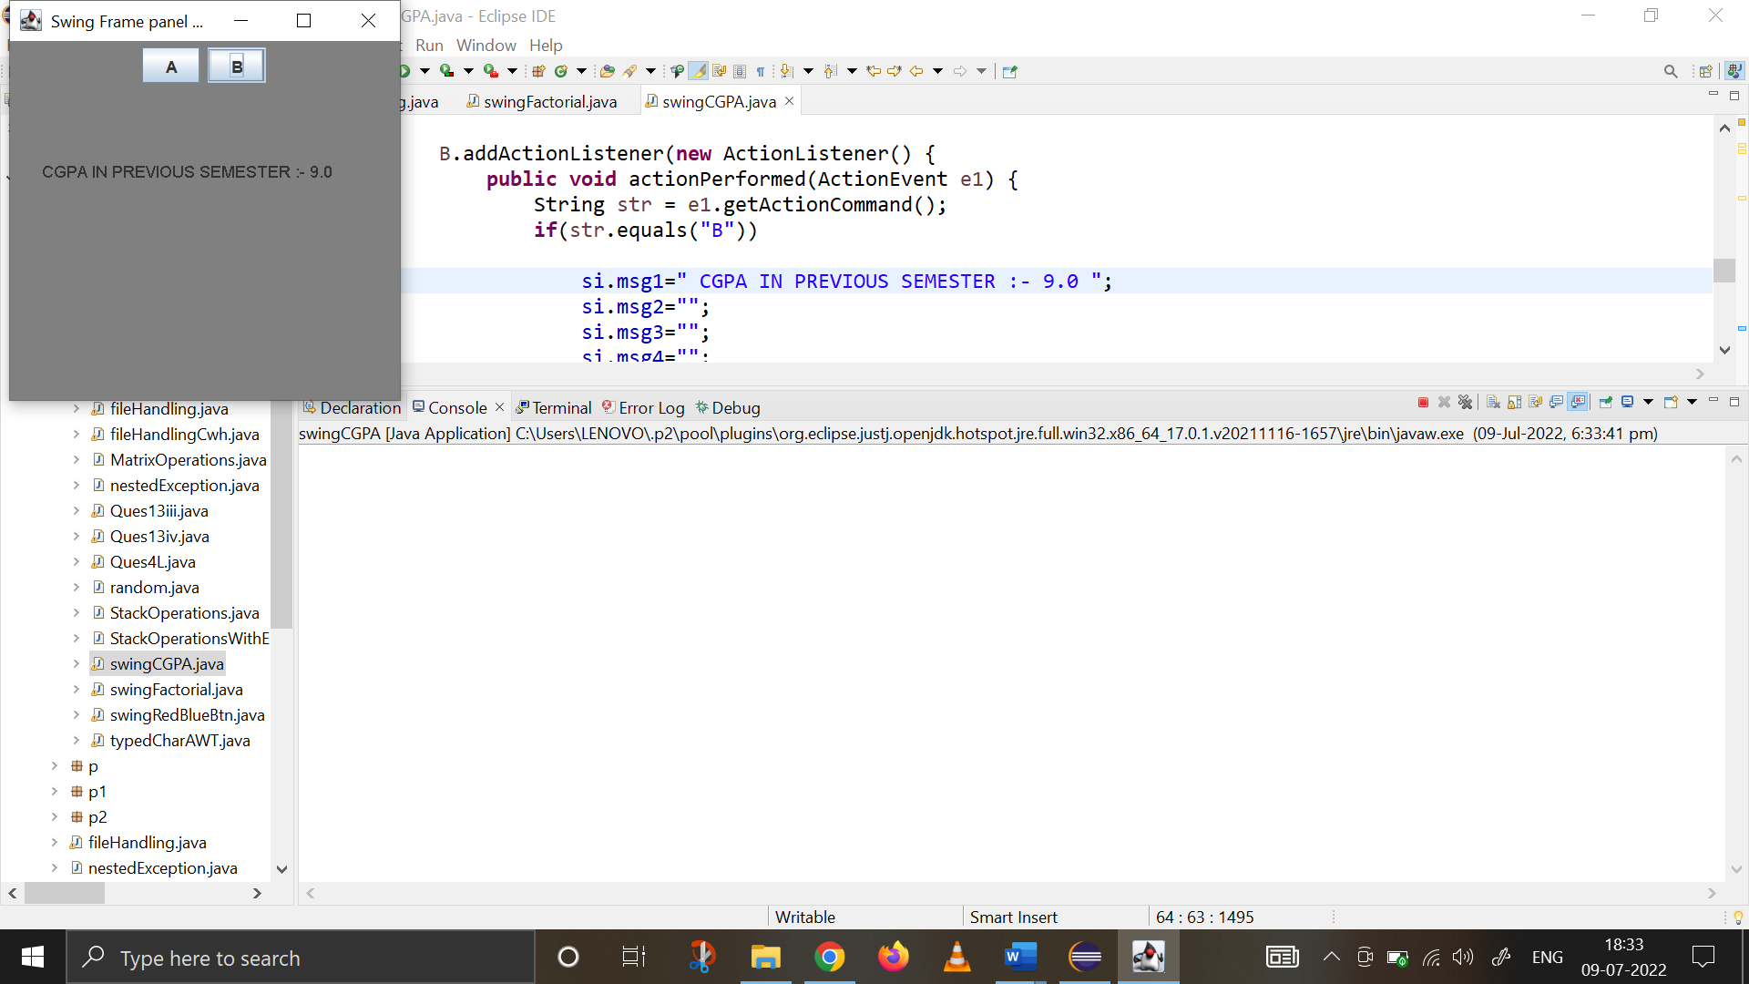

1. **WAP to find factorial using swing:**

**import** java.awt.*;

**import** java.awt.event.*;

**import** javax.swing.*;

**public** **class** swingFactorial {

**float** CalculateFactorial(String a){

**float** num=Float.*parseFloat*(a);

**float** fact=1;

**for** (**int** i=1; i<=num; i++) {

fact=fact*i;

}

**return** fact;

}

swingFactorial(){

//Basic Frame Settings to set up display window

JFrame jfrm=**new** JFrame("Java Application for Factorial");

jfrm.getContentPane().setBackground(Color.***WHITE***);

jfrm.setSize(500,500);

jfrm.setLayout(**new** FlowLayout());

jfrm.setDefaultCloseOperation(JFrame.***EXIT_ON_CLOSE***);

//text field settings

JTextField textBox=**new** JTextField(15);

//color and button settings

Color c=**new** Color(255,255,255);

JButton CalcFact=**new** JButton("Calculate Factorial");

CalcFact.setBackground(Color.***PINK***);

CalcFact.setAlignmentY(60);

CalcFact.setAlignmentX(90);

//adding all components to the frame

JLabel jlab=**new** JLabel("Enter a number : ");

jlab.setAlignmentX(50);

JLabel status1=**new** JLabel("");

JLabel status2=**new** JLabel("");

JLabel outputBox=**new** JLabel("");

//when button is clicked

CalcFact.addActionListener(**new** ActionListener() {

**public** **void** actionPerformed(ActionEvent ae) {

status1.setText("\nThe Value entered :"+textBox.getText());

String input=textBox.getText();

**float** output=CalculateFactorial(input);

outputBox.setText("\n The Factorial is "+output);

}

});

//adding components and visibility

jfrm.add(jlab);

jfrm.add(textBox);

jfrm.add(CalcFact);

jfrm.add(status1);

jfrm.add(status2);

jfrm.add(outputBox);

jfrm.setVisible(**true**);

}

**public** **static** **void** main(String[] args) {

SwingUtilities.*invokeLater*(**new** Runnable() {

**public** **void** run() {

**new** swingFactorial();

}

});

}

}

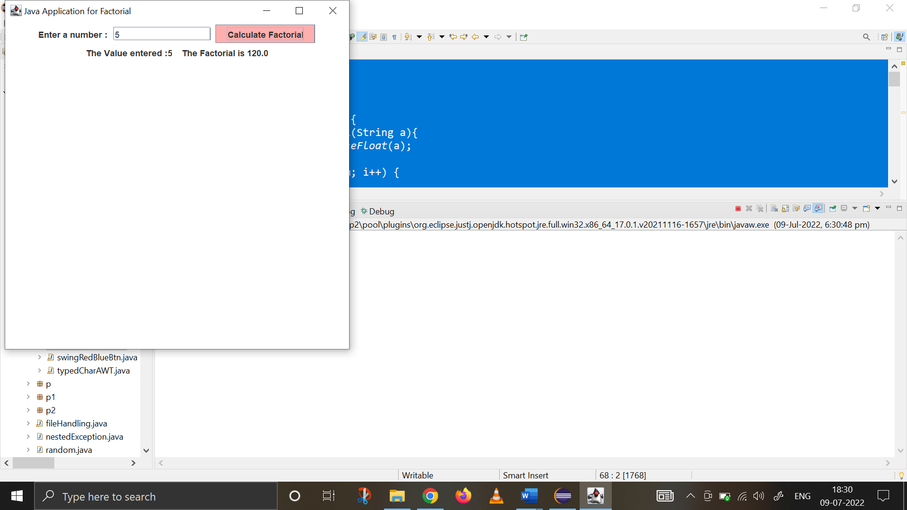

1. **Using Panel and key adapter, write a program to display the message the Typed character when user types any key.**

**import** java.awt.*;

**import** javax.swing.*;

**import** java.awt.event.*;

**import** java.awt.Graphics;

**import** java.awt.FlowLayout;

**class** panel1 **extends** JPanel

{

String msg = " TYPED CHARACTERS ";

**protected** **void** paintComponent(Graphics g)

{

**super**.paintComponent(g);

g.drawString(msg, 150, 150);

}

}

**class** Frame1 **extends** JFrame {

panel1 p1;

Frame1()

{

**super**(" KEY EVENT HANDLING USING SWING @_@ ");

setSize(500,500);

setDefaultCloseOperation(JFrame.***EXIT_ON_CLOSE***);

p1=**new** panel1();

add(p1);

addKeyListener(**new** MyKeyAdapter2(p1));

setVisible(**true**);

}

}

**class** MyKeyAdapter2 **extends** KeyAdapter {

panel1 o1;

MyKeyAdapter2(panel1 o2){

o1=o2;

}

**public** **void** keyTyped(KeyEvent ke) {

o1.msg+=ke.getKeyChar();

o1.repaint();

}

}

**public** **class** keyAdapterPanel {

**public** **static** **void** main(String[] args) {

SwingUtilities.*invokeLater*(**new** Runnable() {

**public** **void** run() {

**new** Frame1();

}

});

}

}

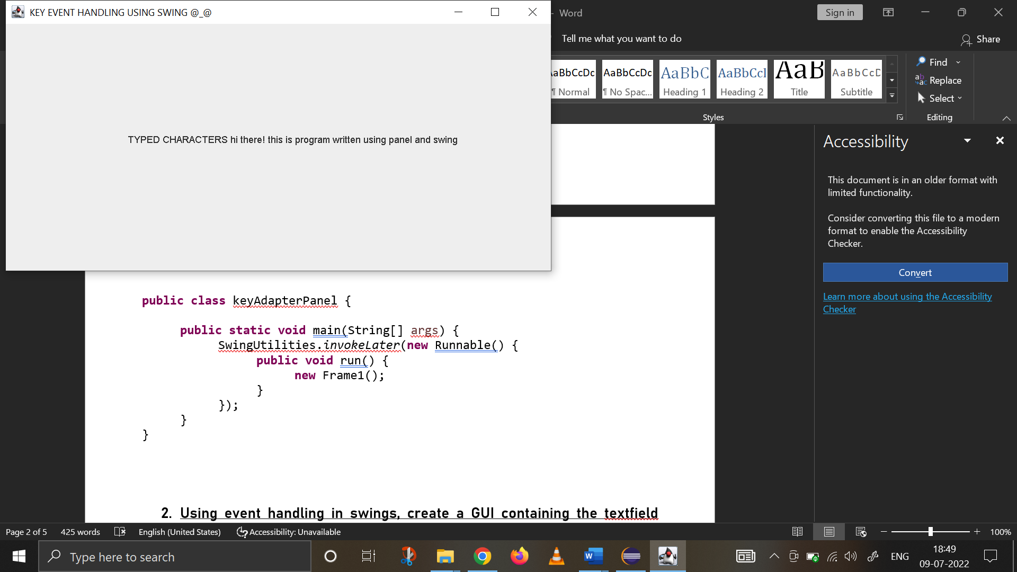

1. Using event handling in swings, create a GUI containing the textfield allowing the user to enter the number and create two buttons factorial and Fibonacci that will display of factorial and Fibonacci series based on number entered in the text box. The factorial and factorial should be displayed in the window.

**import** java.awt.*;

**import** java.awt.event.*;

**import** javax.swing.*;

**public** **class** Ques6 {

**float** CalculateFactorial(String a){

**float** num=Float.*parseFloat*(a);

**float** fact=1;

**for** (**int** i=1; i<=num; i++) {

fact=fact*i;

}

**return** fact;

}

String CalculateFibonacci(Float a) {

**float** terms=a;

**int** n1=1;

**int** n2=2;

String str=" ";

**for** (**int** i=1; i<=terms; ++i) {

str+=n1+",";

**int** n3=n1+n2;

n1=n2;

n2=n3;

}

**return** str;

}

Ques6(){

//Basic Frame Settings to set up display window

JFrame jfrm=**new** JFrame("Java Application for Factorial & Fibonacci Series Calculation");

jfrm.getContentPane().setBackground(Color.***WHITE***);

jfrm.setSize(500,500);

jfrm.setLayout(**new** FlowLayout());

jfrm.setDefaultCloseOperation(JFrame.***EXIT_ON_CLOSE***);

//text field settings

JTextField textBox=**new** JTextField(15);

JButton heading=**new** JButton("PROGRAM TO CALCULATE FACTORIAL AND FIBONACCI SERIES");

heading.setBackground(Color.***YELLOW***);

heading.setForeground(Color.***BLACK***);

heading.setAlignmentX(50);

//color and button settings for Factorial Button

Color c=**new** Color(255,255,255);

JButton CalcFact=**new** JButton("Calculate Factorial");

CalcFact.setBackground(Color.***PINK***);

CalcFact.setAlignmentY(60);

CalcFact.setAlignmentX(90);

//color and button settings for Fibonacci Button

Color d=**new** Color(255,255,255);

JButton CalcFib=**new** JButton("Calculate Fibonacci Series");

CalcFib.setBackground(Color.***PINK***);

CalcFib.setAlignmentY(60);

CalcFib.setAlignmentX(90);

//adding all components to the frame

JLabel jlab=**new** JLabel("Enter a number : ");

jlab.setPreferredSize(**new** Dimension(200,100));

jlab.setHorizontalAlignment(JLabel.***CENTER***);

JLabel outputBox1=**new** JLabel("");

outputBox1.setPreferredSize(**new** Dimension(200,100));

outputBox1.setHorizontalAlignment(JLabel.***CENTER***);

JLabel outputBox2=**new** JLabel("");

outputBox2.setPreferredSize(**new** Dimension(200,100));

outputBox2.setHorizontalAlignment(JLabel.***CENTER***);

//when button is clicked

CalcFact.addActionListener(**new** ActionListener() {

**public** **void** actionPerformed(ActionEvent ae) {

String input=textBox.getText();

**float** outputFact=CalculateFactorial(input);

outputBox1.setText("\n The Factorial is "+outputFact);

}

});

CalcFib.addActionListener(**new** ActionListener() {

**public** **void** actionPerformed(ActionEvent ae) {

String input=textBox.getText();

**float** inputFloat=Float.*parseFloat*(input);

String outputFib=CalculateFibonacci(inputFloat);

outputBox2.setText("\n The Fibonacci Series is "+outputFib);

}

});

//adding components and visibility

jfrm.add(heading);

jfrm.add(jlab);

jfrm.add(textBox);

jfrm.add(CalcFact);

jfrm.add(CalcFib);

jfrm.add(outputBox1);

jfrm.add(outputBox2);

jfrm.setVisible(**true**);

}

**public** **static** **void** main(String[] args) {

SwingUtilities.*invokeLater*(**new** Runnable() {

**public** **void** run() {

**new** Ques6();

}

});

}

}

